Claiming tax relief on UCU subscriptions

Information available at: https://my.ucu.org.uk/app/answers/detail/a_id/469/

UCU members are entitled to offset a proportion of subscriptions paid against tax paid (less any voluntary contribution made to the Education Support).
Members can claim (using the link provided):
- Online: by creating a Government Gateway ID. You will need your National Insurance number and a recent payslip or P60 or valid passport (see guide on next page).
- Post: by completing form P87 (see info below).
- Telephone: by calling the HMRC.
When completing a tax form, claims should be made under the section relating to 'professional fees and subscriptions'. The allowable figure to be entered should be 67% of the total subscriptions paid for each year.
You have up to four years to claim for each tax year - please note that UCU's subscription year runs from September to August each year, but the tax year from April to March. Tables of national subscription rates for the current and previous tax years, together with tables for local subscriptions, are attached below.
You will need to combine the national and local (if applicable) subscription you have paid for the relevant tax years, then enter 67% of this amount on your form.
Important note - Tax relief applying to UCU subscriptions will be a proportion of 67% of the total annual subscription paid, according the rate at which your earnings are taxed. The exact figure is dependent upon your tax district, tax rate and circumstances.
The union's name appears on the list of approved bodies for tax purposes. See elsewhere on the HM Revenue and Customs website for further information on tax relief for professional fees and subscriptions, including how to claim tax relief.
- File Type xlsxUCU local rates 2019-2020.xlsx (23.39 KB)
- File Type xlsxUCU local rates 2020-2021.xlsx (23.24 KB)
- File Type xlsxUCU local rates 2021-2022.xlsx (17.69 KB)
- File Type xlsxTime Limits Apr23.xlsx (12.34 KB)
- File Type docUCU tax claim form Apr23.doc (71 KB)
- File Type xlsUCU national rates 2019-23.xls (35.50 KB)
- File Type xlsxUCU local rates 2022-2023.xlsx (20.19 KB)

Claiming Tax Relief on UCU Subscriptions online via Government Gateway ID
Using the Excel template ‘Claiming Tax Relief on UCU Subs_May23_template.xlsx’:
- Using the tab ‘National Subs 2019-2023’, find the monthly subscription fee for each tax year. You will find subs for between 06 April – 31 August (5 months) and 01 September – 05 April (7 months) separately, as academic years are different to tax years, and the rates may be different in these 2 periods. Note these 2 monthly fee amounts (monthly fee). You will need to know whether you paid into the political fund or not to select the correct amount (if you opted out of donating to the political fund, use the figure in brackets).
NB: You can use your direct debit payments to UCU instead, if these go back far enough.
- In the 4th column, under ‘National Subs (06 April - 31 Aug)’, use the formula ‘=5*monthly fee’.
- In the 5th column, under ‘National Subs (01 Sept - 05 April)’, use the formula ‘=7*monthly fee’.
- You will see the last 2 columns, ‘Total Subs’ and ‘Total Allowable (67% of total)’ populate automatically.
- Repeat using the 4 other tabs titled ‘Local Subs…’ to work out the local subscription fee you have paid using the same method as above. (You can find the local rates by searching for ‘SO133’ or ‘Kent’ in each of the local rates tabs.)
Go to https://www.gov.uk/guidance/claim-income-tax-relief-for-your-employment-expenses-p87:
- After checking your eligibility, go to ‘Claim expenses online’.
- Sign into the Government Gateway or create new sign-in details to register for the first time.
- You will need your PAYE details from your payslip or P60, and your employer’s details, plus your bank details if you are due a refund.
- Click ‘Start now’ and follow the instructions.
- You will need to claim for each tax year separately. Select ‘6 April 2019 to 5 April 2020’ first, and ‘Save and continue’.
- *Input employer’s name and PAYE reference – you can find this at the bottom of a payslip or P60, so ‘The University of Kent’ and Employer PAYE Reference of ‘577/R636’ – and your job title.
- Under ‘Flat rate expenses’, select ‘No’ and then ‘Save and continue’.
- Repeat for all questions until you get to ‘Professional fees or subscriptions’. Select ‘Yes’ under ‘Have you paid professional fees or subscriptions?’ (see below):
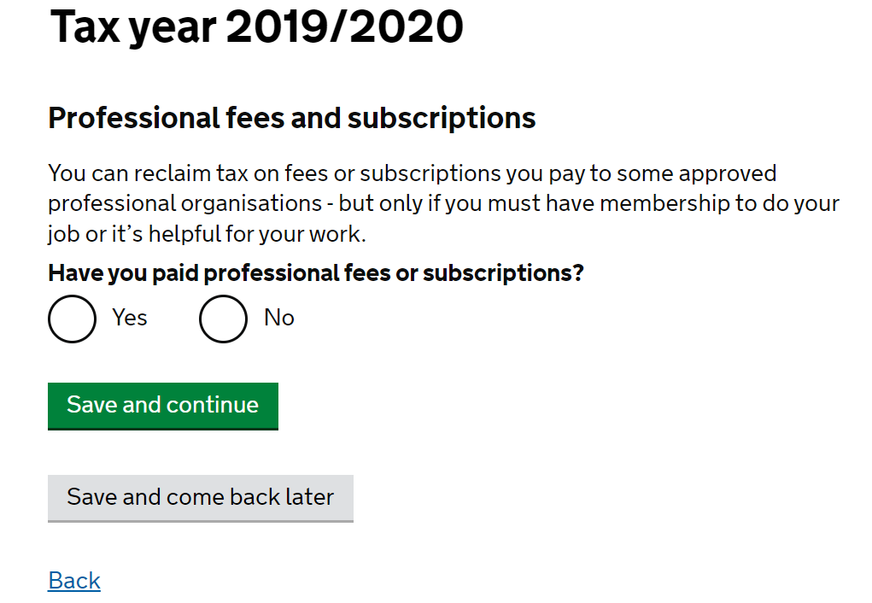
- Start typing ‘University and College Union’ into the box under Full name of the professional body’ and select the correct option (see below):
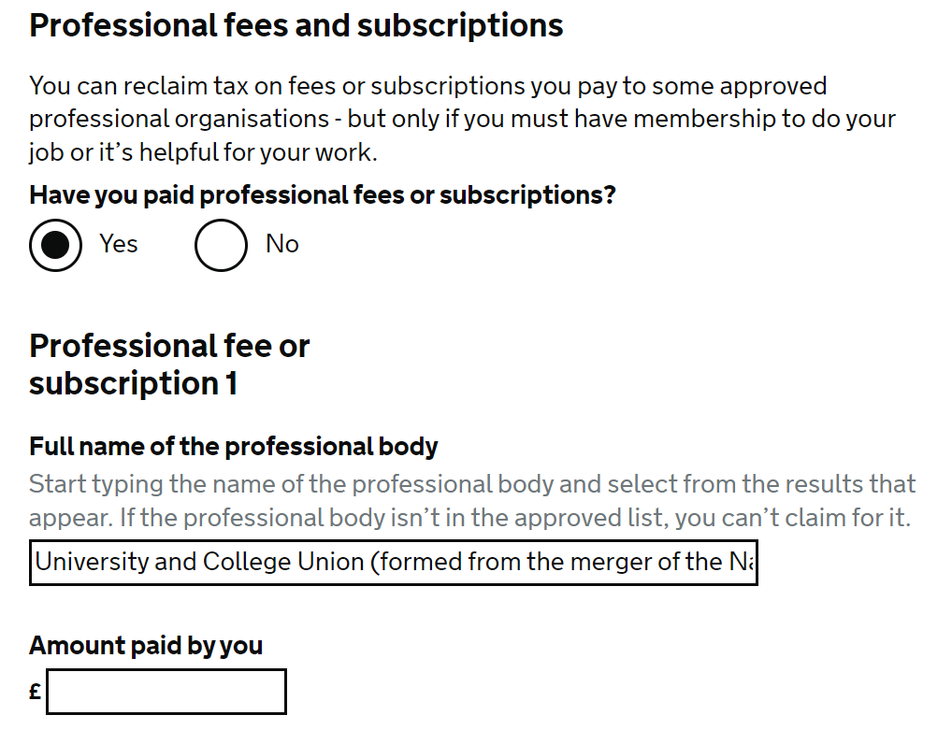
- Enter the total amount of subscription fees paid (NOT the 67%, but the Total Subs for 2019-20 from column 8 on Excel template) and enter ‘0’ under ‘Amount repaid to you by your employer’.
- Under ‘Medical exams and courses’, select ‘No’ and then ‘Save and continue’. Repeat for all further questions, unless you have other expenses to claim for. You will see a ‘Total expenses claimed for this employment’ page. Confirm this is the correct amount, and ‘Save and continue’.
- Select ‘Add another tax year’ to claim for 2020-21, and select tax year, then ‘Save and continue’.
- Repeat from * until you have claimed for all years.
- You will see a summary page titled ‘Total expenses claimed’, listing each year with the expenses submitted. Check this is correct against your Excel template, and if so, click ‘Save and continue’.
- Add who you would like payments to be paid to, and ‘Save and continue’.
- Add where you would like a payable order to be sent to, and ‘Save and continue’.
- Check the details on the ‘Summary’ page and ‘Save and continue’.
- Complete ‘Declaration’, add email for confirmation of application (optional) and ‘Confirm and send’.
- You will then see a confirmation that your claim is sent and your submission reference number.

You will be contacted by letter by HMRC with a breakdown of any tax rebates due to you, and a cheque for the total rebate amount in a few weeks from submitting your claim. You can also do this if you are members of any other professional bodies that are eligible for tax relief (see Approved professional organisations and learned societies (list 3) - GOV.UK (www.gov.uk)), e.g. if you are a joint member with Royal College of Nursing/ Midwives, etc.

