Learning Disability Services
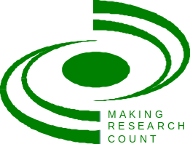
SCWRU & Making Research Count 2016 Workshop Series at King’s College London

These CPD certified workshops explore aspects of working with people with learning disabilities. Speakers involved in current research provide research messages with a practice focus, with time for discussion and debate.
2016 Workshop 1:
Living in Fear: Experience of Hate Crime and Victimisation amongst People with Learning Disabilities and Autism
Monday 21 March 2016, 1.45pm – 4pm
Led by Dr Jill Bradshaw and Lisa Richardson, Tizard Centre, University of Kent


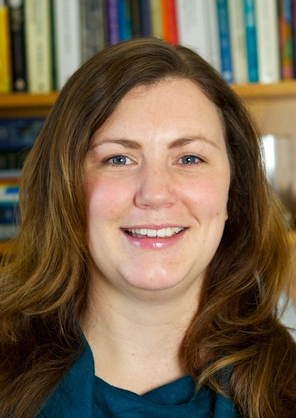

This workshop will focus on our research into Disability Hate Crime and Victimisation. Our research findings capture the views and experiences of people with learning disabilities and autism, family/paid carers and The Police. Some of the research recommendations are being implemented by mcch’s Jigsaw Project and we will also present this follow-on work. There will be an opportunity for group discussions around some of our key themes and recommendations.

Dr Jill Bradshaw worked in a community team supporting adults with intellectual disabilities and challenging behaviour before joining the Tizard Centre in 1995. She convenes the Undergraduate Autism Studies Programme and teaches on Intellectual Disabilities Postgraduate Programmes. Her research interests include communication and challenging behaviour, person-centred active support, staff culture, total communication approaches and autism spectrum conditions.
Lisa Richardson is a Research Associate and PhD student at Tizard. She has an MSc in Analysis and Intervention in Intellectual Disabilities and a first degree in Psychological Science. Lisa has contributed to research, service evaluations and teaching at Tizard since 2007. Previously Lisa worked with people with autism and intellectual disabilities in different capacities.

This workshop is open to all and free to attend
To secure a place please email: janet.noble@kcl.ac.uk
Making Research Count members enjoy priority but must book via Learning & Development Depts.

Venue: King’s College London, Waterloo Campus, Franklin-Wilkins Building, Stamford Street SE1 9NH, room 1.70 (5 minutes from Waterloo Station)

