Source A

Sopade (Social Democratic Party) Report on the KdF Programme, Berlin, February 1938.
Strength Through Joy is very popular. The events appeal to the yearning of the little man who wants an opportunity to get out and about himself and participate in the pleasures of the “top people”. It’s a clever appeal to the petty-bourgeois inclinations of the unpolitical worker. For such a man, it’s really something if he goes on a Scandinavian cruise or even just travels to the Black Forest or the Harz Mountains. He imagines that this has moved him up a rung on the social ladder.

(Give two things you can infer from Source A about the success of the Nazi KdF Programme in the 1930s)

Complete the table below to explain your answer.

- What I can infer:

Details in the source that tell me this:

- What I can infer:

Details in the source that tell me this:

Question 3(a)

There are three key parts to answering this question successfully:
- Judgement made about the value of the contents of the source, e.g. Source A is useful because…
- Own knowledge is used to support this judgement.
- The provenance (origin) of the source is taken into account, e.g. It was written by…
In addition, in your conclusion, give a final judgement on the value of each source. Is one more useful than the other?

Source B
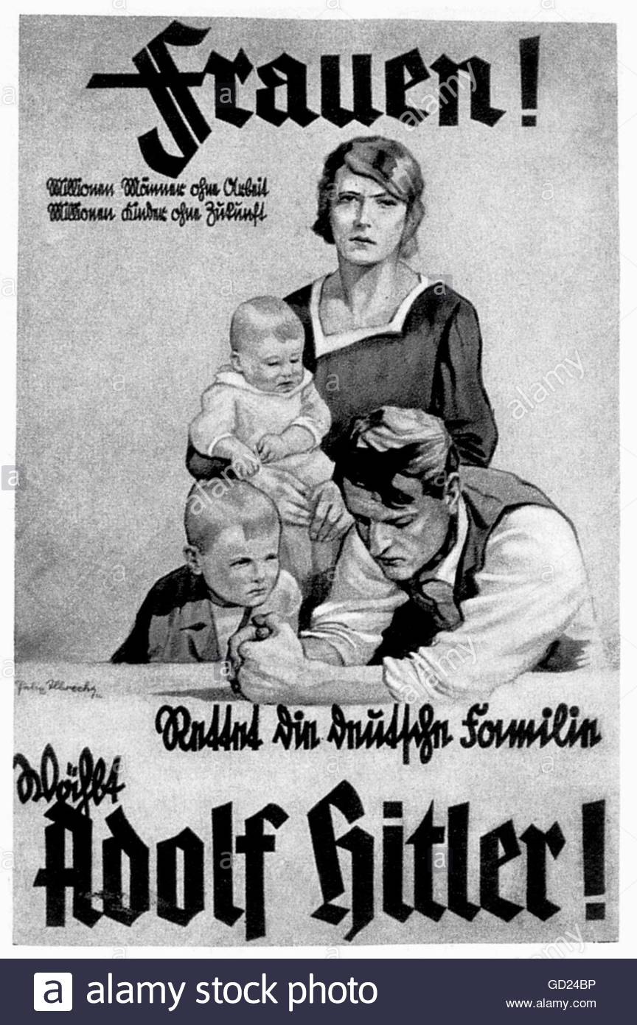
A 1932 Nazi poster: Women! Millions of men without work. Millions of children without a future. Save the German family. Vote Adolf Hitler!

Source C
Report on National Socialism by the KPD (Communist Party of Germany) Central Committee, 6 October 1930
The enormous danger posed by the National Socialist movement resides in its success in winning over the working masses who are almost entirely dissatisfied with, and in despair over bourgeois (middle class) politics; up until now they constituted the support for the bourgeois parties. Among millions of Nazi supporters there is no doubt that groups predominate which belong to the proletariat (working class) in class terms, are close to the proletariat, or could be won over as allies for the revolutionary proletariat: salaried staff, civil servants, the self-employed, farmers etc.

How useful are Sources B and C for an enquiry into why the Nazis came to power in the 1930s?

