Weapons, Wounds and Illness on the Western Front Exercise

Source A
The symptoms all pointed to the gas used being Chlorine. The notice given to troops in the majority of cases that there was a gas attack appears to have been very short. Several men stated they had no time to get their helmets on before they were gassed. Some men stated they never had a gas helmet on before. One officer was reported to have been seen walking about with his helmet pulled on and no attempt made at tucking it in…Several men stated on pulling on their helmets they were alarmed by the sensation of choking and pulled them off again.
(Summary of reports received from evidence obtained from Officers Commanding Field Ambulances in the recent German Gas Attack on 16th Division, 28th and 29th April 1916)

Source B
1. Always put on your Respirator if there is the least smell of gas. Do not think that the gas is useless, because it does not affect you immediately.
2. If a man’s clothing is splashed with Mustard Gas he will be a source of danger to himself and others until the clothing has been changed.
3. Remember that Mustard Gas remains on the ground for a long time after the shelling ceases. This is especially the case in the morning after night shelling, when the sun begins to warm the ground.
(Pamphlet on Mustard Gas issued by First Army on the Western Front, May 1918)

- According to Source A and B, what problems did soldiers face when they were gassed? (State at least 4 problems)

Source C
 | Total | Head/Face/  Neck | Shoulder/  Back | Chest | Abdomen | Buttocks | Thighs | Legs | Arms
Bullets | 897 | 212 | 74 | 60 | 45 | 32 | 110 | 95 | 79
Artillery | 2,171 | 500 | 277 | 99 | 52 | 105 | 194 | 291 | 209
Grenades | 217 | 49 | 9 | 8 | 3 | 6 | 12 | 28 | 19
Total | 3,285 | 761 | 360 | 167 | 100 | 143 | 316 | 414 | 307
(Official British Army Report on the regional incidence of all wounds in cases admitted into casualty clearing stations of 1st, 2nd, and 3rd Armies during 14 days of trench warfare, 14-27 December 1915)

- According to Source C, in what areas of the body were the majority of injuries sustained by soldiers? (Write down the figures in your answer)

- What type of weapon caused the majority of injuries? In what area of the body did this weapon cause the most wounds?

Source D
A study of the literature of trench foot clearly indicates the important part played in the causation of the disease by conditions which interfere with the circulation of the disease by conditions which interfere with the circulation in the feet, such as long hours spent in an upright or crouching position when on or off duty in the trenches and the want of facilities for rest in the recumbent position (laying down). These conditions were unavoidably present in the early days of the campaign; they occurred also in situations where the nature of the ground prevented the construction of dug-outs, or when there had been no time to prepare them, as happened at all times in the case of newly dug trenches.
Month No. of Cases in 1914
August 1
September 1
October 11
November 1,555
December 4,823
6,391
(Major-General Sir W.G. MacPherson, Story of the Great War, based on Official Documents: Medical Services; Surgery of the War, Vol.1, 1922)

- Look at Source D. What sort of conditions caused soldiers to develop trench foot? (Make sure to also look at the no. of cases)

Source E
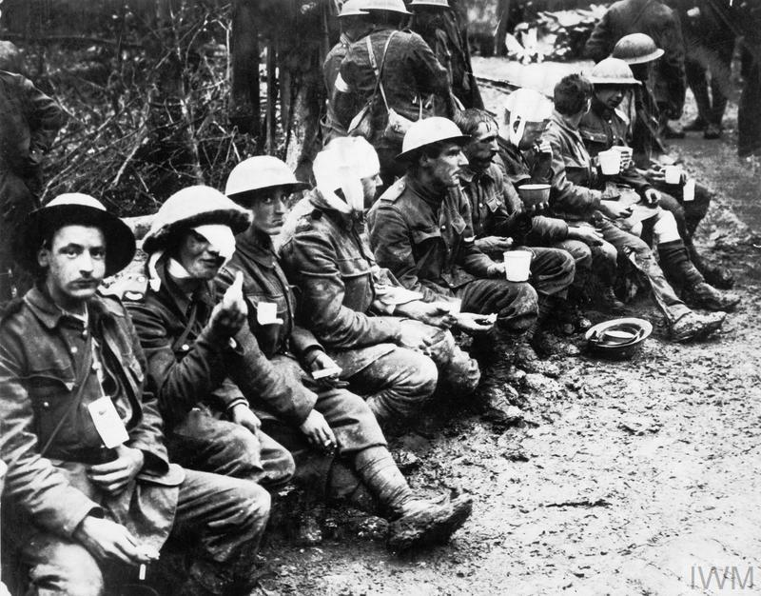
(Wounded British soldiers having tea and food at a dressing station near Aveluy Wood, the Somme, during the Battle of the Ancre, 13 November 1916)

- Looking at Source E, what can we learn about the nature and treatment of the wounds sustained by British soldiers from this picture?

