The Stages of Treatment for Wounded Soldiers Exercises

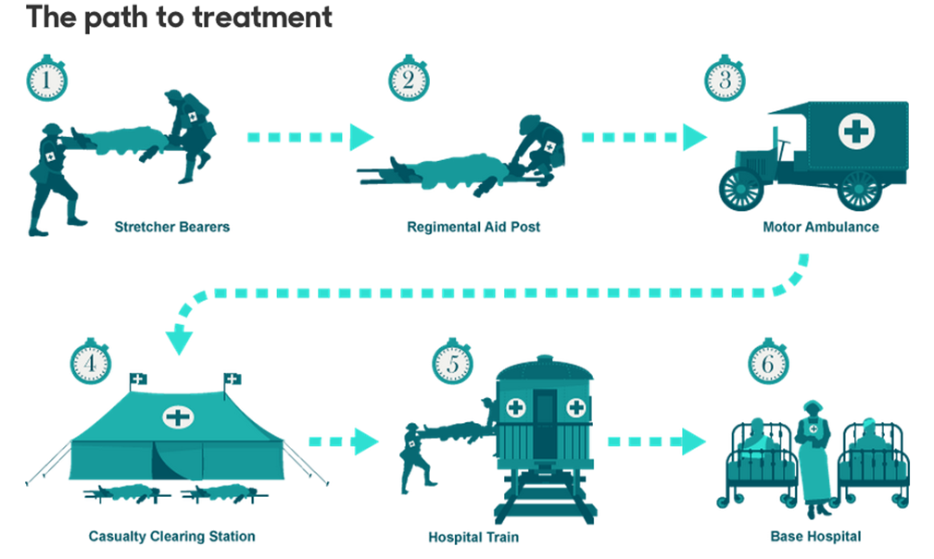

Source A
Things were badly organised, and the conditions were shocking. The wounded were all rushed south as rapidly as possible and the more seriously ill were put off whenever and wherever the trains stopped. They were picked up in any way chance might favour—luckily if by an ambulance, but more often by a cattle or provisions train returning from the Front. One of these trains had dumped about five hundred badly wounded men and left them lying by the side of the tracks in the rain.
(Journal of Harvey Cushing, American neurosurgeon, 5 April 1915)

- What does source A tell us about the organisation for the treatment of the wounded before 1916?

Source B
The next major test of the arrangements came during the battle of Arras, which began on 9 April 1917: the first major engagement involving the British Army since the end of the Somme campaign… It cost the lives of 160,000 British and Australian troops, 13,000 of whom died within the first three days. The battle has the dubious distinction of having the highest average daily death toll of any fought by the British during the war, as well as being the first to make use of conscripts as well as volunteers. The number of wounded men passing through dressing stations and CCSs was correspondingly large. A total of 25,856 British and Portuguese wounded were admitted to British medical units in the 1st Army during the first phase of operations, from 9 April to 10 May. This added to the considerable burden of sick men (some 18,951 over the same period), which had resulted from a period of particularly inclement weather, many being cases of trench foot… Despite the heavy casualties, and the fact that not all the ambulance trains ordered had arrived in time for the beginning of the battle, medical arrangements stood the test. The initial deficiency of trains was made up by a supplement of buses, barges, and lorries and within a day or so all the trains ordered had managed to get through to CCSs.
(Mark Harrison, The Medical War: British Military Medicine in the First World War, 2010, p.78)

- Compared to Source A, what does Source B tell us about how the organisation for the treatment of the wounded had changed by 1917?
- What can Source B tell us about the problems face at various stages when transporting and treating the wounded?
Source C
At Passchendaele, Casualty Clearing Stations were grouped together in teams in different sectors, much as in earlier battles, but with a greater degree of specialization than hitherto. Most CCSs were detailed to take particular cases such as walking wounded, self‐inflicted wounds, infectious cases, abdominal wounds, severe chest injuries, compound fractures, nervous and gas cases; only a few were open to cases of all kinds. Another change was the way in which the lightly wounded were dealt with. In previous battles, there had been a tendency to treat slight cases relatively close to the front but it was now proposed to send some of them further back. While retaining the lightest cases near the front in Rest Stations, he advocated sending those cases that required a little more treatment to the CCSs in the rear, leaving units closest to the front for the reception of more serious cases such as abdominal wounds.
(‘Summary of Medical Arrangements for 5th Army’, 1-15 July 1917, The National Archives, WO95/532)

- How useful is Source C for understanding how Casualty Clearing Stations dealt with the wounded throughout the whole war?

Source D
There was a little doctor’s shelter thing dug into the side of the hill, so I went in there and got bandaged up and that’s where I did see Jack Beament. He’d brought this chap Redman in and he’d got wounded and all. But the doctor said, “Can you make it further back on your feet?” We both said we could, so we set off back together. What with the loss of blood, we was both feeling pretty unwell by the time we got down to Happy Valley…We get down to the dressing station eventually and then we was shipped off to the casualty clearing station in an old general service waggon. The padre was at the dressing station asking us all when we came in if we’d seen anybody get killed and who they were. See anybody get killed! I should say we did!
(Rifleman J. Brown, MM, A Company, 16th Battalion, King’s Royal Rifle Corps, recalling his experiences at the Battle of the Somme, July 1916)

- What does Source D tell us about the experiences of some of the wounded soldiers at the Battle of the Somme?
- How useful is Source D for understanding how the evacuation of the wounded happened at the Battle of the Somme?

- What evidence is there from the sources provided which support the argument that a soldier stood more chance of survival from a wound in 1917 than he did at the start of the war?

