Question 2(a)

There are three key parts to answering this question successfully:
- Judgement made about the value of the contents of the source, e.g. Source A is useful because…
- Own knowledge is used to support this judgement.
- The provenance (origin) of the source is taken into account, e.g. It was written by…
In addition, in your conclusion, give a final judgement on the value of each source. Is one more useful than the other?

Source A
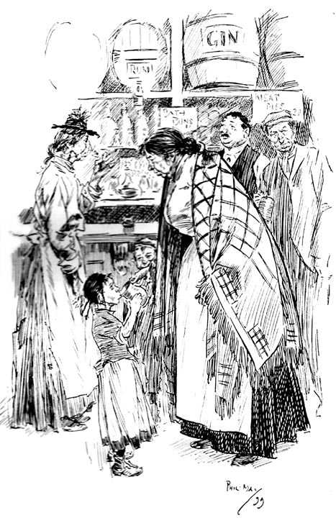
In An East-End Gin-Shop (1899), by Phil May, an influential Victorian caricaturist for Punch Magazine

Source B
Case no. t18870627-713
713. WILLIAM WARNER (25), Robbery with violence on John Ford, and stealing 17s. 6d. his money.
JOHN FORD. I am a labourer, and live at 112, Whitechapel Road—on Sunday evening I was in company with the prisoner in Whitechapel Road—it was about 10 minutes to 11 when we came out of the public-house—we stood some time outside the door, and I bid him good night and walked down the road—I saw no more of him for about half an hour, when I found his hand in my left-hand trousers pocket, where I had 17s. 6d.—I caught him by the hand in my pocket, and we both fell to the ground, and in taking my pocket off he cut my finger—he was the worse for a drop of drink, or I don't think he would have done it—I struggled with him for about half an hour—he then got away—I went to the London Hospital and had my finger dressed—I saw the prisoner on the Monday following, and gave him into custody—I knew him—the 17s. 6d. was in silver; it was all taken.
GUILTY. Recommended to mercy by the prosecutor — Nine Months' Hard Labour. There was another indictment against the prisoner.

Study Source A and B. How useful are Sources A and B an enquiry into the problems of alcohol in the Whitechapel area? Explain your answer using Sources A and B and your own knowledge of the historical context.

Study Source A

How could you follow up Source A to find out more about alcohol and crime in the Whitechapel area?

In your answer, you must give the question you would ask and the type of source you could use.
Complete the table below.

Detail in Source A that I would follow up:

Question I would ask:

What type of source I could use:

How this might help answer my question:

