Source A, cartoon depicting the cholera outbreak in Britain in 1848
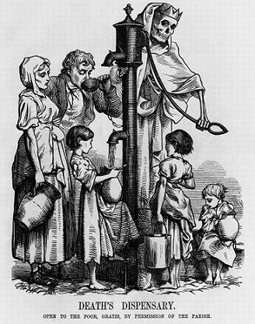

How useful is Source A to a historian studying the cholera epidemic?

Explain your answer using Source A and your own contextual knowledge.

Elements to include in your answer:
- Explain what the source is actually showing and why this is useful for the subject?
E.g. if a source shows the negative reaction to Edward Jenner’s discovery of the smallpox vaccination, this is useful because although the discovery is significant today, it was rejected by lots of people at the time.
- What is the purpose of the source?
E.g. is it attempting to show a positive/negative light on an issue or decision made by people/the government?
- What type of source is it? E.g. if it is a cartoon it might be exaggerated so this might make it less useful for historians.
- Is the source actually useful?
E.g. the source is useful because…

Source A, cartoon depicting the cholera outbreak in Britain in 1848

How useful is Source A to a historian studying the cholera epidemic?

Explain your answer using Source A and your own contextual knowledge.

Elements to include in your answer:
- Explain what the source is actually showing and why this is useful for the subject?
E.g. if a source shows the negative reaction to Edward Jenner’s discovery of the smallpox vaccination, this is useful because although the discovery is significant today, it was rejected by lots of people at the time.
- What is the purpose of the source?
E.g. is it attempting to show a positive/negative light on an issue or decision made by people/the government?
- What type of source is it? E.g. if it is a cartoon it might be exaggerated so this might make it less useful for historians.
- Is the source actually useful?
E.g. the source is useful because…

