The Impact of the Western Front on Medicine Exercises

Source A
The Thomas splint is adjustable to any size limb and can be adapted to either the right or the left side. Being made from one pattern and in one size, it is therefore standardisable. The ease of application of the splint, which takes a few minutes, is a most important matter for the consideration of the hard-working surgeon who is obliged to cope with a rush of work. The wounded can be transported with the greatest possible comfort and safety under the circumstances. A great difficulty in the immediate treatment, and transport, of these cases is overcome by the application of this splint.
(W.B. Hayes, An Adjustable and Standardised Splint for the Treatment of Fractures, The British Medical Journal, December 1915)

- What does Source A say were the main advantages of the Thomas splint?

Source B
The adoption of the Thomas splint in the treatment of compound fractures of the femur caused by gunshot wounds has done much to alleviate the suffering resulting from the injury, has saved many lives and limbs, and has led to much improved functional results. From the casualty clearing station at the front to the general hospitals at the base there is every facility for the application of the splint and the carrying out of the principles which its use entails. In front of the casualty clearing station, however, these facilities are not forthcoming, and the full value of the splint has not been obtained owing to the difficulty of applying simple and efficient first-aid extension.
(O. Herbert Williams, The Early and Effective Reduction and Fixation of Gunshot Fractures of the Femur, The British Medical Journal, June 1918)

- What positives does Source B identify in using the Thomas splint?

- According to Source B, what problems were experienced by the wounded before arriving at casualty clearing stations?

Source C
In this war the variety of sepsis that has claimed more victims than any other is that known in doctor’s slang as “gas gangrene”. Gas gangrene is caused by the presence in a wound of certain types of bacilli (bacteria) which cannot live in air, the vital principle of which is oxygen. They exist in cultivated soil, and it is because the war is being fought in France among the peasants’ fields that they are introduced so constantly by ricocheting bullets, or scraps of earth-stained clothing, into the wounds of our soldiers… Once there they set about producing tiny gas bubbles among the tissues, hence the name “gas gangrene”. But the gas they cannot endure is oxygen, and the obvious way to destroy them is to introduce oxygen into the innermost recesses of the wound. A hole right through the shoulder will be sterilised by the use of a which drawing peroxide of hydrogen from a small tank above the bed. Another kind of wound will be sprayed with ozone, and a third more conveniently dealt with by means of a tube fed with oxygen gas from a cylinder.
(Mending the Broken Soldier; Our Debt to the Surgeon, The Times, 12 August 1916)

- What was the main cause of gas gangrene for those fighting on the Western Front?

- What methods were employed by surgeons to try and treat gas gangrene?
Source D
During the fighting in the Ypres salient (3rd Battle of Ypres) transfusion of blood was first employed on a large scale, and proved of greatest value. It was given either direct through a paraffin-coated glass receiver, or else mixed with a “citrate solution”, and before the end of 1917 the methods of transfusion and the classification of donors were standardised in every casualty clearing station, with the consequent saving of many lives. During 1917 also much more attention had been paid to the treatment of shock, and in every casualty clearing station a special hut or tent was provided where arrangements were made for warming such patients for transfusing blood.
(Major-General Sir W.G. MacPherson, Story of the Great War, based on Official Documents: Medical Services; Surgery of the War, Vol.1, 1922)

- What does Source D say about how important the use of blood transfusion was for wounded soldiers? What developments had occurred by 1917?

Source E
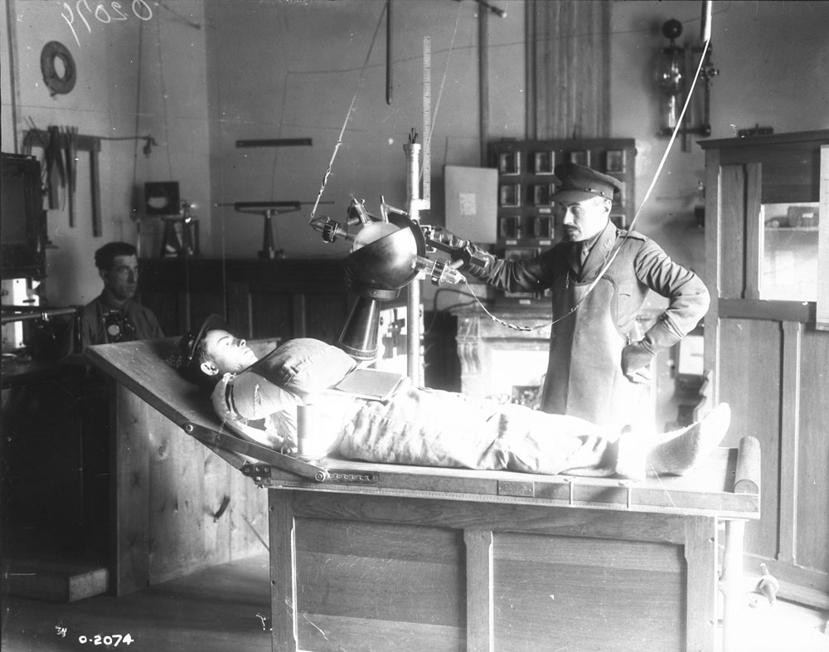
A bullet in the arm of a French soldier being X-rayed at No.8 General Canadian Hospital, Paris, October 1917

- What can Source E tell us about the type of equipment used to x-ray during the First World War?

- Why do you think it was important to x-ray wounds such as this one shown in Source E?

- What do you think was the most important development in medicine on the Western Front? Explain your answer using the sources provided and your own knowledge.

