‘To form one United Association for all Ireland for the purpose of maintaining the Union existing between Great Britain and Ireland, and upholding the rights and liberties to which every Irishman is entitled under the laws and constitution of the United Kingdom…
To use every Constitutional means to carry out the objects for which the ILPU was formed, and invite all Unionists, especially those who have capital invested in commercial undertakings, or who are otherwise interested in Irish industrial enterprises, irrespective of creed or party, to join…
To organise public meetings throughout the United Kingdom, at which members of the association and others could attend, and properly represent the condition of Ireland and the true character of the so-called Nationalist movement’.
Source A: Extract from a report from the Irish Times, 9 January 1886, of the first annual general meeting of the Irish Loyal and Patriotic Union.

- What does the source say is the intention of the ILPU?

- What methods does the source say that they are going to pursue?

I receive letters every day asking me to write a manifesto and make a speech; that I am the only man who could do so with effect; and all that. Why should I? I warned the country about Ireland before the General Election and told them to be vigilant, or there would be something happen there, "worse even than famine or pestilence". It has happened. And there have been elections since the Irish Revolution in England, Wales and Scotland, and they have supported the policy of imbecility and treason that has brought about all this disaster.
Source B: Letter from Benjamin Disraeli to Lady Chesterfield, 22 December 1880

It has been asked in this debate, why have we put aside all the other Business of Parliament, and why have we thrown the country into all this agitation for the sake of the Irish Question? ("Hear, hear!") That cheer is the echo that I wanted. Well, Sir, the first reason is this — because in Ireland the primary purposes of Government are not attained. What said the honourable Member for Newcastle (Mr. J. Cowen) in his eloquent speech? That in a considerable part of Ireland distress was chronic, disaffection was perpetual, and insurrection was smouldering. What is implied by those who speak of the dreadful murder that lately took place in Kerry? And I must quote the Belfast outrage along with it; not as being precisely of the same character, but as a significant proof of the weakness of the tie which binds the people to the law. Sir, it is that you have not got that respect for the law, that sympathy with the law on the part of the people without which real civilization cannot exist. That is our first reason. I will not go back at this time on the dreadful story of the Union; but that, too, must be unfolded in all its hideous features if this controversy is to be prolonged — that Union of which I ought to say that, without qualifying in the least any epithet I have used, I do not believe that that Union can or ought to be repealed, for it has made marks upon history that cannot be effaced. But I go on to another pious belief which prevails on the other side of the House, or which is often professed in controversies on the Irish Question. It is supposed that all the abuses of English power in Ireland relate to a remote period of history, and that from the year 1800 onwards from the time of the Union there has been a period of steady redress of grievances. Sir, I am sorry to say that there has been nothing of the kind.
Source C: A speech by William Ewart Gladstone MP, British Prime Minister, to the House of Commons on Home Rule for Ireland, given on 7 June 1886

- What do these two sources tell us about Disraeli and Gladstone’s attitudes towards Ireland?

- What tone do each of these sources take?

- What reasons for pursuing Home Rule does Gladstone put forward in Source C?

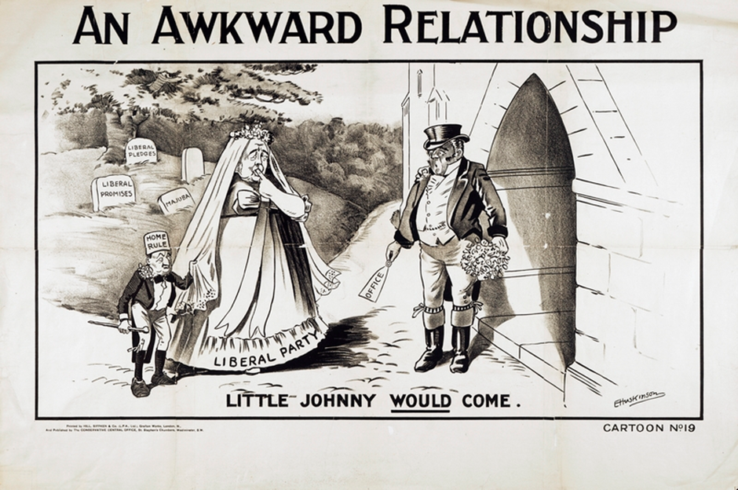
Source D: Published by the Conservative Central Office, 1905-1908

- What is the cartoon depicting to its viewer?

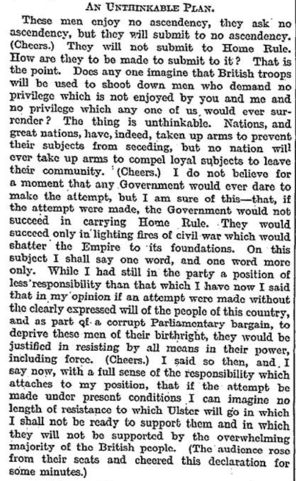
- What is Andrew Bonar Law justifying in this source?

- What tone does Law take in his speech?

- Do you think what he is saying is significant in our context? And, why?
Extract from a public speech made by Andrew Bonar Law at a Unionist demonstration at Blenheim Palace, reported in The Times, 29 July 1912.

