Social Reform at the end of the Second World War

- Use your knowledge about reform’s after the Second World War to assess how useful Source B is as evidence of resistance to social reform post-1945.

- Using these three sources in their historical context, assess how far they support the view that the Beveridge Report was the main reason for the Labour Party’s General Election victory in 1945.

Source A Report on Social Insurance and Alliance Services, by Sir William Beveridge, a British civil servant and Liberal, 1942.
Three Assumptions. No satisfactory scheme of social security can be devised except on the following assumptions:
- Children’s allowances for children up to the age of 15 or if in full-time education up to the age of 16;
- Comprehensive health and rehabilitation of services for prevention and cure of disease and restoration of capacity for work, available to all members of the community;
- Maintenance of employment, that is to say avoidance of mass unemployment…

Source B A Speech made by George Orwell, novelist and journalist, during a BBC Radio broadcast, 20 February 1943.
The Beveridge scheme of social security is still under debate. The government has already proposed the adoption of the greater part of it but a Labour amendment in the House of Commons demanding the adoption of the scheme in its entirety received as many as 117 votes have spoken of the Beveridge scheme in earlier news commentaries and don't want to detail its provisions again I merely mention the debate now taking place in order to emphasise two things. One is, that whatever else goes through, family allowances are certain to be adopted though it is not yet certain on what scale. The other is that the principle of social insurance has come to stay and even the most reactionary thinkers in Great Britain would now hardly dare to oppose this. The Beveridge scheme may ultimately be adopted in the somewhat mutilated form, but it is something of an achievement even to be debating such a thing in the middle of a desperate war in which we are still fighting for survival.

Source C A cartoon by Leslie Illingworth, published in the Daily Mail, 17 February 1943.
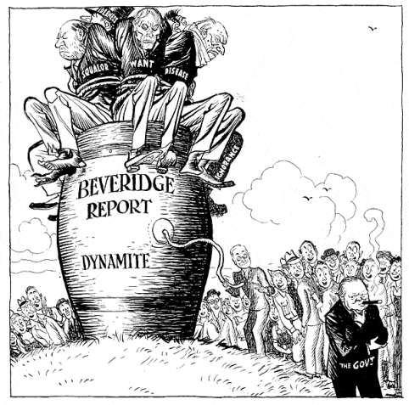

Appeasement and Foreign Affairs, 1919-39

- Use your knowledge of British foreign policy between the world wars to assess how useful Source A is as evidence for opposition to Neville Chamberlain’s policy of appeasement up to 1939.

- Using these three sources in their historical context, assess how far they support the view that Neville Chamberlain was responsible for Britain entering the Second World War unprepared to fight it.

Source A Results of British Public Opinion Polls taken from October 1938 onwards.
Hitler says he has ‘No more territorial ambitions in Europe’. Do you believe him (Oct 1938)
Yes 7%
No 93%

In the present situation do you favour increased expenditure on armaments? (Oct 1938)
Yes 72%
No 18%
No opinion 10%

Which of these statements comes nearest to representing your views of Mr Chamberlain’s policy of appeasement? (Feb 1939)
- It is a policy which will ultimately lead to enduring peace in Europe – 28%
- It will keep us out of war until we have time to rearm – 46%
- It is bringing war nearer by whetting the appetite of the dictators – 24%

Source B Historian Alan Farmer, writing in Britain: Foreign and Imperial Affairs, 1919-39, published in 1992.
Chamberlain has been criticised for lacking an insight into the minds of the dictators. In his defence, however, Chamberlain certainly did not trust Hitler, Mussolini or the Japanese. (He soon believed Hitler ‘utterly untrustworthy and dishonest’). For this reason he was not simply intent on appeasing the dictators. He also favoured rearmament. He was convinced that ‘you should never menace unless in a position to carry out your threat’. Until Britain was adequately armed, ‘we must adjust our foreign policy to our circumstances and even bear with patience and good humour actions which we would like to treat in a very different fashion’.

Source C A cartoon by David Low, published in the Evening Standard 20 May 1940.

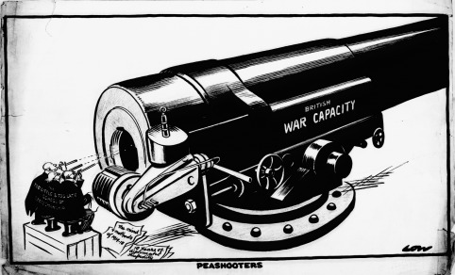
Text reads:
The Too Little & Too Late School of statesmanship
The mind & methods of 1914-18
10 years of diplomatic stupidity

The Impact of the First World War on British society

- Use your knowledge of the impact of the First World War on Britain to assess how useful Source A is as evidence of the impact of the war on people’s daily lives.

- Using these three sources in their historical context, assess how far they support the view that the First World War had a major impact on British society.

Source A David Lloyd George, War Memoirs, published in 1938.

So far as the vast bulk of the population was concerned, this rationing system, troublesome though in some respects it was to them, ensured a regular and sufficient food supply; and it made it possible for those in charge to calculate with some precision how best they could make the stocks of available food-stuffs go round equitably. When meat was slightly more plentiful, the ration could be raised. When it grew scarcer, the amount purchasable with each meat coupon was cut down. The steady improvement in our national health figures during and after the War, as compared with pre-War returns, shows that compulsory temperance in eating was in general more beneficial than harmful in its effects. Although there was a degree of scarcity, we were never faced with famine or actual privation. Credit is due to our people for the loyal manner in which they submitted themselves to these strange and unwelcome restrictions. Without general goodwill it would have been impossible to make the regulations effective.

Source B An article published in Punch Magazine, June 1916.

It is quite impossible to keep pace with all the new incarnations of women in war-time - 'bus-conductress, ticket-collector, lift-girl, club waitress, post-woman, bank clerk, motor-driver, farm-labourer, guide, munition maker. There is nothing new in the function of ministering angel: the myriad nurses in hospital here or abroad are only carrying out, though in greater numbers than ever before, what has always been woman's mission. But whenever he sees one of these new citizens, or hears fresh stories of their address and ability, Mr. Punch is proud and delighted. Perhaps in the past, even in the present, he may have been, or even still is, a little given to chaff Englishwomen for some of their foibles, and even their aspirations. But he never doubted now splendid they were at heart; he never for a moment supposed they would be anything but ready and keen when the hour of need struck.

Source C Front page of the Defence of the Realm Act Proclamation, August 1914.

