Battles of the Western Front Source Exercises

The Battle of the Somme, 1 July – 18 November 1916

Source A
Medical preparations for the Somme offensive were far more sophisticated than those for any British military operation to date. But the number of sick and wounded men cleared from the battlefield and sent down the lines of evacuation exceeded expectations... [General] Rawlinson had estimated around 10,000 casualties per day but by the end of the first day of the offensive he was informed that they amounted to 16–20,000. By the following day, the number had risen to over 30,000. As is well‐known, even this figure fell well short of the actual number of men killed and wounded, there being 57,000 British casualties on the first day alone. Of these, around 40,000 were classified as wounded, half of them gravely. The huge number of casualties—the single greatest loss in the British Army's history—placed an enormous burden on the system of evacuation. (Mark Harrison, The Medical War: British Military Medicine in the First World War, 2010, p.72)

Source B
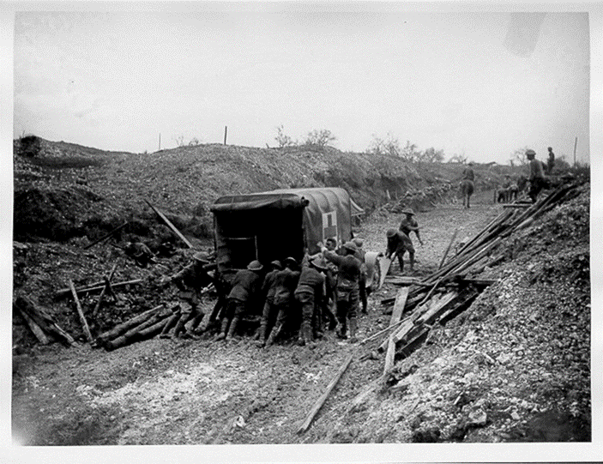
(Photograph of an ambulance making its way from the front at the Somme, July 1916)

Source C
The whole of the valley was being swept with machine-gun fire and hammered with shells. We got the men organised as best we could – those of us who were left. So many gone, and we’d never even got past our own front-line trench! And then we found we couldn’t get back. The trenches were indescribable! We were simply treading on the dead. Eventually my sergeant and I got out on top. I heard a shell coming. It burst above my head. The Sergeant was blown one way and I was blown the other. He was killed. I don’t know how I got back. I simply don’t know how I got back. It was murder.
(Diary of Captain Arthur Agius, 3rd Battalion, Royal Fusiliers. 468 of his battalion were killed or wounded on 1 July)

Look at Source A. What pressures did the medical services face during the first days of the battle?

Look at Source B. What can it tell us about the conditions faced by medical services during the battle?

Look at Source B and C. What can they tell us about the experiences of soldiers during the battle?

The Battle of Passchendaele (3rd Battle of Ypres), 31 July – 10 November 1917

Source A
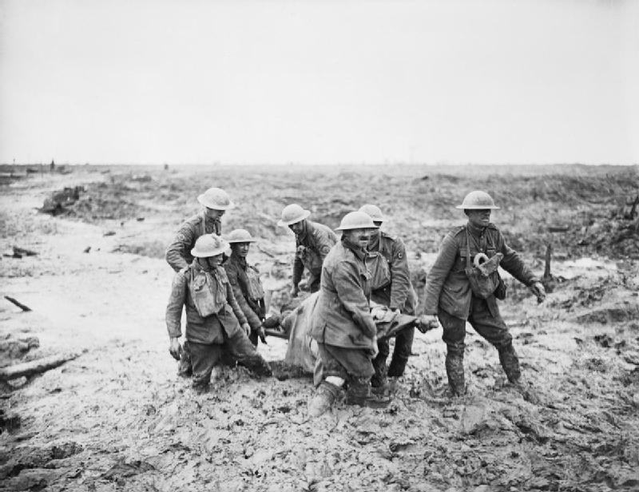
(Stretcher Bearers wade through the mud at the Battle of Passchendaele (3rd Ypres), 1917)

Source B
Very few stretcher cases have been brought down (to No.33 Field Ambulance) today. This is owing to the difficulty which the regimental stretcher bearers have in getting them back from near the front line owing to the sniping…The conditions were very bad owing to the heavy rain today.
(War Diary of No.33 Field Ambulance, The National Archives, WO95/1805)

Source C
Yesterday our C Company got badly gassed… Seemingly, they didn’t know they were gassed at all as this new gas of the Germans does not take effect form some time after. For that reason it seems a dangerous thing and will be difficult to avoid.
(Diary of J. Campbell, 13 July 1917)

Look at Sources A, B, and C. What problems did soldiers and medical services face during the 3rd Battle of Ypres?

Look at Source C. What new weapon was used during the battle? Describe the ways in which it effected soldiers.

The Battle of Cambrai, 20 November – 7 December 1917

Source A
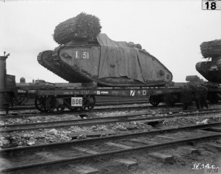
The Battle of Cambrai was the first-large-scale use of massed tanks in battle. Here British Mark IV tanks are being loaded onto railway trucks for transport to the front line. These are ‘Female’ tanks armed with machine-guns, as opposed to ‘Male’ tanks armed with small artillery pieces.

Source B
All began well. The unfortunate German soldiers garrisoning the Cambrai sector were unprepared for the hurricane bombardment that descended upon them at 6.20 on the morning of 20 November and the appearance of dense columns of tanks, 324 in all, rolling forward with infantry following. Within four hours the attackers had advanced in many places to a depth of four miles, at almost no cost in casualties.
(John Keegan, The First World War (1998), pp.396-7)

Source C
The English attack at Cambrai for the first time revealed the possibilities of a great surprise attack with tanks. We had had previous experience of this weapon in the spring offensive, when it had not made any particular impression. However, the fact that the tanks had now been raised to such a pitch of technical perfection that they could cross our undamaged trenches and obstacles did not fail to have a marked effect on our troops. The physical effects of fire from machine-guns and light ordnance with which the steel Colossus was provided were far less destructive than the moral effect of its comparative invulnerability. The infantryman felt that he could do practically nothing against its armoured sides. As soon as the machine broke through our trench-lines, the defender felt himself threatened in the rear and left his post.
(German Army General Paul von Hindenburg, Out of My Life (1934))

Look at Sources A, B, and C. What effect did tanks have at the opening of the Battle of Cambrai?

Look at Source C. Explain why German soldiers found it difficult to face tanks during the Battle of Cambrai.

