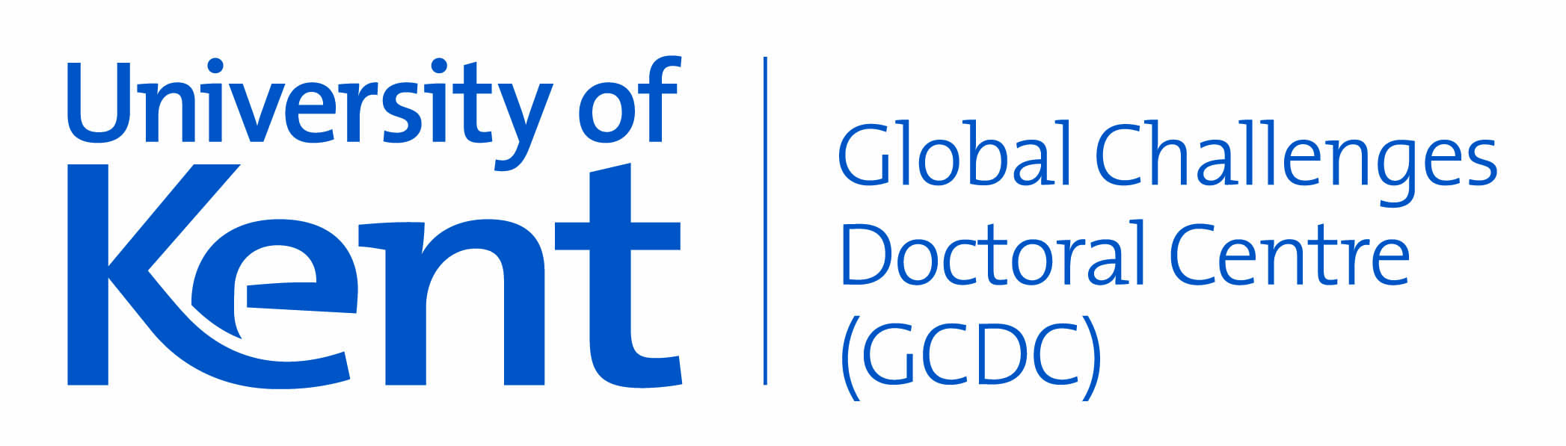
Global Challenges Doctoral Centre
Project-led Doctoral Studentship Application Form

For guidance on the scheme please read the call for applications provided on the GCDC website. Email kentgcdc@kent.ac.uk if you have any questions about the form.

- Kent applicant(s)

Name | School | Faculty | Supervisory arrangements
 |  |  | (First or second supervisor)
 |  |  | (First or second supervisor)

- Project

Name of project

Short summary of project and main aims
(max 500 words)

Key attributes and skills required of prospective applicants
(max 300 words)

GCDC students will receive an annual Research Training Support Grant (RTSG) of £1,500 per year for the first 3 years of study. Please outline additional top up funding required per year (if any). | Year 1
 | Year 2
 | Year 3

- Justification and Fit
ODA compliance statement
(max 200 words)
Which GCRF challenge area(s) does your project meet and how?
(max 200 words)
Which UN sustainable development goal(s) does your project meet and how?
(max 200 words)
Which specific DAC-list country/countries will benefit from your project and how?
(max 200 words)

- International Funding
The GCDC project-led studentships are offered at the Home/EU rate. Please indicate whether your school might be able to cover the fee difference if the scholarship was offered to an international applicant (this is for information only and will not be used as a criteria in judging applications). (yes/no)

Once complete, please send the form to kentgcdc@kent.ac.uk
Deadline Monday 23 September 2019

