Financial Authority Form - Applicants

This guide will explain how to apply for a financial authority limit on SharePoint. SharePoint is accessible here https://sharepoint.kent.ac.uk/finance/FA/

The Financial Authority SharePoint form is the only recognised University process for requesting financial authority for members of staff and is where you will now complete your application. When you submit an application, the form will be sent to your Director of Division/Head of Professional Service to review, authorise or reject. Where an application form relates to a Director of Division/Head Service it will be sent to the Director of Finance to review, authorise or reject. If an application is for a financial authority limit for over £15,000, the form will be sent to the Director of Finance for secondary approval.
A Financial Authority Application should be completed whenever a member of staff is appointed or changes roles within the University and requires financial authority. Financial authority permits a member of staff to commit the University to paying for goods and services. For example, purchase orders, invoices, journals, timesheets or expenses. Please continue to use local practices to agree any expenditure in the first instance.
You will be able to view or edit your form on SharePoint at any time.
Please note that if you are entering an application from home or abroad, you will not need to use the Kent VPN.

Completing the Form

Applicant Details

Enter your Name as it appears on the Delve Directory.
N.B. If you share a name with another individual on Delve, you will need to use the Delve search option detailed below to select your details.
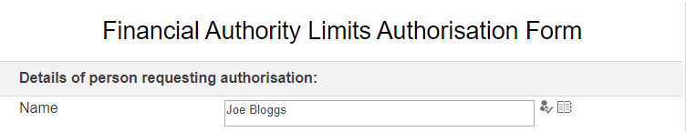
If you are unsure how your name appears, click on the Directory option.
This will open a search window that links to Delve. Type in your name in the search field and select Find.
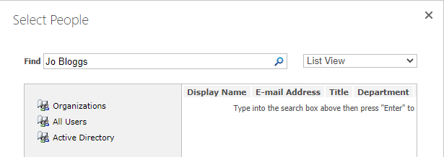
Double click on your name in the Display Name window. This enter your name into the Name field.
When these details have been entered please click Done.
Enter your Kent IT login e.g. abc1. Please note this field in mandatory.
Enter your Job Title / Position
The application can be saved at any stage by clicking on the Save icon.
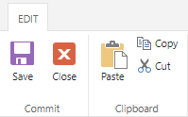
Tick Yes to confirm if you a Director of Division or Head of Professional Service Department.
Tick No to confirm if you NOT a Director of Division or Head of Professional Service Department.
This will inform the workflow of the Approver required for this application. Please note this field in mandatory.
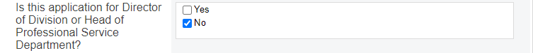

Click to upload a scanned image or photograph of your normal signature.
Select Choose File in the Attach File pop up window.
Use the pop-up screen to navigate to the folder location where your attachment is saved. Click on the document and select Open. The file will appear in the Choose File window. Click Attach.
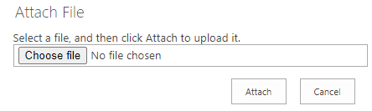
N.B. If a valid signature is not attached to the form, the Approver will reject the form and ask you to resubmit with the attachment.

Authority Limit Requested

Select all the Approval Limits required.
If you wish to approve all items up to a value, you will need to tick all of the limits up to and including the value required. For example, to see everything up to £5,000, you should tick Up to £1,000 and £1,000.01-£5,000.
If you only want to see items over £5,000, you should tick £5,000-£15,000 and above.

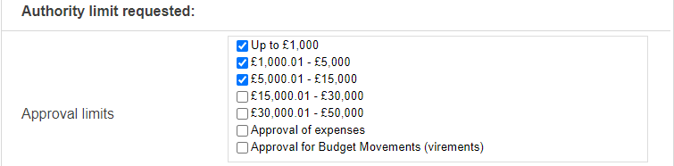
Select all the areas for Approval Required.

Select all Report(s) Required.

Select your Division or Professional Service Department name from the drop-down menu.
Enter all of the Cost Centres that are required. Each Cost Centre should be separated by a semi colon ( ; )
Add any Notes to Support Your Application. Any notes should assist your Director of Division or Head of Professional Service Department approve your application.
When you have completed all of the fields and added any supporting notes, click Submit for Approval.
When your application has been successfully submitted, you will receive an email confirmation.
When your application has completed the approval stages and UBW has been updated, you will receive a final email confirmation.

Approval Stages

When an application form is submitted an email will be sent to the Director of Division or Head of Professional Service Department with a link to the form.
The Director of Division or Head of Professional Service Department will approve or reject the application by selecting the option from the drop-down menu.
If the application is rejected, the Rejection Notes field will be completed with sufficient details for the applicant to amend the form and resubmit if appropriate.

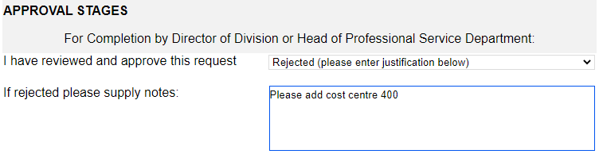
If an application is rejected, a rejection email will be sent to the applicant with a link to the form.
If an application is for a Director of Division or Head of Professional Service or for a financial limit over £15,000, an email will be sent to the Director of Finance (or their nominees) with a link to the form.
The Director of Finance (or their nominees) will approve or reject the application by selecting the option from the drop-down menu.
If the application is rejected, the Rejection Notes field will be completed with sufficient details for the applicant to amend the application and resubmit if appropriate.
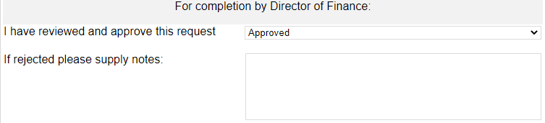
Once an application has completed all the necessary approval stages, an email will be sent to UBW Support with a link to the form. UBW Support will make the necessary updates to UBW.
If the application is rejected, the Rejection Notes field will be completed with sufficient details for the applicant to amend the application and resubmit if appropriate.
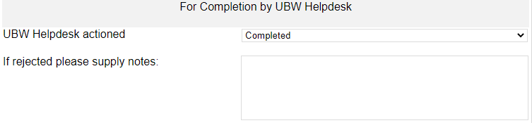
When all approval stages have been completed and UBW updated, the applicant will receive an email confirming their application has been finished with a link to the form.
N.B. If an application is amended by the applicant at any stage, the application will pass through the approval stages again.

Accessing and editing an existing form

To access an existing form, click on the following link to SharePoint.
<insert link>
Alternatively, click on the link contained within an email confirming an application has been submitted or finished.
To edit the form, click on Edit Item
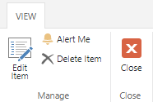
When the required edits have been completed, click on Submit for Approval.
The form will pass through the approval stages as detailed in Section c.

