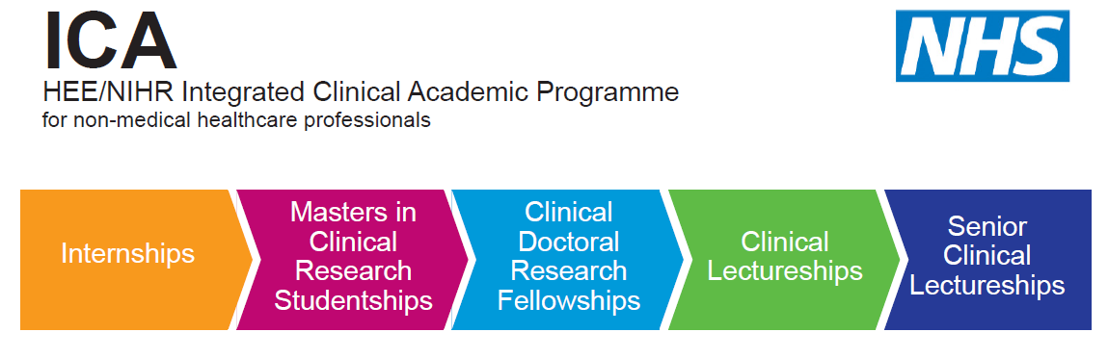

HEE/NIHR ICA Programme
Pre-Doctoral Bridging Awards
University of Kent
Centre for Health Services Studies
Application Form
2020-21

Please fill in this form as directed. Where necessary, please refer to the available guidance notes to support the quality of your application.

Please complete in BLOCK CAPITALS OR type, so that your information can be read easily.

If you have any questions about completion of this form please contact the following:
Dr Julie MacInnes

ICAP Internship and Bridging Programmes Leader
Research Fellow
Centre for Health Services Studies
University of Kent
Email: j.d.macinnes@kent.ac.uk

1. Personal details

Please note you must be employed in the Kent, Surrey and Sussex area to be eligible for the HEE/NIHR Clinical Award programme starting in October 2020.

Name:
DOB:
Country of birth: | Nationality:
Profession:
Name of current employing organisation:

Address (work): | Address (home):
(W) Phone Number: | Phone Number:
(W) Email: | Email:
Mobile:

2. Profession
Please review the list of approved professions from the NIHR website. We are sorry to say that if your profession is not listed we are unable to offer you a place on this programme. Please note your professional registration must be active.
https://www.nihr.ac.uk/documents/heenihr-ica-programme-eligible-professions-and-regulators/12204

Profession | Specialty | Professional body | Registration number

3. Professional Qualifications
Name of institution | Dates of study | Qualification obtained | Other information

4. Academic Qualifications (Diploma, Degree and research /clinical related awards)
Name of institution | Dates of study | Subject studied | Qualification & classification obtained | Other information

5. Are you employed by an organisation whose core business is delivery of NHS care as a primary aspect of your professional role?
Yes
No

6. General overview:
For sections 6-8 please refer to the advertising material and guidance notes about this award to help guide your responses.

Why do you wish to apply for this award (max 500 words):
What skills and experience do you bring to this award (max 1,000 words):
What are your career aspirations should you be successful in completion of this award (max 1,000 words):

7. Research Interest
Please refer to the advertising material about this award to help guide your responses.
What is the area of practice of your research interest? (max 500 words)
Please describe your proposed research? It is not essential that your research question is fully formed at this stage (max 1500 words):
How will patient/client care be improved through your research interest? (max 500 words)

8. How does your research support the HEE NHS Mandate? (500 words)

9. Mentor support
Have you identified an academic mentor to support your proposed research and clinical development?
Yes
No
If ‘Yes’ provides details of the proposed mentor below:
If ‘No’ we can help identify an appropriate mentor from the approved Mentor database list.
Name:
Role:
Profession:
Address (work):
Name of employing organisation:
(W) Phone Number:
(W) Email:

10. Managerial Support
Please refer to the advertising material about this award to help guide your responses.
This section must be completed by your line manager.

Line managers name:
Address:
Phone number:
Email:
Please provide a statement which directly confirms that you as the line manager and your Head of Service/Operational Director will release the named applicant for the his/her full entitlement for the Pre-Doctoral Bridging Award:
Signed by Line manager:

Date:
Signature of Head of Service:

11. Additional declarations
Do you have any criminal convictions Y/N
If you have answered [Y] (excluding motoring offences for which a fine and/or penalty points were awarded) you may be required to provide details.

12. Declaration and signature:
I confirm that the details and information given on this application form are correct and accurate and no information requested or other material information has been omitted.
Signed by applicant:

13. Additional Information

Available budget:
45 hours backfill = £1170.00
Training budget = £900

Checklist of documents to submit

Up to date Curriculum Vitae ☐

Evidence of registration with eligible professional regulator ☐

Evidence of relevant qualifications and certificates ☐

HEE / NIHR ICAP Pre-doctoral Bridging application form ☐

Provide two references (one academic, one professional) ☐

Please email all of your completed documents to:

Dr Julie MacInnes
ICAP Internship and Bridging Programme Leader
Email: j.d.macinnes@kent.ac.uk

The closing date is by Friday 21st August 2020 by 5pm.

