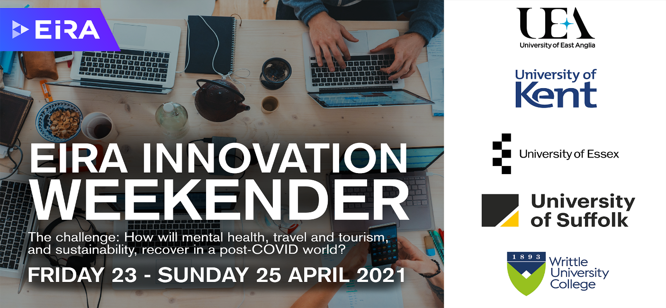
EIRA Innovation Weekender 2021 - Application Form

Friday 23rd April - Sunday 25th April 2021
A weekend of innovation & creativity awaits you at the EIRA Innovation Weekender 2021. In collaboration with our partner universities: University of Kent, UEA, University of Suffolk, NUA, Writtle College and Harlow College - we are offering 3 days of teamwork, creative thinking and innovation, working on business challenges set by our industry partners – all around the topics of sustainability, tourism and mental health in a Post-Covid world.

Event Details
Supported by EIRA, University of Essex is teaming up with University of Kent, UEA, University of Suffolk, NUA, Writtle College and Harlow College to deliver the EIRA Innovation Weekender 2021 to approx. 80 students looking for something a bit different.
You’ll be asked to think innovatively in teams to work towards the challenges faced by industry right now. The entire weekender will be hosted online with fun and creative sessions by external speakers plus lots of team working time.

- Date: 23rd-25th April 2021 (Fri-Sun)
- Venue: Online
- Open to all students
- Limited spaces per university
- Students will be selected from submitted application forms.
Deadline for application is 11.59pm on 12th April 2021.
- If you are successful, we will email you shortly after the deadline.
PLEASE NOTE: You must be able to attend all three full days. Friday starts around 11am and we aim to close around 6pm on Sunday. Please only apply if you can make the entire 3 days. 30 Employability Points will be awarded on attendance.

Please now complete the application form on page 2 and return to eirakent@kent.ac.uk

Full Name:
Student Number:
Area and level of study:
Email Address:
Your email address will be shared with Essex University staff managing the Weekender only.

Please outline in 200 words why you are a deserving candidate.

Please outline in 200 words how attending the weekender will benefit you personally and academically.

Declaration:
I confirm that I can attend all three full days (Fri, Sat & Sun) and am prepared to work in teams cross-institutions.

Signature:
Date:

Complete and return to: eirakent@kent.ac.uk

