Kent’s Centre for Interdisciplinary Spatial Studies

Presents a week-long festival of events
13th June – 17th June 2016
University of Kent, Canterbury

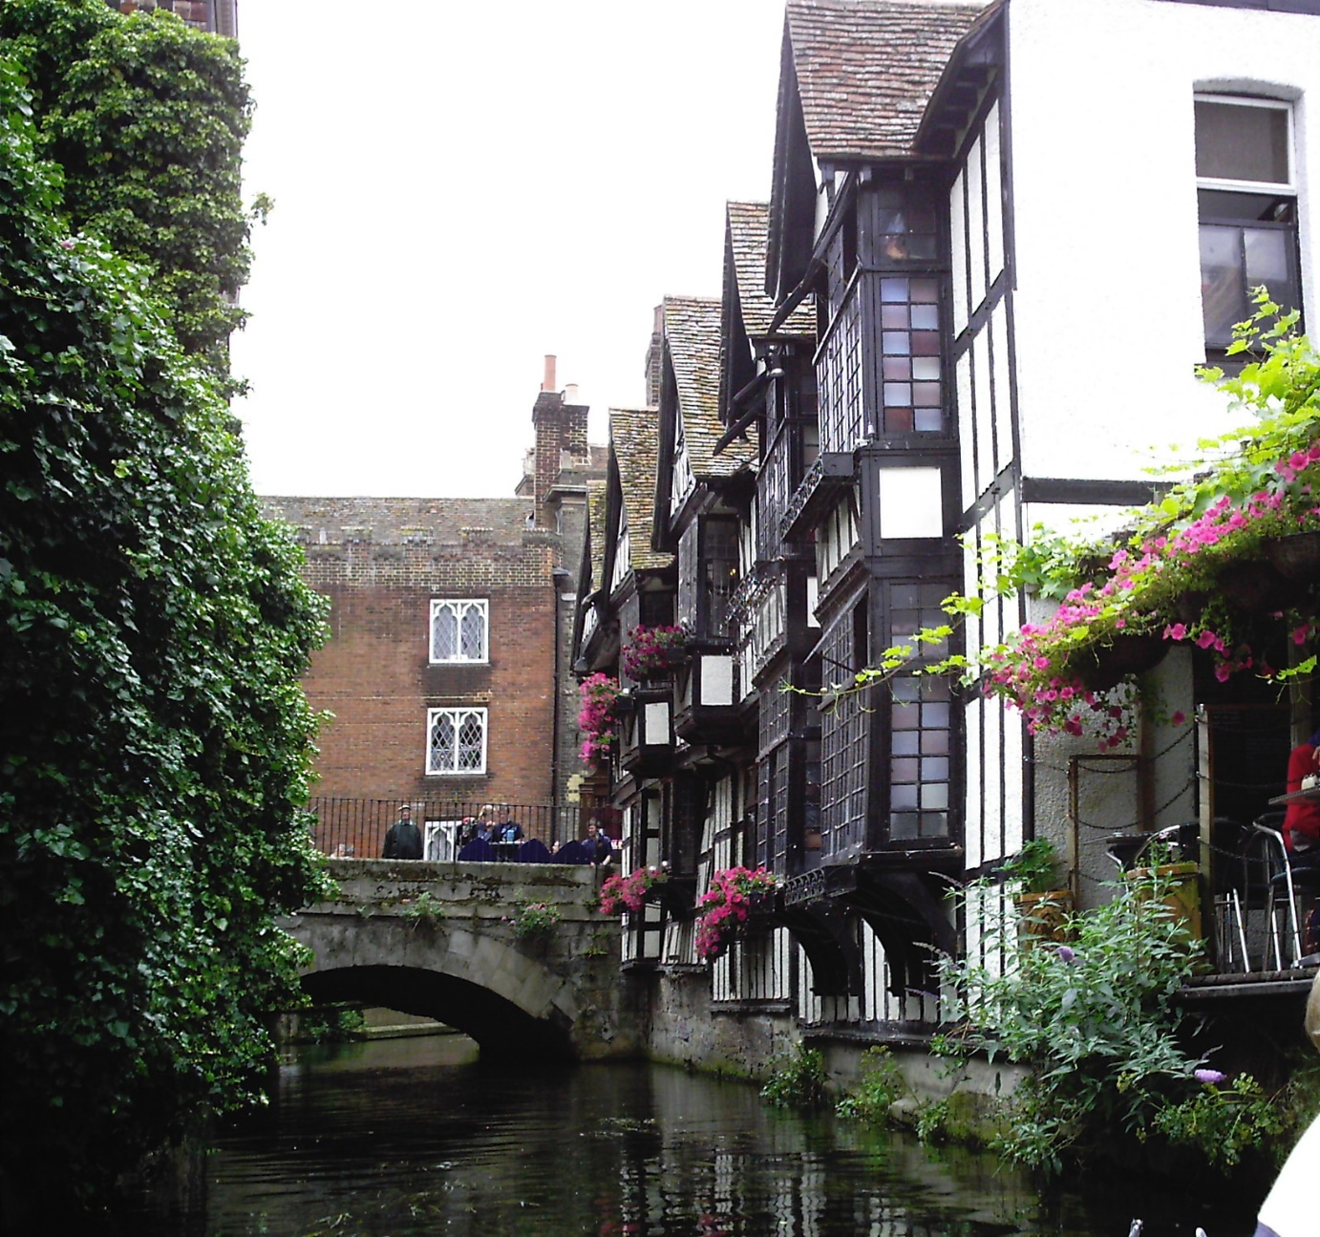
Outline of Programme

13 June Monday (Canterbury)
Didier Fassin - Public Lecture & Workshop

14 June Tuesday (Canterbury)
CANCELLED DUE TO THE UCU STRIKE

15 June Wednesday (Canterbury)
Training - Introduction to Geographic Information Systems (GIS)

16 June Thursday (Medway)
Listening, Spaces and the Sounding World

17 June Friday (Canterbury)
MEMS Festival - Medieval & Early Modern Studies Festival

13 June MONDAY
Kent Law School, University of Kent & KISS
Public Lecture, Professor Didier Fassin
The Carceral Condition in a Punitive Time
AND
Workshop
Critical reflections on punishment, confinement and spaces of exclusion in contemporary states
General Information:
Organised by the Social Critiques of Law Research Group (SoCriL, Kent Law School), in association with the Kent’s Centre for Interdisciplinary Spatial Studies Centre (KISS).
Organisers: Dr Emilie Cloatre; Dr Sara Kendall; Dr Sinead Ring; Dr Thanos Zartaloudis
On 13 June 2016, Kent Law School and SoCriL will be hosting Professor Didier Fassin, (in association with the Kent’s Centre for Interdisciplinary Spatial Studies). You are warmly invited to the following events organised for this occasion.
The events are free, but please register on the SoCriL website: https://www.kent.ac.uk/law/socril/
Fassin Bio:
Didier Fassin is James D. Wolfensohn Professor of Social Science at the Institute for Advanced Study in Princeton and Director of Studies at the École des Hautes Études en Sciences Sociales in Paris. Prof. Fassin is an anthropologist and a sociologist who has conducted fieldwork in Senegal, Ecuador, South Africa, and France. Trained as a physician in internal medicine and public health, he dedicated his early research to medical anthropology, illuminating important dimensions of the AIDS epidemic, mortality disparities, and global health. He later developed the field of critical moral anthropology, which explores the historical, social, and political signification of moral forms involved in everyday judgment and action as well as in the making of international relations with humanitarianism. He recently conducted an ethnography of the state, through a study of urban policing as well as the justice and prison systems in France. His current work is on punishment, asylum, inequality, and the politics of life, and he is developing a reflection on the public presence of the social sciences. His books include The Empire of Trauma: An Inquiry Into the Condition of Victimhood (2009), Humanitarian Reason: A Moral History of the Present (2011), Enforcing Order: An Ethnography of Urban Policing (2013), At the Heart of the State: The Moral World of Institutions (2015). He is the author of the forthcoming monograph, Prison Worlds. An Ethnography of the Carceral Condition (Polity Press).

Programme:
Roundtable workshop: Critical reflections on punishment, confinement and spaces of exclusion in contemporary states
(Woolf Seminar Room 5; limited spaces: please book your place via the website).
In this roundtable we will discuss the question of confinement as a form of punishment in contemporary states, both in the context of prison, and beyond.
Session 1: 11.30-12.45
Woolf Seminar Room 5
Prof. Stuart Murray (Department of English Language & Literature and Department of Health Sciences; Carleton University)
“Death By Whose Own Hand? Forensic and Legal Sovereignties in Question”
Prof. Ian O’Donnell (School of Law, University College Dublin)
“Surviving Solitary Confinement”
Dr Eddie Bruce Jones (School of Law, Birkbeck College, University of London) (Title TBA)
Session 2: 13.15-14.45
Woolf Seminar Room 5
Dr Romola Sanyal (Department of Geography and Environment, London School of Economics)
"From Camps to No Camps: Marginalizing Syrian refugees through Informality"
Laura Binger (Kent Law School, University of Kent)
“Punishment, Space and Resistance at King’s Hill Hostel”
Remarks and reflections: Dr Sara Kendall, Dr Lorenzo Pezzani, Gavin Sullivan
Public Lecture: 15.00-17.00
NB: Templeman Lecture Room, University of Kent.
Prof. Didier Fassin The Carceral Condition in a Punitive Time
Abstract:
The prison is a recent invention, hardly more than two centuries old, yet it has become the universal system of punishment and has had an unprecedented expansion in most Western countries. How can we understand the place that the correctional system occupies in contemporary societies? What are the experiences of those who are incarcerated as well as those who work there? Based on a thorough discussion of legal and philosophical theories of punishment, and on an ethnographic study conducted in a French prison over four years, Didier Fassin will attempt to answer these questions.

Film Screening 17.30-19.30
Templeman Lecture Room, University of Kent.
Sur les Toits (On the Roofs, Dir. Nicolas Droic, 2014),
(Templeman Lecture Room), with a short Introduction by Dr. Thanos Zartaloudis.
Between September 1971 and the end of 1972, for the very first time in French history, prison inmates collectively initiated revolts that led to a takeover of their prisons, to the occupying of prison roof tops, and to the direct communication of their demands to the public. Now, forty years later, filmmaker Nicolas Drolc explores this forgotten page of social struggle.
Through a mixture of archival footage and recordings and extensive interviews with the leaders of the revolt at Nancy, a prison warden from Toul, lawyer Henri Leclerc, sociologist and GIP co-founder Daniel Defert, as well as the ex-convict, writer, and political activist, Serge Livrozet, Sur les toits (On the roofs) paints a portrait of a time and a struggle whose legacy challenges us to confront in our own day the questions of imprisonment, punishment, and the diffusion of the carceral practices of control, surveillance, and normalization.

14 June TUESDAY
KISS Research Presentations
CANCELLED DUE TO THE UCU STRIKE

15 June WEDNESDAY
Training - Introduction to Geographic Information Systems (GIS)
Conducted by Joseph Tzanopoulos
GIS are increasingly being used in many disciplines to help solve a wide range of “real world” problems and advance current state of research by exploring the spatial properties of events and processes.
The overall aim of this training session is to provide an applied introduction to the use of GIS. The training will provide an introduction to the theory and practice of GIS and an introduction to a range of methods for collection, management and interpretation of spatial data.
Indicative topics:
· Introduction to the fundamental principles of GIS;
· Data sources and methods of data acquisition
· Types of spatial data, working with raster and vector data
· Mapping (how to create and transform maps),
· Elementary database management

The training course will provide hands-on experience using ArcGIS which is the most widely used GIS software. This is an introduction to GIS so no prior knowledge is required.

Programme:
9.00-17.00 Training Sessions
Open to all staff members (and graduate students) of the University.
However, due to logistical reasons the group size is limited to 15-18 participants. Registration is on first come first served basis. To register please contact Joseph Tzanopoulos at j.tzanopoulos@kent.ac.uk

Where: CNEPC1 (Cornwallis East)
Directions: Cornwallis East entrance is located near the Darwin Road bus stop. Entering by the main door, turn right. The room is on the ground floor.

16 June THURSDAY
Medway Events
Listening, Spaces and the Sounding World

Conducted by Aki Pasoulas
Lecture Theatre CT102 at the Clock Tower building
Map and Directions can be found here: https://www.kent.ac.uk/maps/medway/historic-dockyard/building/clock-tower-building
NB: Please bring with you an A4 writing board (or similar, a notebook etc.) and a pen, which you can carry with you during the soundwalk.
Programme:

11.30am-13.30 Soundwalk and discussion - Soundscape and Ear Cleaning.

13.30 Break

14.15-15.10 Listening Event - ‘Talking Rain’ (multichannel work by Hildegard Westerkamp): listening session and discussion.

15.15 Film Screening and Discussion - ‘Berlin Babylon’ (dir. Hubertus Siegert, music by Einstürzende Neubauten).

17 June FRIDAY
MEMS Festival - Medieval & Early Modern Studies Festival
[NB: Continues on the 18th for those interested; free but requires registration; details below]
Full details here: https://memsfestival.wordpress.com/programme/
The Festival is free and open to all.
If you would like to join us in what promises to be an exciting event, please complete the REGISTRATION FORM by 3rd June 2016.
MEMS Festival is jointly funded by the Centre for Medieval and Early Modern Studies of the University of Kent and the Consortium for the Humanities and the Arts South-East England (CHASE) with a postgraduate and ECR bursary fund offered by Eastern ARC.
Contact: memsfestival@gmail.com
Where: Grimond (Various locations, please see the signs at the building when you enter)
Programme:
9.15am - REGISTRATION & COFFEE
9.30 - OPENING REMARKS & INTRODUCTIONS TO EXHIBITS
10.15-11.30 SESSION 1 [3 parallel panels]
PANEL A – AHRC Illuminating the Past Presents: Beyond Gothic Glass
Oliver Fearon – ‘I will that a knoleche be sought’: The patronage of heraldic displays for English houses c.1490-1540
Jack Wilcox – ‘O Radix Jesse’: The Iconography of Tree of Jesse Window
Bahar Badiee – Orsi: Coloured Windows of Iran
PANEL B – Book Culture in Tudor England
Nicole Perry – Interpreting reading practices in a Tudor Primer
Lorraine Flisher – Books and Book Ownership: Contextualising the mental world of readers in Cranbrook, Kent and its neighbourhood, 1570-1660
Claire Bartram – ‘Gentle Reader’: Patronage and Authorial Pretension in Elizabethan Administration

PANEL C: Remedying Perspectives on Medical History
Evana Downes – Tracking the evolution of Scapegoating during Pre-Modern Plague Epidemics
Hillary Burgardt – Problems in the Categorization of Epilepsy in Medieval Europe
Richard Johnson – ‘If any be surprized that we have spoken nothing of Pain’: Rethinking Pain and Surgery in Early Modern England
11.30 COFFEE BREAK

11.50-13.00 SESSION 2
PANEL A – AHRC Illuminating the Past Presents: Picturing Gothic
Roísín Astell – Visualising the Visionary: Artistic Transmission and Adaptation in BnF MS Lat 14410
Amy Jeffs – Sight, Sightlessness and the Cult of Edward the Confessor
Dan Smith – The Rood and the Doom: Interconnections between the Passion and the Last Judgement in Late-Medieval Text and Image
PANEL B– Material Perspectives
Lydia Goodson – ‘tovallie nuove nostrale listate’: Tracing the Materiality and the Despiction of Perugia Towels in Renaissance Italy
Sadie Harrison – Collecting and Consuming Natural Knowledge in Seventeenth Century Embroidery
Elizabeth Stewart – ‘The Royaltie of Sight’: Using 3d-GIS to recreate contemporary ‘prospects’ and ‘perspectives’ of English designed landscapes, c. 1550-1660
PANEL C – Corruption, Revolt and Crisis in Late Medieval England
Phil Slavin – Privateers and Profiteers: Piracy and Food Crisis in the British Waters in the early Fourteenth Century
Jack Newman – Corruption of Officials in Lincolnshire during the Fourteenth Century
Daniella Gonzalez – The Uses of ‘Common Profit’: Gower and Langland’s London
13.00 LUNCH

14.00-15.00 WORKSHOPS

GIS-Mapping with Justin Colson
An introduction to the digital technique of GIS (geographic information system) Mapping, which enables people to more easily see, analyse and understand patterns and relationships within spatial topographies.
Painted Cloth with Melissa White
An opportunity to create your own painted cloth using Elizabethan decorating techniques, with professional artist and restorer Melissa White, whose work includes the painted interiors at Shakespeare’s Birthplace Museum, Stratford-Upon-Avon.
Special Collections with Josie Caplehorne
Come and hear Josie Capelhorne speak about her work with some of the most beautiful, unique and culturally significant books from Rochester Cathedral Library and about the challenges these materials present.
16.00 QUIZ
Would I Lie To You? with host Alex Holland
How honest are academics really? Come and find out if you can spot the fact from the fiction as staff and students attempt to pass off invention as “research”.
18.30 DRINKS RECEPTION with musical performance by Invicta Voices at the private garden of Canon Irvine, Canterbury Cathedral Precincts

THANK YOU AND WE LOOK FORWARD TO SEEING YOU THERE
THE ORGANIZERS ON BEHALF OF KISS
Thanos Zartaloudis
Joseph Tzanopoulos
Catherine Richardson

