Source A
Old Bailey Case t.18750405-252
252. WILLIAM WILSON (19) and THOMAS NEWTON (17) , Robbery on Henry Pond and stealing from his person one ring and 11s., his property.
HENRY MORPHET (Policeman K 243). On 21st March I was in the Mile End Road, about 11.15 p.m., but was not on duty—I followed a gang of fifteen or twenty persons who were behind the prosecutor—I saw them make a movement and throw him down, and saw Newton rifling his pockets while he was down; Wilson was helping to hold him down—Newton took his hand from Pond's pocket and handed something to someone standing by—I know the prisoners by sight as being associated with a gang of thieves—the gang—then separated, I watched my opportunity and seized the prisoners, saying "I must take you into custody for robbing a man;" they said they had not done it—I handed Williams to another constable—I found 4s. 8d. in Newton's pocket.

Study Source A

How could you follow up Source A to find out more about violent crime in the Whitechapel area?

In your answer, you must give the question you would ask and the type of source you could use.
Complete the table below.

Detail in Source A that I would follow up:

Question I would ask:

What type of source I could use:

How this might help answer my question:

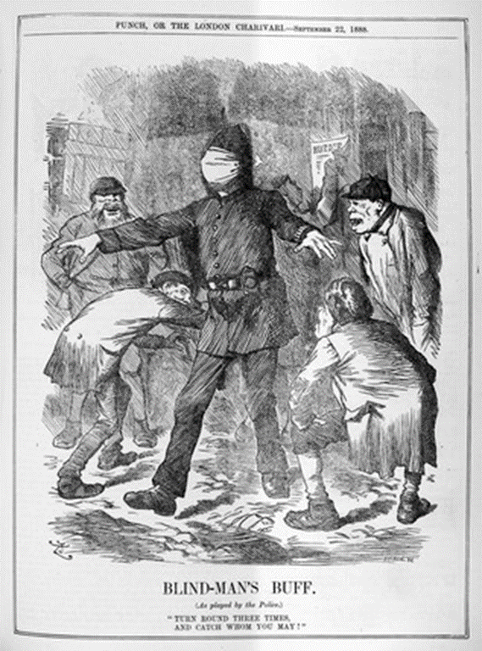
Source B
Blind-Man’s Buff (As played by the Police) ‘Turn round three times, and catch whom you may!’
Punch Magazine, 22nd September 1888

Study Source B

How could you follow up Source B to find out more about the Ripper murders in Whitechapel?

In your answer, you must give the question you would ask and the type of source you could use.
Complete the table below.

Detail in Source A that I would follow up:

Question I would ask:

What type of source I could use:

How this might help answer my question:

