Joint Resolution of the Central Committee of the SED [Socialist Unity Party of Germany], the national executive board of the FDGB [Free German Trade Union Federation], and the Council of Ministers of the GDR on sociopolitical measures in carrying out the main tasks of the Five-Year Plan resolved at the Eighth Party Congress of the SED
(28 April 1972)
The Central Committee of the Socialist Unity Party of Germany, the national executive board of the Free German Trade Union Federation, and the Council of Ministers of the German Democratic Republic hereby resolve:
- to raise the pensions and social welfare of 3.4 million citizens;
- to implement measures to support working mothers, young married couples, and birth-rate development;
- to create improved living conditions for workers and employees and to adjust rents for apartments in new [i.e. post-war] housing so that they better correspond to income.
These decisions continue the path that was set by the main task of the Five-Year Plan from 1971 to 1975. The path consists of further raising the material and cultural living standard of the people on the basis of a high rate of development of socialist production, increased effectivity, scientific and technological progress, and the growth of work productivity.
The successful implementation of the resolutions of the 8th Party Congress, the progress made in the continuous and stable development of our national economy, the reduction of existing disparities, and the vigorous struggle to satisfy the plan – all of this makes us certain that our socialist economy will continue to develop well; and therefore it is now possible to carry out an extensive part of the social policy program of the 8th Party Congress. This shows the workers of the GDR that commitment and diligence pay off.
The measures now adopted demand a great expenditure of financial and material resources, which must be continually reacquired. Without a doubt, these measures will serve as an incentive to the working class, collective farmers, members of the intelligentsia, and all other workers to further increase the economic strength of our country through good work and creative initiative, and, with their high achievements in socialist competition, to contribute to the general strengthening of the GDR through socialist rationalization and increased work productivity. The workers themselves are carrying out the principle: The resolutions of the 8th Party Congress will come to pass!
These significant measures show how the main task of the Five-Year Plan that was decided by the 8th Party Congress will be implemented, how everything possible is being done for the well-being and happiness of the people, and for the interests of the working class and all workers.

A Civics Lesson in East Berlin
(1988)
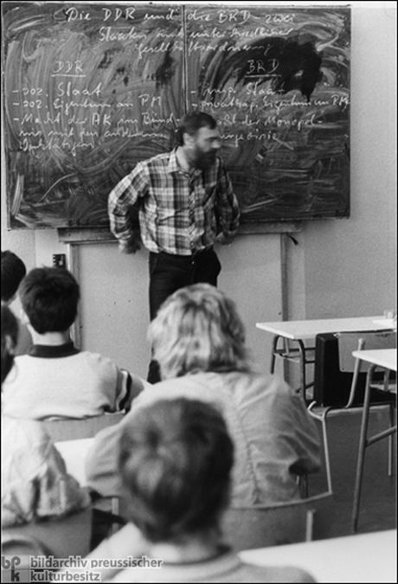
The heading on the blackboard reads: "The GDR and the FRG [Federal Republic of Germany] – two states with different social orders."
Under the category ‘GDR’, the following are listed: socialist state; socialist ownership of the means of production; power of the working class in alliance with other working people.
The category ‘FRG’ includes: imperialist state; private-capitalist ownership of the means of production; power of the bourgeoisie monopoly.
Politburo Decision on the Work of the Ministry for State Security
(18 March 1952)
The Ministry for State Security has had considerable successes in the fight against the criminal enemies of our anti-Fascist-democratic order. Numerous attempts by the warmongers and their agents to inflict serious damage on the GDR have been thwarted.
However, these successes in the work of the Ministry for State Security must not obscure the fact that the work of the ministry and all its organs, both political and technical, must be elevated to an even higher level.
To this day, a number of serious deficiencies and weaknesses can be seen in the work of the Ministry for State Security. Above all, the Ministry for State Security has not understood how to win the full confidence of the entire progressive population, and for this reason it has only been able to rely weakly on its help in carrying out tasks. The reason for this can be found, among other things, in the inadequate connection of the organs of the Ministry for State Security to the population, in the arrogant behaviour of some of its members, and in the fact that democratic legality has not always been observed.
This deficit is caused above all by the fact that technical and political training was instituted much too late in the ministry and has remained inadequate to this day.
The development of the mid-level cadre was grossly neglected in particular.
On account of this deficient training, many employees of the Ministry for State Security have fallen victim to practicality. This was also encouraged by the fact that many ministry employees completely lack the level of political understanding needed to carry out their operational work. Party work has long been neglected, critique and self-critique are at an insufficient stage of development. So far, the work of both the ministry and the subordinate offices has been haphazard. Firm working plans were not drawn up. The guidance of state administrations by the ministry and of district offices by state administrations was completely inadequate. Instead of personal oversight and assistance in the implementation of certain tasks there were written directives.
The measures to strengthen the work discipline and morale of employees are inadequate.
A high rate of employee turnover was one noticeable impediment to the development of the work. Above all, the all too frequent turnover of those employees responsible for on-site work in enterprises and factories has impeded the development of this work.

East German Code of Family Law
(20 December 1965)
Section 1:
(1) The socialist state protects and promotes marriage and the family. Through various measures, state and society use their influence to assure that the achievements connected with the birth, upbringing, and care of children in the family are acknowledged and duly appreciated. State and society contribute to strengthening the relations between man and woman and between parents and children, as well as to the development of the family. Citizens have a right to state protection of their marriage and family and to the respect of marriage and family bonds.
(2) The socialist society expects all citizens to behave responsibly towards marriage and family.
Section 2:
The equal rights of man and woman contribute decisively to the character of the family in socialist society. They obligate the husband and wife to arrange their mutual relationship such that both can take full advantage of the right to develop their abilities for their own and for society’s benefit. At the same time they also demand the mutual respect of each other’s personalities and support in developing their individual abilities.
Section 3:
(1) Citizens shall arrange their family relations in such a way as to promote the development of each family member. It is the noblest task of parents to raise their children in trusting cooperation with the institutions of the state and society to become healthy, industrious, and all-around educated individuals who enjoy life and actively work to build up socialism.
(2) Raising children is also the task and concern of all of society. For this reason, through its institutions and measures, the socialist state guarantees that parents can exercise their rights and obligations in raising their children. Special attention shall be paid to assistance for large families and for single mothers and fathers.
Section 4:
(1) The state institutions, especially those responsible for general education, youth services, and the health and social welfare departments, as well as the organs for the administration of justice, are obliged to give spouses the appropriate support in developing their family relations and [are obliged] to help parents in raising their children. Social organizations, work collectives, and parent councils shall participate to the extent they are able.
(2) In cooperation with social organizations, state organs shall establish marriage and family counselling centres in which experienced, informed citizens can offer advice and aid to people who are preparing for marriage or who turn to them in other family matters. The staff of the marriage and family counselling centres is obliged to treat the matters brought to them confidentially.

