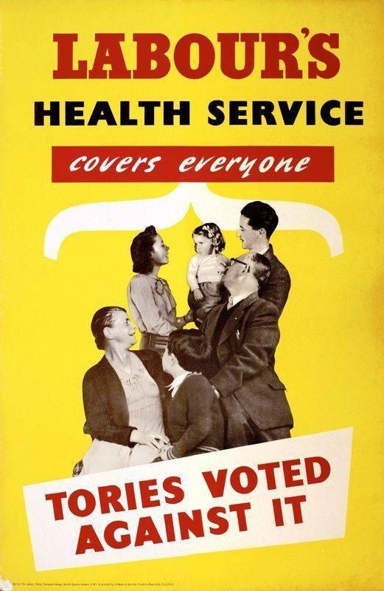

During the fighting in the Ypres salient (3rd Battle of Ypres) transfusion of blood was first employed on a large scale, and proved of greatest value. It was given either direct through a paraffin-coated glass receiver, or else mixed with a “citrate solution”, and before the end of 1917 the methods of transfusion and the classification of donors were standardised in every casualty clearing station, with the consequent saving of many lives. During 1917 also much more attention had been paid to the treatment of shock, and in every casualty clearing station a special hut or tent was provided where arrangements were made for warming such patients for transfusing blood.
(Major-General Sir W.G. MacPherson, Story of the Great War, based on Official Documents: Medical Services; Surgery of the War, Vol.1, 1922)

In the midst of his very busy life as a practising doctor, William Harvey did something very unusual: he found time and space to undertake an enormous programme of research at his own expense. For fifty years, mostly at home, and with no institutional support, Harvey passionately and doggedly pursued anatomical research…He had a novel object of study: it is the heart (the whole of it0 plus the arteries. No one since Aristotle had investigated this particular set of things.
(Andrew Cunningham, William Harvey: The Discovery of the Circulation of Blood, 1987)

Perhaps the most immediately striking feature of 18th century pathology was the general lack of agreement about the causes of illness and the effectiveness of therapies. Medical knowledge consisted of a chaotic diversity of schools of thought, each strenuously seeking to attain ascendancy over the others.
(Nicholas Jewson, ‘Medical Knowledge and the Patronage System in 18th Century England’, Sociology, 1974)

Populations of Towns and Cities in Britain:
1801 1831 1851
Birmingham 71,000 144,000 233,000
Bradford 13,000 44,000 104,000
Liverpool 82,000 202,000 376,000
Manchester 75,000 182,000 303,000
Sheffield 46,000 92,000 135,000
Leeds 53,000 123,000 172,000

(Quoted in Anthony Wohl, Endangered Lives; Public Health in Victorian Britain)

