Source D: Cartoon from the British Magazine Punch, 1917

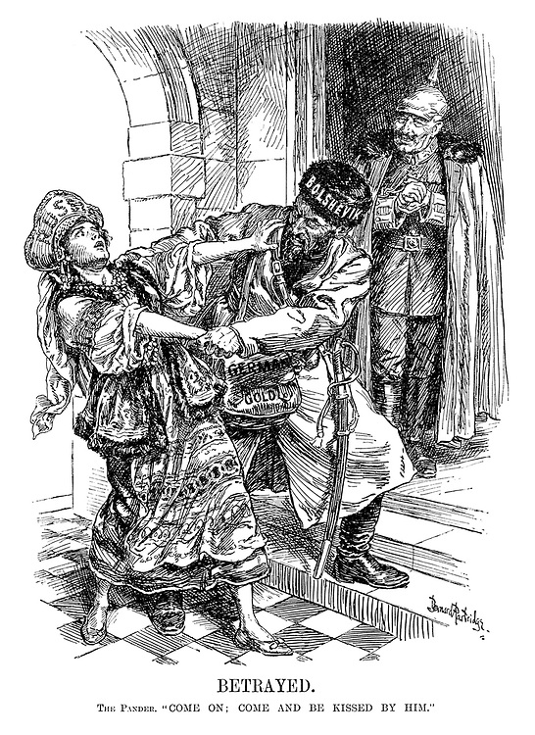

Source D shows Germany negatively. How do you know?

Explain your answer using Source D and your contextual knowledge.

Source D shows…

