Source A Cartoon by the artist David Low, published in a New Zealand newspaper, The Spectator, during the Bosnian Crisis, 15 October 1908
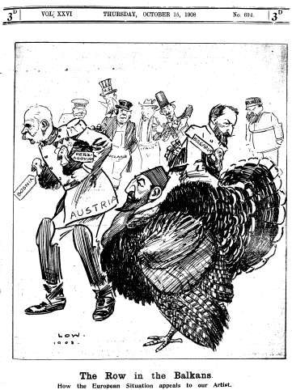

Source A depicts Austria-Hungary negatively in actions during the Bosnian Crisis. How do we know?

Explain your answer using the source and your contextual knowledge.

Source A shows…

