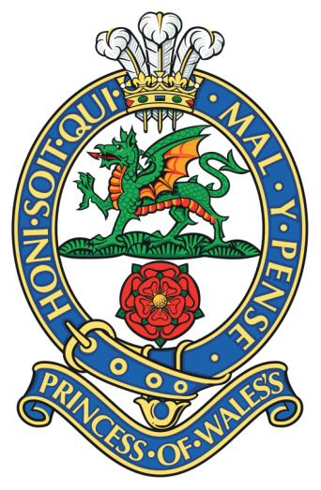
PWRR & Queen’s Museum
Volunteer Role: Collections Assistant
Responsible to: Assistant Curator
Based at the PWRR & Queen’s Museum (inside Dover Castle)
Hours & Time Frame: 6hrs per week (10.30-16:30 Mon-Fri)
For further information please email: pwrrqueensmuseum@btconnect.com.

The collections assistant(s) will play a key role in caring for our collection, as well as developing and delivering our exhibitions programme.

Main task/ responsibilities:
- Object cataloguing
- Condition Checking
- Photography of museum objects
- Research
- Preventative conservation

Requirements:
• Enthusiasm for military history/ museums.
• Prior experience useful but not essential.
• Good attention to detail
• Able to follow directions and to work on own initiative where appropriate
Training opportunities:
- Full training in collections care for museum objects.
• Gaining demonstrable practical experience working within the museum environment
• Continued professional development

