Critical Kent:
Listening to Lidos:
Cliftonville Lido, Margate, Kent. 2016.

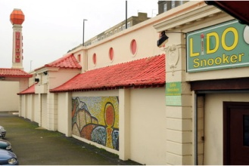
The desolation of the site. An over large, lumpy, car-park inclines towards the sea. Shuttered buildings outlined in tawdry orange still strive to be gay. A tower capped with a beacon; no longer illuminated. Below, the outline of a swimming pool carved from the sea – concrete sea-defences stand against the thrashing waves, but inside the curve of the basin a beach is being rebuilt as sand is deposited by the receding tide. A work of reclamation from the inside: hollowing out the site through acts of filling in. The concrete rim now shelters sand and the detritus of rubbish blown by the wind, rather than holding and protecting water. Down stairs covered with debris and pass barred doors and shuttered windows, layers of building carry subtle traces of past pleasures. But it takes an effort now to repopulate this place, and reimagine its past. At sea level, a concrete shell, a small stage or platform on the edge of the once swimming pool, carries the declaration, in bright colours, that this is ‘Lido Sands’. Turning away from the sea and walking back up the stairs, the words written on the tower echo back – LIDO. The desolation of the site.
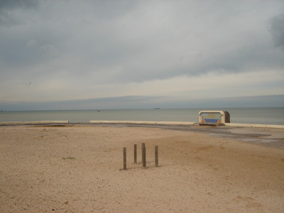
2016. In March, the lido was put up for sale again, by auction in London. Advertised as potential for residential use, it failed to reach the reserve price and was withdrawn. The guide price had been £600,000. £40,000 less than when it failed to sell in 2014; then it was advertised as a potential mixed use site, earlier plans for a Sea-life centre having been abandoned.
It has been a development site since 1978, when the swimming pool and principle facilities of the lido were closed (a small number of rooms were and are still tenanted), following commercial decline and a particularly bad winter storm which wreaked havoc with the lower terraces and pool.
Just around the headland from the re-generation activities of Margate, and the focus of The Turner Gallery, the lido site suffers from being sited in Cliftonville, an area now marked by significant economic deprivation. Ironically, Cliftonville was originally designed and developed on the premise that it must be differentiated from Margate. A once genteel (rather pretentious) suburb turning away from the tawdry mass tourism of the sands, Cliftonville now seems unable to partake in the gentrification of the coastal revival.
There is another reason why the LIDO site is so difficult to develop. In 2008, it was given Grade 2 listing, and thereby a level of protection as a site of historical significance. Working with(in) the strictures of listed status, alongside the character of the buildings and setting, creates a complex development challenge, especially for private enterprise. Meanwhile, other than a billiards club and small entertainment venue which operates out of a small number of rooms on the top level, and the use of some other rooms for storage, the site is abandoned and increasingly decayed. A small but loyal and vociferous band of local activists, many of whom remember the pleasures of the lido, keep a watching brief over its future, hoping for some kind of renewal which will make use, once again, of its facilities – but for the general public, rather than privatisation into an up-market complex. For them, the lido was and still could be a place to swim, to relax and to be entertained. It is simply a matter of recovering what has been lost – of reanimating the complex of pool and buildings, and putting them back to purpose. But the story of this place is rather more complex than that narrative of recovery of its visible, recent history suggests.
The lido.
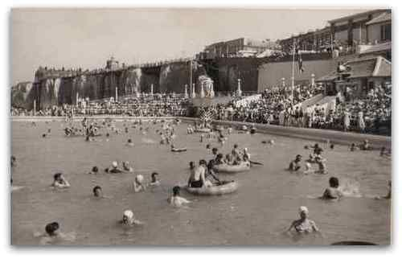
In the late 1920s, John Henry Iles, who owned the Dreamland Amusement Park, acquired the site and developed it into the lido complex which is visible today. Bars, cafes, restaurants and entertainment venues were laid out along a series of terraces leading from the cliff top down to a large swimming pool which covered the beach and created an enclosure projecting into the sea. In 1938, this marine lido was re-launched as Cliftonville Lido. Not surprisingly, especially given lles’s ownership of Dreamland, the development of the lido was aimed at a clientele which reached beyond the gentility of Cliftonville to attract the ever increasing crowds of Margate. Located next to the Winter Gardens, and surrounded by the open air attractions laid out along the top of the cliffs, the lido became very popular. A chance to swim and sunbathe in the open air, and then to spend time spectating, eating or dancing in surroundings which conveyed a sense of leisured glamour, but at a price which could be afforded, was the popularist offering of marine lidos in the inter-war years. Sir Josiah Stamp (governor of the Bank of England) when opening the Morecambe lido in 1936, is recorded as saying “when we get down to swimming, we get down to democracy”. Photos and short films record the amusements the lido hosted; bathing beauty contests were particularly popular. But by the 1970s, the attraction of outdoor swimming and the associated entertainment offered by marine lidos had declined in popularity and, in 1978, after appalling winter storms, the lido was closed.
Clifton(ville) Baths.
In fact the twentieth lido is built on top of, partly enclosing and partly obliterating, an earlier structure. Some traces are visible on the outside of the later buildings: in particular, what looks like a purely ornamental beacon designed as a prominent landmark to carry the word ‘LIDO’, actually encloses a chimney built when the site was developed in the nineteenth century as a sophisticated, and gentrified, sea-bathing complex. The full extent and significance of this earlier structure, now subsumed by and within the later layering, is essentially hidden – erased from the surface. To look beyond the obvious and recover what lies below, takes an effort of imagination and some knowledge of the history of the site.
The first development of the site was as Clifton Baths in 1824-8. At a cost of £15,000, chambers were excavated from the chalk cliff and lined with brick. At clifftop level, a picturesque Gothic style building of flint and stone was built as an entrance to the baths. At beach level, and reaching back into the cliff, a central circular chamber (12.8 meters in diameter) was designed as an embarkation and turning point for horse-drawn bathing machines which would then be pulled down to the sea along a wide tunnel 30.5 meters in length. Eight alcoves from which passages lead off lined the central chamber; one leading down to a large rectangular lower reservoir designed as a plunge bath for women and children which opened, through a large arch on the seaward side, into the open air (which can be seen clearly in the illustration below).

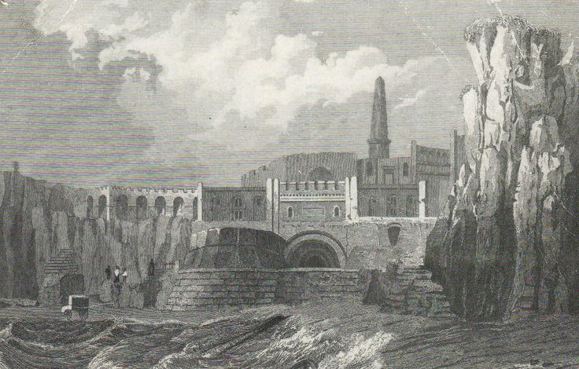
A sub-terrain region under the existing lido buildings, was, and still is, a maze of passage ways and chambers of a sophisticated design and structure. Despite having been subsumed by the twentieth century lido buildings (perhaps in part protected by these acts of entombment), much of this underground complex is still there and can be, albeit illegally and with some difficulty, accessed.
It is this the earlier, now subterranean complex which is listed – not the later lido which Historic England describes as ‘not of special interest’. The early nineteenth century structures now embedded under the concrete structure of the lido are described as especially important as they are ‘one of the earliest surviving seawater bathing establishments in the country’, with ‘the lower reservoir … probably the earliest seawater plunge bath in the country to survive’ and ‘the circular chamber and bathing machine tunnel of the Clifton Baths … the only known examples of purpose-built structures built to store bathing machines and convey them to the beach’. And the baths are ‘the only known example of a sea bathing establishment … dug out of the cliffs’ which ‘as a result, altered the local topography’.
The baths combined cold sea-bathing with warm salt baths. Sea water was pumped from the lower reservoir to an upper reservoir by (literally) horse power. The obelisk-shaped chimney (visible in the illustration above) served the boiler which heated water for baths, showers and hip baths. There was a waiting room which was also a reading and subscription room, and a newsroom which had an organ and billiard table. The upper terrace had round-headed alcoves, seats and benches for enjoying the sea views, and a bathers' terrace was added by 1831. Soon after that, a second chimney was erected (visible in the illustration below dated c 1860).
In the second late nineteenth century the facilities were extended – using electricity to add ozone baths, and, more prosaically, building for the first time an outdoor swimming pool.
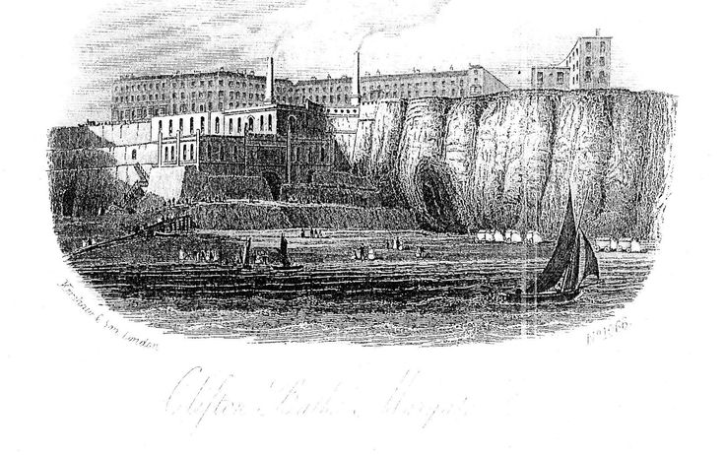
It was on this foundation that the lido development in the 1920s was built – literally and figuratively.
As you walk across the car-park and down the steps to view the remains of the twentieth century lido, one narrative of the past is visible and evocative. This is the narrative of bright sunlight, loud and care free laughter and of bodies enjoying the pleasures of sun and sea; it is the narrative of the marine lidos built for and enjoyed by the many who also enjoyed the pleasures of Margate and Dreamland. This is what locals remember and talk of, and seek to protect and reclaim. But under this clamour lies a much more quiet and genteel murmuring. Echoed in curved ceilings and passageways are the sounds of muffled horses hoofs and the cranking of wheels; hot water hisses and sound ripples off bodies moving slowly through dark water. A very different narrative: these subterranean, uncanny, sounds are the aural traces of the structure which has been listed and now must be protected. This is the architectural challenge: a combining of both narratives into a future which overcomes the abandonment of desolation and refuses the exclusion of further privatisation by development gentrification.

eg., see https://www.youtube.com/watch?v=AfplD649yiU
Exemplified by The Ward Locke Guide of 1903: “(Cliftonville) is the most exclusive and aristocratic part of Margate. It cannot be said too often that there are two Margate’s and that Cliftonville has scarcely anything in common with the area frequented by the vulgar tripper. Cliftonville has magnificent hotels with their private orchestras and admirable cuisine catering for all types of continental clientele.”
https://www.facebook.com/Cliftonville-Lido-Action-Group-136654829810683/
See eg https://www.youtube.com/watch?v=2De73s3rpiU
For photographs , see https://www.youtube.com/watch?v=zyHBaAbGITw
These buildings were lost when the later lido complex was developed.
The mouth of this tunnel is now blocked, but the original opening could be seen in the French Bar of the Cliftonville Lido.
See photographs of some of the tunnels at https://www.youtube.com/watch?v=wxsSA7SjZPE.
https://historicengland.org.uk/listing/the-list/list-entry/1392729
All taken from the relevant Historic England report.

