Critical Kent: The Topographies Project: Beaches (2015).
Background notes for Explorations of:
From Whitstable into the Thanet Coast.
(Directions and major ‘sites’ are in red – notes follow a route from Whitstable (off map to left) to Pegwell Bay, and then back to Whitstable along the coast through Ramsgate, Broadstairs, North Foreland, Cliftonville, Margate, Birchington. Any comments, corrections, additions, welcome – a.b.bottomley@kent.ac.uk. All mistakes and prejudices are mine. Enjoy!)
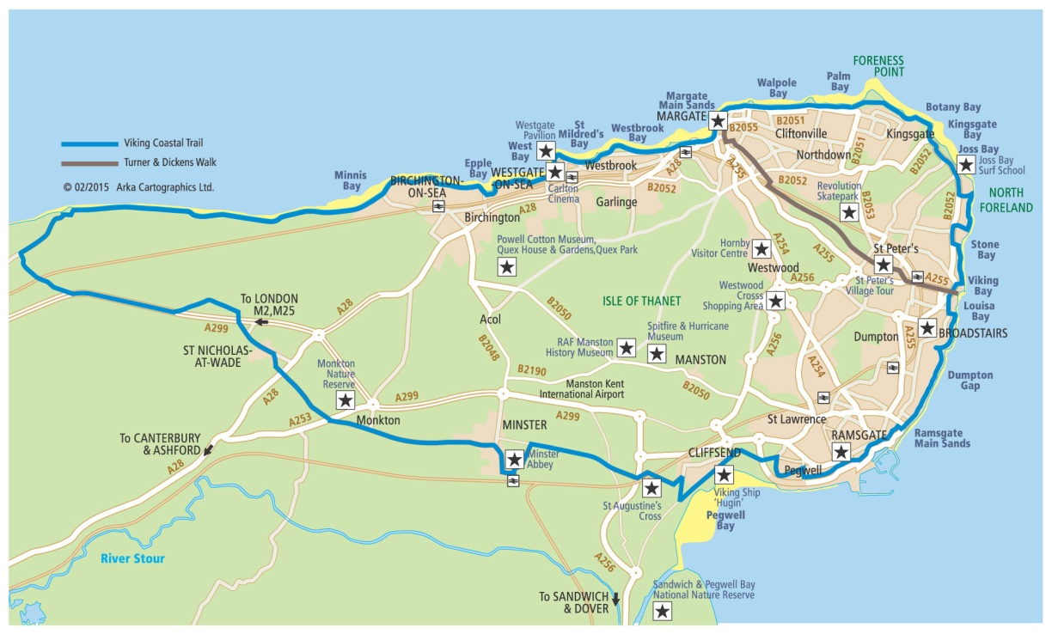

Whitstable 3
Pegwell Village Bay 10
Ramsgate 13
Broadstairs 15
North Foreland 19
Cliftonville 20
Margate 23
Birchington 24

Some introductory comments:
This route takes us from the North Kent coast (and Whitstable) and onto the Isle of Thanet – a large open space of fields and small villages, surrounded by sea on three sides and ringed with coastal towns. It has some beautiful (often sandy) beaches – some the central focus of a resort, others still quite wild and seemingly remote. It is also characterised by chalk cliffs: not as high and quite as white as on the south coast, these are rather grey/white, crumbly and clunch like; and for much of the coast line finding or making interconnecting routes between cliff –top and beach has been a central characteristic of the area (hence the constant references in place names to ‘gate’ and ‘stairs’). The softness of the chalk has meant that the coast is not only subject to erosion; it has also honeycombed with tunnelling (much of it man-made or enhanced.)
The other significant geographical feature is the strategic position of Thanet at the eastern tip of England, reaching out towards the Continent, as well as marking the beginning of the wider Thames estuary. Now, looking out to sea, there are few ships visible, of any size, whereas once this would have been a major shipping route – along the coast, up into the Medway and Thames, and across to Europe. Fishing boats, barges carrying heavy goods, steamers carrying passengers as well as cargo. Wealthy Londoners in the 18th and 19th centuries, could come down to the coast by sea to then sail their yachts out of, for instance, Ramsgate. Then from the 1840s, the advent of the railway line from London into Thanet opened another route into the area and the potential of mass tourism – the groundwork having already been laid in the development of towns like Margate as health resorts (bathing in sea water, but not necessarily the sea, and a great deal of fresh, ozone heavy, air).
The architecture of the coastal towns evidences the layers of each historical era – from small coastal ports, little more than fishing villages, through to the 1830s and the villas built by and for the first wave of ‘respectable’ seasonal visitors; then from the 1850-70s the speculative building of estates laid out with grandiose terraces and crescents, parks and promenades. And by then, thanks in part to such developments as the invention of the bathing machine in Margate, the beach and sea had become more than merely a setting, a view from the cliff-top, developing into a place of engagement - with nature, with pleasure, and with company. As the 20th century brought more affluence and leisure to more people (or at least the aspiration to both), Margate, in particular, moved from still genteel (if rather fading) respectability up to the 1930s, to post-war mass tourism – Kiss me Quick in Dreamland. So close to London, by train, coach or car - day trippers found Thanet just the right distance for a short jaunt away. With enough savings, they could purchase a caravan on one of the many new caravan sites, the larger run rather like holiday camps, or buy a plot of land to build on, perhaps retire to. However, by the time the infamous ‘Jolly Boys Outing’ was screened in 1989 (an ‘Only Fools and Horses’ special), the tide was, already, beginning to turn as new destinations and attractions became accessible and Thanet, along with much of the rest of the coastal resorts of England, went into what seemed to be terminal decline. In soci-economic terms, Thanet now includes some of the most deprived areas in England. Attempts to find and try ways to re-generate the economy, including the use of European money, have not been very successful – and the politics of the area are such that at the last election UKIP took control of the local authority. And yet…
In small but significant ways, Thanet is now becoming the target of gentrification. Rediscovering the glorious beaches, and the renovation of what remains of some good or pleasingly eccentric architecture, has become rather fashionable for some, described by locals as, ‘down from London’. A renaissance in food and hospitality is underway for those whose taste, income, and habits incline them towards the enjoyment of good food and the pleasures of good hotels. The extent to which this creep of gentrification can regenerate a local economy (and for whom), is moot – especially given the extensive depravation in the area, as well as a strong sense from some locals that those (recently) ‘down from London’ are a rather irrelevant minority. There is at present in Thanet quite a clash of cultures: or perhaps just a series of parallels.
Throughout this history, what continues to remain is the potential of the beaches and the sea: but, as is the case so often, it is frequently contested: not least in Whitstable, which is a reminder of the beach as working beach, not merely as one of pleasure -

Whitstable:
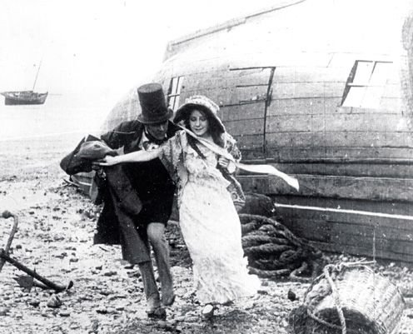 Still from a scene shot on Whitstable beach for David Copperfield (1913).

Whitstable is not Thanet – it is on the much lower, marshy, coastline where the Swale and Medway form an inlet from the wider Thames estuary. Stand on the beach and to the left is the Isle of Sheppey, and, if the weather is clear, you can see the outline of Essex, on the other side of the Thames, in front of you.
Whitstable’s origins are tied up with oyster fishing, which (with other shell fishing) provided the main income for the town until into the early 20thC. So important was the trade that a dedicated railway (‘The Crab and Winkle’) was built in 1830 to carry the catch from Whitstable to Canterbury (see crabandwinkle.org). Imagine a small village clustered around the beach and a small port, with a ring of ‘services’ (church, school etc) around it. The community was structured around not only the activity of fishing, but the mode through which it was organised and controlled:
From ‘All the Year Round’ November 1859 (author Charles Dickens?):
The Happy Fishing Ground.
There has always been a charm for me about the fisherman's trade.. nothing but the grey sky, or the blood-red sunset, is over my head. I see the dwarfed fishing village across the waves; the cobwebbed lane of drying nets that winds down to the sands; and the sodden lobster-catches struggling between the sunken rocks.
With such day-dream visions as these,..it is not to be wondered at that I have a passion, in all weathers, for dropping quietly down to the coast, and burying myself, for a time, in one of those hilly nooks, where none but boatmen and fishermen can be born, can live, and can die. The places that I love most are those where the "season visitor" is almost, if not totally, unknown; where bathing-machines have never yet penetrated; where the stranger is truly a being of another world; and where the inhabitants believe, with a proud and simple faith, in the unequalled beauty and importance of their little scaly town. Many such places as these do I know, even within fifty miles of the Royal Exchange; and Whitstable, in Kent, the port of Canterbury, on the estuary of the Thames, is one of my especial favourites...
`Its one idea is oysters. It is a town that may be called small, that may be considered well-to-do, that is thoroughly independent, and that dabbles a little in colas, because it has got a small muddy harbour and a single line of railway through the woods to Canterbury, but its best thoughts are devoted to oysters. Its aspect is not sightly, for the line of its flat coast is occupied by squat wooden houses, made soot-black with pitch, the dwellers in which are sturdy freeholders, incorporated free-fishers, or oyster-dredgers, joined together by the ties of a common birthplace, by blood, by marriage, capital, and trade. It has always been their pride, from time out of mind, to live in these dwarfed huts on this stony beach, watching the happy fishing grounds that lie under the brackish water in the bay, where millions of oysters are always breeding with marvellous fertility, and all for the incorporated company's good. How can the free-dredgers, and the whole town of Whitstable, help thinking of oysters, when so many oysters seem to be always thinking of them?
A primitive and curious joint-stock company it is, a joint-stock company whose shares are unknown upon the Stock Exchange, because they are never in any market except Billingsgate market; a joint-stock company that may not be peculiar to Whitstable, but is peculiar, so it seems, to all happy fishing grounds, where oysters are cultivated...
It came together in the dim old times, as a family compact, and a family compact it still remains. Its three hundred and forty odd members are all Whitstable men, or Whitstable widows and children. The stranger is never admitted to the rights and profits of a dredging-freeman, though the strange woman may be brought in by marriage, into the oyster tents, and may rear up sons who shall go forth and fish.
The male infant is born, a young shareholder, in one of the low pitch-black wooden houses on the beach; he is nursed to the tune of an oyster-dredging lullaby, to the howling of the wind, to the hissing of the surge. He staggers into the back parlour as soon as he can walk, and finds it a Robinson Crusoe's storeroom, filled with canvas, coils of rope, old oars, nails, paint-pots, and parts of ships. He tumbles out of a door at the end, and down some steps, on to the pebbly shore, where he plays on the border of his happy fishing ground, or clambers into a boat bearing his father's name, which lies high up on the beach, half filled with the skins of dead star-fish, with cockle-shells and maddy crabs.
He thinks that the handkerchief which his sister wears over her head and shoulders in the summer, like a monk's cowl, or the shawl that she wears, for greater warmth, in winter the most elegant head-dress that was ever planned. The fact that Canterbury, a cathedral city, about seven miles off, has never adopted this head-dress, is nothing to him, for he knows that Whitstable men are perfect in matters of fish, and he gallantly considers that Whitstable women must consequently be perfect in matters of taste.
The free-dredger is thoroughly independent, not given to touch his hat to lord or squire; and if he does pay any mark of respect to the Duke of Cumberland, it is only as the sign of the dredgers' public-house, where the profits of the free company of oyster fishers are divided and paid. At fourteen years of age he may look with hope towards this old smoky tavern, and may enter as a fisherman's apprentice, to see his master paid; but at twenty-one he comes into his full birthright, his share in the myriads of oysters he has so long been thinking about, with all the claims and privileges that belong to the free-fishing state. He is then permitted to attend the "Water-Court" on the second Thursday in July. Here all the dredgers meet and vote by ballot, revise the by-laws, appoint the nine watchmen with three watching boats, the foreman of the ground, with his deputy, and twelve jury-men are chosen as the board of management for the year.
On this great day the whole town of Whitstable is hung with flags; and the sound of festivity is heard in the two principal taverns, and in the many small wooden drink-shops that are scattered along the shore.
If a free-dredger dies without male issue, then his share becomes engulfed in the common stock, but his widow receives a certain reduced payment out of each day's fishing profits, upto the time of her death. The aged, infirm and superannuated, about one-fifth, are provided for in the same way, as well as those who are compelled by temporary illness to stop on shore. No one that has once been connected with the happy fishing-grounds is ever found begging for a loaf of bread.
The industrious little fleet consists of about eighty fishing-smacks, and fourteen market-hoys. The hoys are, of course, occupied in going to and coming from Billingsgate, but the fishing-boats are always moored in the bay, opposite the free dredging settlement of the town. During three days of the week these floating representatives of the happy fishers are employed in what is called "dredging for planting" and the general cultivation of the ground. Young oysters are caught and transferred to places where they will find the most nourishment; samples are drawn up, inspected, specimens tested, and the remainder returned to the sea. The natural enemies of the oyster are sifted out and destroyed - especially the poisonous star-fish, and the mysterious "borer". The whole of this planting process is agricultural in its character; and it occupies about six hours on each of the three days.
The dredging for the London market, a task of about two hours' duration, is performed on the other three days of the week generally on Mondays, Wednesdays, and Fridays. It is regulated by the two salesmen who represent that happy fishing-ground in the market of Lower Thames-street, and it is this regulation which prevents any violent fluctuations of price. The telegram received from these agents direct the number of bushels that are to be caught for market on each fishing day, and the catching of these bushels is work that is equally divided amongst all the effective members of the little oyster fleet. Each crew of three men goes off to its particular boat to dredge its particular "stint", and it is not allowed to draw up more than its allotted portion.
The first step in oyster-dredging is to put on an armour of warm clothing in which it is extremely difficult for a novice to move or breathe. There are long worsted stockings to be drawn over trouser legs; a pair of long, heavy, sewer-boots, reaching almost to the waist,, to be forced over these, a thick Guernsey shirt to be stretched over your body-coat, and an oilskin sou'-wester hat (like a dustman's) to be placed on your head. In case of dirty weather, which is always provided for, you have a black, or yellow, salt, clammy oilskin overcoat thrown into your arms, which feels like the soddened casing of some large fish.
About eight o'clock on a fresh October morning, the united company of free, happy family oyster-fishers, plunge heavily and slowly through the stones on the beach, and proceed, in the thoughtful and deliberate manner, to push off their boats, and row out to their little oyster fleet. They are all equal; they are all working together for good. . . the whole scene is a picture of quiet, profitable, patriarchal trade. A dozen happy family shareholders will join to shoulder a rope, and pull off a barge-like boat that the tide has left high and dry. So confidently do they lay their heads together to do this, that they look like a little open-air board meeting held on the beach. Their whole movements seem to be regulated by a strong feeling that they have many centuries before them in which to do their work. They have lived amongst oysters, and thought of them so long, till at last, it is possible to trace something of that steady, stationary shellfish in their nature.
The ship in which we row off is a small yacht-like smack, of about fifteen tons burden. Its deck is almost flush with the bulwarks, and covered with baskets, buckets, and nets. When our grey sails are set we skim away from our inner coast moorings, through the little busy fleet, until we come to our proper anchorage. The bright green hills of Kent, and the island of Sheppey, half-circle us on the landscape. The blue salt water comes rolling in from the North Sea at the mouth of the bay; the thin, pale, fleecy, grey and golden clouds are flying over our heads; and the dull sound of boat-building hammers comes to us from the low black town.
Our nets are like fish - a thick trellis-work of undressed buffalo hide, washed almost white with repeated dipping; and the iron knife-like bar at the mouth is formed so as to scrape the oyster beds. They are dropped with their iron work, like small anchors; and, when they are hauled in, there are shelly heaps in each net, numbering about eight hundred oysters. The haul is emptied on to the soppy deck, the nets are again cast over, and the happy dredgers stoop down to begin the labour of sorting.
A few whelks have come up in the haul; a few strips of green, glistening seaweed; a few cockles whose kicking claws are hanging from their shells, as if they were struggling to crawl in out of the cold; a few snuff-coloured old oyster-shells, eaten through till they are like rusty rings, and a few muddy spider crabs, who run quickly from between the crevices of the little shelly hill.
The oysters are of all sizes, in their different stages of growth. Some are like blocks of flint, a mass that perhaps, numbers nearly thirty mature oyster lives. Some shells are covered with little pearly counters, the size of shillings, which represent a brood of infant oysters, all less than a year old. Some shells are ornamental with red-looking pimples, which the happy free-dredgers call "quats". Some oysters come up highly clean and perfect in their formation, but not much larger than half-a-crown. These are generally the two year-olds, and, with all the preceding varieties, they are pushed on one side by the dredger, while he picks out only the sightly fish of four years' growth, and casts them into his basket.
His theory is that the oyster, if left alone, may live about ten years, and that it is extremely good eating at five years of age. He knows the five-year-old oyster by the layers outside the bottom shell. The little perfect yellow circle at the small end of the fan represents one year; the three successive brown pearly semi-circles represent three other years, and the rough fringe round the outer edge represents the one year more. He is satisfied with the four-year-old oyster for general eating; and what he considers good the London market is compelled to take.
When the sorting of the oysters is finished, and the baskets, which serve as measures, are filled with the picked fish, the refuse is swept back into the sea through trap-holes in the bulwarks. The loaded baskets, after being dipped in the bay, for the purpose of giving the oysters a slight wash, are placed on one side, and the same work is gone through again, until the "stint" is caught. When the proper number of baskets are filled, they are placed in the boat belonging to the smack, and rowed to one of the market-hoys that are anchored amongst the fleet.
The baskets are lifted out of the boat into the hands of the hoy sailors - a very fishy, patched, and soppy crew - and their separate hundred-weights of contents are tilted, like coals, into the long wet hold. A soddened inspector is kneeling on the deck, and watching through a pair of spectacles the descent of the quantity and quality at the same time. When the last smack has delivered its required load, the markethoys turn their heads due Billingsgate; the fishing vessels are mopped up, are run to their coast moorings, and made tight for the night, and the happy fishers go on shore to dinner, the masters of their own time for the remainder of the day.
Towards night they assemble at the "Duke of Cumberland" to hear and participate in the results of the last sale. The money is sent down by the two market salesmen in London and the sum is drawn out and divided by the managing jury of twelve. Their gains may fluctuate, but it is generally found that if they want a pound on account, they know exactly where they can get it.
The joyous songs that come from the free-dredgers chief tavern, up to a late hour of the night, are not the sounds usually made by men who linger over an unsatisfactory pay table.
(In 1884, Somerset Maugham, as a 10 years old orphan, was sent to live with his elderly, strait-laced aunt and clergyman uncle in their gloomy gothic vicarage in Whitstable. “Blackstable” and “Tercanbury” (Canterbury) appear in two of his novels (Of Human Bondage, 1915, and Cakes and Ale, 1930), in which he portrays the tight knit fishing community from which he (and the middle classes) were excluded and stood apart. He did not like Whitstable, or living in either the vicarage or the town, and did not share the romantic vision of the author of ‘Happy Fishing Ground’.)
The importance of the beach as access point to the fishing grounds, a place to keep the boats and deal with the catch etc, meant that some guarantee of control was important to the oyster company – and, indeed, their Charter guaranteed it as a significant aspect of the grant of the fishing rights made to them by the Diocese of Canterbury (who held manorial rights).
During the 19th and early 20thC the West Bay was dominated by their activities. Therefore, when a potential for developing Whitstable as a ‘resort’ was suggested by the success of the Thanet resorts, it was on the other side of the harbour that any possibility might arise. And eventually it did – the Tankerton estate (a house and large grounds) finally came onto the market, and was then purchased by speculators who laid out plans for the land to be developed as a building estate with a ‘front’ along the beach of a promenade, leas etc. The development, whilst not quite following the original plans or becoming quite as ‘up-market’ as originally envisaged, was successful in promoting the area as Whitstable’s pleasure beach area. In front and to the right of The Continental, would have been busy with amusements, booths, rides etc…especially attractive to day trippers coming in on the steamers from London.
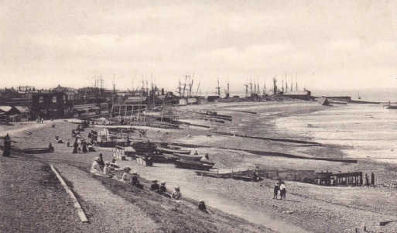

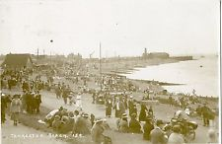
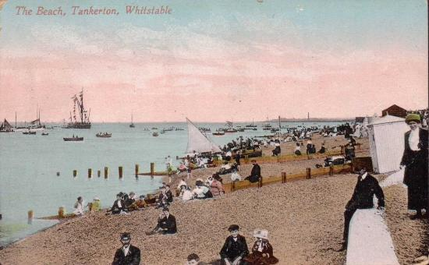

(The Tankerton Estates still have a controlling interest in the area, see: www.countyestateagents.co.uk/tankerton-estates )
After the second world war, the oyster fishery was in major decline and the town rather run down (if charming). Tankerton was no longer a popular tourist destination, but rather (like much of Thanet) a place of retirement. In 1978, The Oyster Company was bought by the Green family who were interested in the potential of commercial development in the area. This was the beginning of significant local investment made by them, along with the regeneration of Whitstable as a tourist destination – especially for those who favoured the traditional seaside holidays of swimming, paddling, picnicing and fishing (in other words a nostalgic recreation of past childhoods). And then, tensions began to arise between the Greens and (some of) the locals:
Ros Coward, The Guardian, Tuesday 8 October 2002’
"Have you ever visited the oyster houses of Whitstable?" That is the opening question in Andrew Davies's raunchy new TV drama, Tipping the Velvet, partly set in Victorian Whitstable. The series will be another boost for a town already loved by the media, not just for its restaurants but its quaint high street and beach - a place to watch sunsets immortalised by Turner or study flocks of wading birds. But as the main character also says in Tipping the Velvet, which starts on ITV1 tomorrow night, "Open an oyster and it's a secret world in there". So it is with Whitstable.
"Visitors to Whitstable and even many locals think its beaches are public," says veteran campaigner Ann Wilkes, "but they are private property, owned by the Whitstable Oyster Fishery Company (WOFC). In theory, it could end up with no one having any right to put a foot on them."
Across the town, the company, which says it just wants to preside over the restoration of the oysterbeds, is engaged in numerous disputes - over leases to land, escalating rents and planning permissions. Now the company's proposals to build huts and a cafe on the beach is creating a furore which is engulfing the town like one of its historic floods.
Whitstable beach is an anomaly. The crown owns 98% of Britain's coast. But the north Kent coast is an exception. It dates back to a royal charter of 1793, which gave local oystermen the right to use the beach for "the better ordering and government of fishery". The WOFC was a true socialist collective in which oystermen worked together and shared income as the best way to protect the oysterbeds. Many families inherited shares in the company from the original oystermen.
But in the 50s, the trade was destroyed by an oyster virus. By 1976, the company was little more than a collection of disused buildings with only one employee. It was then that Barry Green's partnership bought 42% of the company's shares. He restored the old oyster stores, first as a tearoom, then as an upmarket fish restaurant. The colour supplements were soon beating their way to the door. A few residents like "Moany Old Git" on the town website blame the Green family (Barry's sons James and Richard are involved in the business) for turning the town into Islington-by-the Sea, but most acknowledge their part in the town's current popularity. "There's no doubt that the restaurants, hotel and cinema are real assets," says former councillor Julia Seath. "But this company has a track record of unorthodox methods. People are worried that the latest proposals signal the start of commercial development on the beach itself."
Under the Greens, the company has shed its shambolic but benign reputation and become a business with a £2.2m turnover and 100 employees. It has pursued its commercial interests so zealously that it even suggested fishermen should be charged for digging bait on the beach. Locals become particularly indignant at the flouting of planning regulations. The most notable occurred when the company got a grant from English Heritage to convert fishermen's huts into workshops for artisans, and used them for hotel accommodation.
"Barry Green has made himself very unpopular," says a member of the Yacht Club, which has had to pay escalating fees to leave boats on the beach they used to occupy freely. "Someone suggested the best way to deal with Green was to offer him an honorary membership. The proposer was practically lynched."
Recently, the company has registered the beach and pockets of surrounding land as private property. The land `included a tiny area underneath the decking of the Yacht Club, a move hardly calculated to win friends.
No one in Whitstable would have known about the registration if not for 83-year-old Ann Wilkes, veteran of a number of battles with the WOFC. In 1968 she tried to register Whitstable beach as a village green and was, ironically, supported by the company, in its previous manifestation. But she was defeated by Kent county council. Since the Greens took over, her battles have become more urgent as she has fought to establish rights of way for beach footpaths and village greens. "I probably should have kept a tally. It's a fair few and there will probably be a fair few more."
Last summer, she led another attempt to have the beach registered as a village green to protect it from any possible development. But it was again defeated. The council took the company's side, arguing that if the beach became a public village green it would prevent them from maintaining sea defences. On one occasion Ann was cross-examined for six hours. Residents booed and hissed the council's barrister. "She won the moral victory," says resident Paul McNally. "It was an incredible sight - one tiny woman with a huge pile of papers opposed by the massed ranks of the company's and the council's barristers."
The company said again that it did not intend to deny access to the beach. But since it officially registered its property interests, some locals have received letters demanding money for leases to allow them to use other company land they had always accessed freely. The solicitors' letters carry a hint of menace. "It's a tiny strip of land from my front door to the sea which I've used for over 20 years," says one recipient. "I'll have to put up a drawbridge. They can't charge for the air." The Land Registry at Tunbridge Wells has been inundated with inquiries from angry residents. "People don't like the highhanded way the company is operating," says Ann Wilkes. "It's like having a bad lord of the manor."
You might expect the company's shareholders to be enjoying good times, but there's discord here too. John Pettman, a lawyer and shareholder for 20 years, says: "I am sentimentally attached to the company. It's part of Whitstable's history. But now the Greens control 80% of the shares. We never get directors' reports and in 22 years we've had dividends only twice." When Pettman challenged this he was called "outrageous", described as "having a silly face".
Green objects strongly to being cast as a wicked businessman. He says his property and business interests are subsidising his "vision" of restoring the oyster fisheries to their full glory. "I love Whitstable. I use the beach every day. My dream is restoring the oysterbeds, something we are investing in at the moment."
He's "shocked" at the hostility to his latest plans, which he describes as "a cafe and a couple of dozen beach huts". But beach huts are a sore subject in Whitstable, and not just because, according to the site manager, "Tracey Emin left the site in such a disgusting mess when she dismantled hers and took it off to London." Most locals are more concerned about prices after one sold for £60,000. Green describes his interest in building more huts in philanthropic terms. "There used to be huts all over the beach in Victorian times. I think they are lovely. The opposition is 100% nimbyism. These people just don't want scruffy children playing tennis in front of their windows."
McNally, a member of the new Whitstable Beach Campaign says, "We are not stupid. Beach huts are big business. This company wants to milk a public asset for private gain. The company supposedly owns the beach, because of some archaic deeds, but its flood defences, cleaning and maintenance are all paid for by ratepayers. It should be managed in their interests. This is a lovely, unencumbered part of the beach, a conservation area and a site of special scientific interest. If the company develops on the beach it will destroy what makes it special. The beach is the pearl in Whitstable's oyster."
And the disputes continue… whitstablebeachcampaign.org/ …including attempts to protect the beach through registration as a village green.

DRIVE FROM WHITSTABLE ALONG ‘THE THANET WAY’ TOWARDS RAMSGATE (20-30 mins).
This is a fast road, by-passing the coastal towns and built to carry traffic quickly across The Isle of Thanet and on to Ramsgate. Just past the Herne Bay turn-off, on the left there is one of the few remaining windmills and behind that, in the horizon, is a glimpse of the twin towers of Reculver – looking like a brutalist urban intrusion, but actually the only remains of a once thriving coastal town (origins Roman). The twin towers are of a once-church now maintained by Trinity House as a marker for navigation.
Driving on over the flat open expanse of Thanet, look out for the signs which tell you that you are well on the way – ‘Thanet Earth’ (actually a mega agri-industrial complex).
Approaching Ramsgate, on your left is ‘Kent International Airport’, aka ‘Manston’, and one of the intended destinations for traffic carried on ‘The Thanet Way’.
Once an RAF station, since the 1980s Manston has been the focus of a number of commercial investment strategies (with local authority support) to develop it as an international airport for freight and passengers. However, all projects were financially precarious and the history of Manston has been one of short lived projects and frequent changes in ownership. In 2013 it was sold to Stage Coach owner Ann Gloag – and it was presumed locally that she would invest in the airport and, finally, make a success of it. Instead, in 2014 it was closed and Gloag announced her intention to sell the site for housing. Local hostility to the closure was vehement, and the defence of the airport as an economically viable project of crucial importance to the economic development of Thanet was a major part of local political campaigning in the local and General Elections of 2015. Local support for the future of the airport became focused on the demand that it be ‘compulsory purchased’ by the local authority, and an argument that as Labour would not agree to the purchase, UKIP were the party most likely to be willing to be committed to this strategy. However, after UKIP was elected as the majority party in North Thanet, the party split over support for the campaign to buy the airport: http://www.kentonline.co.uk/thanet/news/ukip-councillor-sacked-in-row-42093/
For now, the airport remains mothballed and the signs on ‘The Thanet Way’ still point you to ‘Kent International’. It has been used, in 2015, as part of ‘Operation Stack’, a lorry park when Channel crossings are closed and traffic backs up.
Just outside Ramsgate, on the traffic circles, follow through from A253 to A299 towards Ramsgate. Then A255 and next traffic circle right onto B2054. Right down Pegwell Road to Pegwell Village. Park by the Pegwell Bay Hotel. (The road across the cliff top from Pegwell Village to the rest of the bay and the Viking Ship is, in September 2015, closed to traffic due to road works.)

Pegwell Bay (the Lost Pier…and the lost beach):
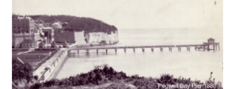
Taken from: http://www.piers.org.uk/pierpages/NPSpegwell.html
Britain’s shortest-lived pleasure pier at just five years was conceived as part of the Ravenscliff Gardens development by the Pegwell Bay Aquarium and Hotel Company. The Company was formed by James Tatnell, who owned the Clifton Hotel in the village, in 1872 to reclaim six acres of foreshore for the gardens. The aquarium part of the scheme was later dropped, but the Clifton Hotel was enlarged, and in addition to the pier, the gardens were also to house a swimming pool, restaurant, skating rink and photographic studio.
An application was forwarded to the Board of Trade in June 1874 and work began on reclaiming the cove the `following year. On 16th September 1879 the Ravenscliff Gardens and Pier were formally opened and a basic entrance fee of 2d was charged to use the gardens and pier, although this was increased to up to 6d for special occasions such as regattas. The pier was a rather fragile structure, 300ft in length, constructed of wood with slender iron supporting columns. A kiosk was placed on the pier head, which also had two small landing stages. However, no evidence has come to light that any vessels ever called there and the gardens and pier were a colossal failure; leading to the failure of the Pegwell Bay Aquarium and Hotel Company within a year of opening.
`The Clifton Hotel and Ravenscliff Gardens and Pier passed to the mortgage company (the Sheffield & South Yorkshire Building Society) who leased them in 1880 to John Garratt Elliott, who, as a member of the London Swimming Club, was principally interested in the swimming pool. However he departed in the following year and the mortgage company tried unsuccessfully to sell the development. It appears that in 1883-4 the gardens and pier were leased to Jane Carter at the Belle Vue Tavern (famous for its shrimp paste), but the short and rather sad life of the little pier came to an end on 4th December 1884 when the hull of the wrecked barge Usko drove through the shore end of the structure during a gale. In January and February 1885 the surviving portion of the pier was sold off upon the cliff top.
The gardens eventually came into the hands of the Working Men’s Club & Institute Union, which had utilised the former Clifton Hotel since August 1894. A corner was also used by the Conyngham Café for various entertainments between the years 1894-1908. The swimming pool was filled in in1895 and the gardens steadily over the years became unkempt. They were abandoned by the convalescent home in the late 1960s and are now very overgrown. However, at low tide, the piles of the head of the long-lost pier may still be seen.

Before 1870s, and after:
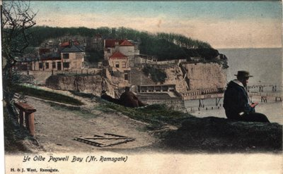
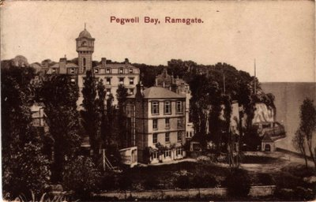
The reclaimed land clearly laid out ‘lawns’ and ‘pleasure gardens’:
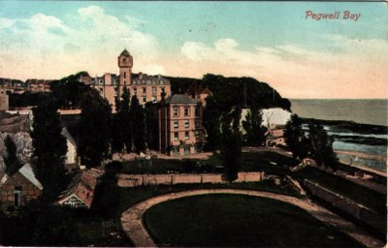

And this is ‘a portrait’ of the bay before it was ‘reclaimed’ by the development scheme described above:

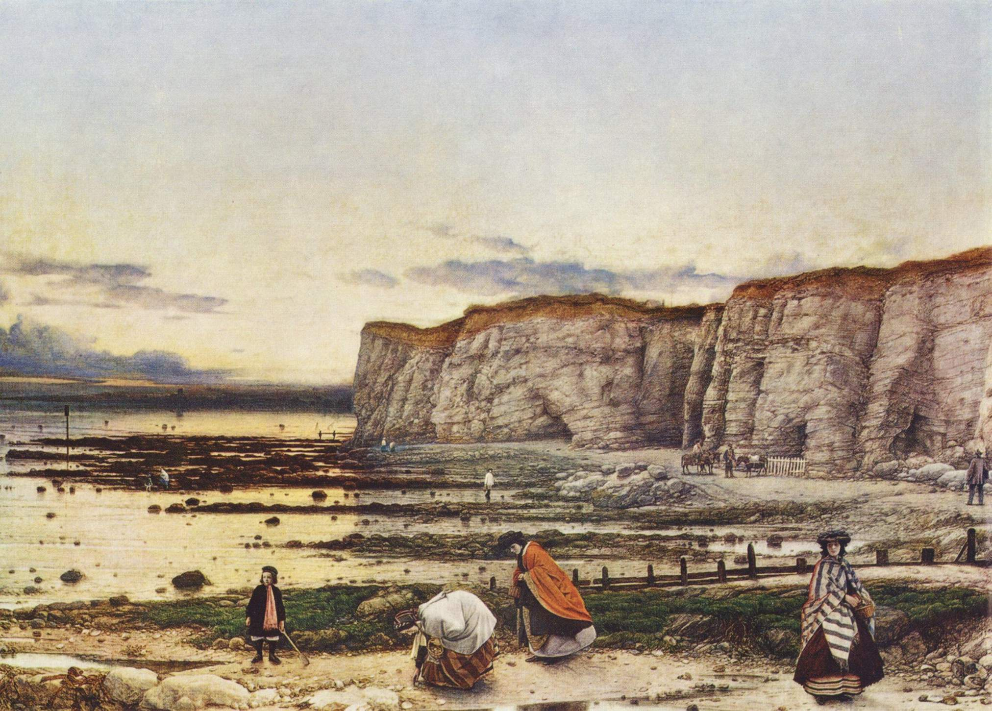
William Dyce Pegwell Bay: A Recollection of October 5th 1858. (Tate Britain.)
Dyce’s painting can be read as little more than a family portrait, but it is generally accepted to be much more than this. The light produced by the time of year, of day and the low tide, renders an ethereal glow which might also be thought of as a romantic evocation of a past time remembered: but, again, it could be very much more. The family are gathering fossils and shells, they are surrounded by (and sharing in) the wonders of geology and above them (just visible) is a comet falling towards the cliff. Here the beach becomes a place (or space) in which, through which, time opens (unfolds) beyond the every-day immediate patterns of the familiar and short lived, into the rhythms and pulses of the mystery of tides and moons and onto many pasts, out to deep time, a new cosmic. The artist walks on, he is the small figure beneath the cliff – doubled by his own portraiture, in which we can see him, but are also aware of his other, invisible, presence as the author of the work in which the figures of his family are grouped in front of him/us.
Details in this painting are compelling as social history, and as a record of the environment (note the coastguards cottages and the entrance to a tunnel linking cliff to beach. For more on local tunnels see: wttp://www.subterraneanhistory.co.uk/2010/01/pegwell-bay-tunnels-kent.html). But given my reading of the picture as so much more than representation (or as metaphor!), it is particularly poignant that the view has now so changed: behind the artist is Pegwell Village, soon to be developed as a hotel for which this beach was no more than land to be ‘reclaimed’ for a lawn.
Here is another story of privatisation – again for commercial, speculative reasons – this time to provide for more comfortable, tamed, pleasures.
Turn left back towards Ramsgate, and then left into The Royal Esplanade….drive along the seafront until reaching the centre of the front at Ramsgate - just beyond the Royal Habour and yacht club (note the Royal Temple Yacht Club on left), to parking by the obelisk.
Ramsgate:
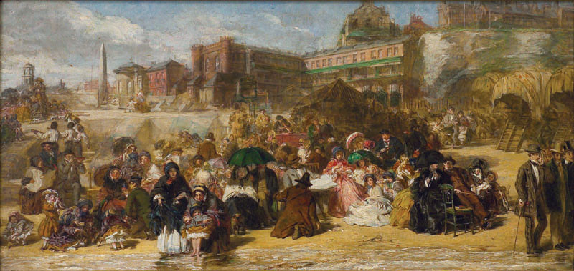
William Frith Ramsgate Sands (1854/6) (Royal Collection.)
Frith’s painting is in the ‘narrative’ style – a collection of characters that one could meet on the beach, or activities one could indulge in, all grouped densely together in front of the then recent speculative developments to the west of Ramsgate. It is so busy! A kind of Dickensian caricature of industrious and still (if only just) respectable, fun. Queen Victoria, a visitor in her youth to Ramsgate, loved it and purchased it. It is jokey and has much detail in it to speculate on – but one can’t help feeling that the beach is not, to them, quite a comfortable place to be. It feels almost experimental and new – as if this is the beginning of how to learn to inhabit the beach as leisure/pleasure, and very different from Dyce’s scene set around the same time and not far away.
Ramsgate is interesting for a number of reasons – once a busy port, the local authority valiantly are trying to keep the port viable, but, other than the boast which service the wind farms, yachts in the marina are now even more dominant as a local industry. Ramsgate, like the rest of Thanet, has experienced a period of decline, but it does now seem to be undergoing something of a (gentrified) revival. As part of local regeneration, more is now made of its history, although much remains, or as become, rather shadowy. In the 19thC the town was a port, a place of departure for the continent, and a place of quiet peace and relaxation for those escaping London for the summer, seeking the sea air and maybe a little sailing or sea bathing. This was as more about a pleasant and restorative life, than a search for pleasure. It was respectable enough to attract a mix of serious religious adherents – Elizabeth Fry (Quaker philanthropist)died here; Pugin built and lived here, pursuing his vision of sturdy (English) Gothic buildings embodying and carrying forward the virtues of Anglo-Catholic living; and Moses Montefiore lived for the summer months in one of the largest houses in town, East Cliff Lodge, a late Strawberry Hill Gothic in white stucco, standing in extensive gardens looking over the sea.
Walk: From the habour there is a choice, either walk along the beach towards Broadstairs, or go up to the George VI Park, walk through the park and then along the cliff to Broadstairs.
The park is the site of Montefiore’s villa, which was demolished by the council in the 1950s when it was so badly in need of repair that it was deemed too costly to try and save it. Scattered through the park are some remains – and the occasional reference to the family. BATHING POOL>>>>
Drive: towards Broadstairs along Boundary Road and Heresen Road. On Hereson Road, note the Montefiore Health Centre on the left, just beyond this building is a small plot of open land laid out as a community wood. Parking is possible on the road. Walking either through the wood (very scruffy) or along the road – walk to the other side where a small pathway leads from the road and down the side of the wood. There are no obvious signs – but you will glimpse some white buildings on your left as you walk down the pathway. This path is ‘Honeysuckle Lane’ and the white buildings are the synagogue built by Moses Montefiore in 1833, and the mausoleum he built for his wife which is based on the design used when she sponsored the restoration of Rachel’s tomb outside Jerusalem (both of them are buried there). This land was previously part of the family estate – just further along the Heresen Road on the right is Montefiore Avenue which is still lined with the trees which would have marked the walk from the house to the synagogue. At the top of the avenue is an entrance to the park (once the gardens of the house, East Cliff Park, and now the George VI park) past the remains of the coach house and stables (now used as housing). https://www.montefioreendowment.org.uk/sirmoses/ramsgate/ The land which is presently used as the community wood is part of the site of the college that Montefiore also built and endowed – and is now subject to a complex legal dispute.
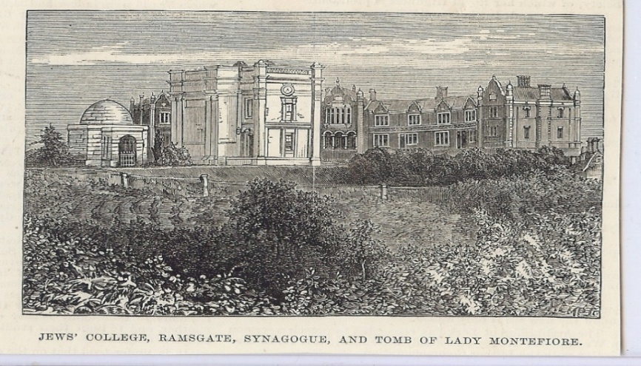
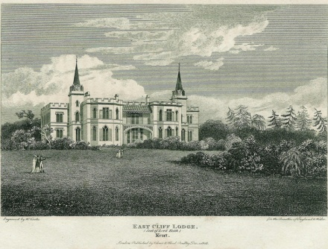
Heresen Road becomes Ramsgate Road. At traffic circle bear right following Ramsgate Road, towards Viking Bay and follow through into Boadstairs Habour. Park.

Broadstairs.
It is impossible to avoid the Dickens’ industry in Broadstairs. He wrote David Copperfield here (at Fort House), which was filmed on location along the coast in 1913, including on the beach at Whitstable. He left a record of the town in:
Charles Dickens ‘Our English Watering Place’ (1851)
In the Autumn-time of the year, when the great metropolis is so much hotter, so much noisier, so much more dusty or so much more water-carted, so much more crowded, so much more disturbing and distracting in all respects, than it usually is, a quiet sea-beach becomes indeed a blessed spot. Half awake and half asleep, this idle morning in our sunny window on the edge of a chalk-cliff in the old-fashioned watering-place to which we are a faithful resorter, we feel a lazy inclination to sketch its picture.
The place seems to respond. Sky, sea, beach, and village, lie as still before us as if they were sitting for the picture. It is dead low-water. A ripple plays among the ripening corn upon the cliff, as if it were faintly trying from recollection to imitate the sea; and the world of butterflies hovering over the crop of radish-seed are as restless in their little way as the gulls are in their larger manner when the wind blows. But the ocean lies winking in the sunlight like a drowsy lion - its glassy waters scarcely curve upon the shore - the fishing-boats in the tiny harbour are all stranded in the mud - our two colliers (our watering-place has a maritime trade employing that amount of shipping) have not an inch of water within a quarter of a mile of them, and turn, exhausted, on their sides, like faint fish of an antediluvian species. Rusty cables and chains, ropes and rings, undermost parts of posts and piles and confused timber-defences against the waves, lie strewn about, in a brown litter of tangled sea-weed and fallen cliff which looks as if a family of giants had been making tea here for ages, and had observed an untidy custom of throwing their tea-leaves on the shore.
In truth, our watering-place itself has been left somewhat high and dry by the tide of years. Concerned as we are for its honour, we must reluctantly admit that the time when this pretty little semicircular sweep of houses, tapering off at the end of the wooden pier into a point in the sea, was a gay place, and when the lighthouse overlooking it shone at daybreak on company dispersing from public balls, is but dimly traditional now. There is a bleak chamber in our watering-place which is yet called the Assembly 'Rooms,' and understood to be available on hire for balls or concerts; and, some few seasons since, an ancient little gentleman came down and stayed at the hotel, who said that he had danced there, in bygone ages, with the Honourable Miss Peepy, well known to have been the Beauty of her day and the cruel occasion of innumerable duels. But he was so old and shrivelled, and so very rheumatic in the legs, that it demanded more imagination than our watering-place can usually muster, to believe him; therefore, except the Master of the 'Rooms' (who to this hour wears knee- breeches, and who confirmed the statement with tears in his eyes), nobody did believe in the little lame old gentleman, or even in the Honourable Miss Peepy, long deceased.
As to subscription balls in the Assembly Rooms of our watering- place now, red-hot cannon balls are less improbable. Sometimes, a misguided wanderer of a Ventriloquist, or an Infant Phenomenon, or a juggler, or somebody with an Orrery that is several stars behind the time, takes the place for a night, and issues bills with the name of his last town lined out, and the name of ours ignominiously written in, but you may be sure this never happens twice to the same unfortunate person. On such occasions the discoloured old Billiard Table that is seldom played at (unless the ghost of the Honourable Miss Peepy plays at pool with other ghosts) is pushed into a corner, and benches are solemnly constituted into front seats, back seats, and reserved seats - which are much the same after you have paid - and a few dull candles are lighted - wind permitting - and the performer and the scanty audience play out a short match which shall make the other most low-spirited - which is usually a drawn game. After that, the performer instantly departs with maledictory expressions, and is never heard of more.
But the most wonderful feature of our Assembly Rooms, is, that an annual sale of 'Fancy and other China,' is announced here with mysterious constancy and perseverance. Where the china comes from, where it goes to, why it is annually put up to auction when nobody ever thinks of bidding for it, how it comes to pass that it is always the same china, whether it would not have been cheaper, with the sea at hand, to have thrown it away, say in eighteen hundred and thirty, are standing enigmas. Every year the bills come out, every year the Master of the Rooms gets into a little pulpit on a table, and offers it for sale, every year nobody buys it, every year it is put away somewhere till next year, when it appears again as if the whole thing were a new idea. We have a faint remembrance of an unearthly collection of clocks, purporting to be the work of Parisian and Genevese artists - chiefly bilious-faced clocks, supported on sickly white crutches, with their pendulums dangling like lame legs - to which a similar course of events occurred for several years, until they seemed to lapse away, of mere imbecility.
Attached to our Assembly Rooms is a library. There is a wheel of fortune in it, but it is rusty and dusty, and never turns. A large doll, with moveable eyes, was put up to be raffled for, by five- and-twenty members at two shillings, seven years ago this autumn, and the list is not full yet. We are rather sanguine, now, that the raffle will come off next year. We think so, because we only want nine members, and should only want eight, but for number two having grown up since her name was entered, and withdrawn it when she was married. Down the street, there is a toy-ship of considerable burden, in the same condition. Two of the boys who were entered for that raffle have gone to India in real ships, since; and one was shot, and died in the arms of his sister's lover, by whom he sent his last words home.
This is the library for the Minerva Press. If you want that kind of reading, come to our watering-place. The leaves of the romances, reduced to a condition very like curl-paper, are thickly studded with notes in pencil: sometimes complimentary, sometimes jocose. Some of these commentators, like commentators in a more extensive way, quarrel with one another. One young gentleman who sarcastically writes 'O!!!' after every sentimental passage, is pursued through his literary career by another, who writes 'Insulting Beast!' Miss Julia Mills has read the whole collection of these books. She has left marginal notes on the pages, as 'Is not this truly touching? J. M.' 'How thrilling! J. M.' 'Entranced here by the Magician's potent spell. J. M.' She has also italicised her favourite traits in the description of the hero, as 'his hair, which was DARK and WAVY, clustered in RICH PROFUSION around a MARBLE BROW, whose lofty paleness bespoke the intellect within.' It reminds her of another hero. She adds, 'How like B. L. Can this be mere coincidence? J. M.'
You would hardly guess which is the main street of our watering- place, but you may know it by its being always stopped up with donkey-chaises. Whenever you come here, and see harnessed donkeys eating clover out of barrows drawn completely across a narrow thoroughfare, you may be quite sure you are in our High Street. Our Police you may know by his uniform, likewise by his never on any account interfering with anybody - especially the tramps and vagabonds. In our fancy shops we have a capital collection of damaged goods, among which the flies of countless summers 'have been roaming.' We are great in obsolete seals, and in faded pin- cushions, and in rickety camp-stools, and in exploded cutlery, and in miniature vessels, and in stunted little telescopes, and in objects made of shells that pretend not to be shells. Diminutive spades, barrows, and baskets, are our principal articles of commerce; but even they don't look quite new somehow. They always seem to have been offered and refused somewhere else, before they came down to our watering-place.
Yet, it must not be supposed that our watering-place is an empty place, deserted by all visitors except a few staunch persons of approved fidelity. On the contrary, the chances are that if you came down here in August or September, you wouldn't find a house to lay your head in. As to finding either house or lodging of which you could reduce the terms, you could scarcely engage in a more hopeless pursuit. For all this, you are to observe that every season is the worst season ever known, and that the householding population of our watering-place are ruined regularly every autumn. They are like the farmers, in regard that it is surprising how much ruin they will bear. We have an excellent hotel - capital baths, warm, cold, and shower - first-rate bathing-machines - and as good butchers, bakers, and grocers, as heart could desire. They all do business, it is to be presumed, from motives of philanthropy - but it is quite certain that they are all being ruined. Their interest in strangers, and their politeness under ruin, bespeak their amiable nature. You would say so, if you only saw the baker helping a new comer to find suitable apartments.
So far from being at a discount as to company, we are in fact what would be popularly called rather a nobby place. Some tip-top 'Nobbs' come down occasionally - even Dukes and Duchesses. We have known such carriages to blaze among the donkey-chaises, as made beholders wink. Attendant on these equipages come resplendent creatures in plush and powder, who are sure to be stricken disgusted with the indifferent accommodation of our watering-place, and who, of an evening (particularly when it rains), may be seen very much out of drawing, in rooms far too small for their fine figures, looking discontentedly out of little back windows into bye-streets. The lords and ladies get on well enough and quite good-humouredly: but if you want to see the gorgeous phenomena who wait upon them at a perfect non-plus, you should come and look at the resplendent creatures with little back parlours for servants' halls, and turn-up bedsteads to sleep in, at our watering-place. You have no idea how they take it to heart.
We have a pier - a queer old wooden pier, fortunately without the slightest pretensions to architecture, and very picturesque in consequence. Boats are hauled up upon it, ropes are coiled all over it; lobster-pots, nets, masts, oars, spars, sails, ballast, and rickety capstans, make a perfect labyrinth of it. For ever hovering about this pier, with their hands in their pockets, or leaning over the rough bulwark it opposes to the sea, gazing through telescopes which they carry about in the same profound receptacles, are the Boatmen of our watering-place. Looking at them, you would say that surely these must be the laziest boatmen in the world. They lounge about, in obstinate and inflexible pantaloons that are apparently made of wood, the whole season through. Whether talking together about the shipping in the Channel, or gruffly unbending over mugs of beer at the public- house, you would consider them the slowest of men. The chances are a thousand to one that you might stay here for ten seasons, and never see a boatman in a hurry. A certain expression about his loose hands, when they are not in his pockets, as if he were carrying a considerable lump of iron in each, without any inconvenience, suggests strength, but he never seems to use it. He has the appearance of perpetually strolling - running is too inappropriate a word to be thought of - to seed. The only subject on which he seems to feel any approach to enthusiasm, is pitch. He pitches everything he can lay hold of, - the pier, the palings, his boat, his house, - when there is nothing else left he turns to and even pitches his hat, or his rough-weather clothing. Do not judge him by deceitful appearances. These are among the bravest and most skilful mariners that exist. Let a gale arise and swell into a storm, let a sea run that might appal the stoutest heart that ever beat, let the Light-boat on these dangerous sands throw up a rocket in the night, or let them hear through the angry roar the signal- guns of a ship in distress, and these men spring up into activity so dauntless, so valiant, and heroic, that the world cannot surpass it. Cavillers may object that they chiefly live upon the salvage of valuable cargoes. So they do, and God knows it is no great living that they get out of the deadly risks they run. But put that hope of gain aside. Let these rough fellows be asked, in any storm, who volunteers for the life-boat to save some perishing souls, as poor and empty-handed as themselves, whose lives the perfection of human reason does not rate at the value of a farthing each; and that boat will be manned, as surely and as cheerfully, as if a thousand pounds were told down on the weather-beaten pier. For this, and for the recollection of their comrades whom we have known, whom the raging sea has engulfed before their children's eyes in such brave efforts, whom the secret sand has buried, we hold the boatmen of our watering-place in our love and honour, and are tender of the fame they well deserve.
So many children are brought down to our watering-place that, when they are not out of doors, as they usually are in fine weather, it is wonderful where they are put: the whole village seeming much too small to hold them under cover. In the afternoons, you see no end of salt and sandy little boots drying on upper window-sills. At bathing-time in the morning, the little bay re-echoes with every shrill variety of shriek and splash - after which, if the weather be at all fresh, the sands teem with small blue mottled legs. The sands are the children's great resort. They cluster there, like ants: so busy burying their particular friends, and making castles with infinite labour which the next tide overthrows, that it is curious to consider how their play, to the music of the sea, foreshadows the realities of their after lives.
It is curious, too, to observe a natural ease of approach that there seems to be between the children and the boatmen. They mutually make acquaintance, and take individual likings, without any help. You will come upon one of those slow heavy fellows sitting down patiently mending a little ship for a mite of a boy, whom he could crush to death by throwing his lightest pair of trousers on him. You will be sensible of the oddest contrast between the smooth little creature, and the rough man who seems to be carved out of hard-grained wood - between the delicate hand expectantly held out, and the immense thumb and finger that can hardly feel the rigging of thread they mend - between the small voice and the gruff growl - and yet there is a natural propriety in the companionship: always to be noted in confidence between a child and a person who has any merit of reality and genuineness: which is admirably pleasant.
We have a preventive station at our watering-place, and much the same thing may be observed - in a lesser degree, because of their official character - of the coast blockade; a steady, trusty, well- conditioned, well-conducted set of men, with no misgiving about looking you full in the face, and with a quiet thorough-going way of passing along to their duty at night, carrying huge sou'-wester clothing in reserve, that is fraught with all good prepossession. They are handy fellows - neat about their houses - industrious at gardening - would get on with their wives, one thinks, in a desert island - and people it, too, soon.
As to the naval officer of the station, with his hearty fresh face, and his blue eye that has pierced all kinds of weather, it warms our hearts when he comes into church on a Sunday, with that bright mixture of blue coat, buff waistcoat, black neck-kerchief, and gold epaulette, that is associated in the minds of all Englishmen with brave, unpretending, cordial, national service. We like to look at him in his Sunday state; and if we were First Lord (really possessing the indispensable qualification for the office of knowing nothing whatever about the sea), we would give him a ship to-morrow.
We have a church, by-the-by, of course - a hideous temple of flint, like a great petrified haystack. Our chief clerical dignitary, who, to his honour, has done much for education both in time and money, and has established excellent schools, is a sound, shrewd, healthy gentleman, who has got into little occasional difficulties with the neighbouring farmers, but has had a pestilent trick of being right. Under a new regulation, he has yielded the church of our watering-place to another clergyman. Upon the whole we get on in church well. We are a little bilious sometimes, about these days of fraternisation, and about nations arriving at a new and more unprejudiced knowledge of each other (which our Christianity don't quite approve), but it soon goes off, and then we get on very well.
There are two dissenting chapels, besides, in our small watering- place; being in about the proportion of a hundred and twenty guns to a yacht. But the dissension that has torn us lately, has not been a religious one. It has arisen on the novel question of Gas. Our watering-place has been convulsed by the agitation, Gas or No Gas. It was never reasoned why No Gas, but there was a great No Gas party. Broadsides were printed and stuck about - a startling circumstance in our watering-place. The No Gas party rested content with chalking 'No Gas!' and 'Down with Gas!' and other such angry war-whoops, on the few back gates and scraps of wall which the limits of our watering-place afford; but the Gas party printed and posted bills, wherein they took the high ground of proclaiming against the No Gas party, that it was said Let there be light and there was light; and that not to have light (that is gas-light) in our watering-place, was to contravene the great decree. Whether by these thunderbolts or not, the No Gas party were defeated; and in this present season we have had our handful of shops illuminated for the first time. Such of the No Gas party, however, as have got shops, remain in opposition and burn tallow - exhibiting in their windows the very picture of the sulkiness that punishes itself, and a new illustration of the old adage about cutting off your nose to be revenged on your face, in cutting off their gas to be revenged on their business.
Other population than we have indicated, our watering-place has none. There are a few old used-up boatmen who creep about in the sunlight with the help of sticks, and there is a poor imbecile shoemaker who wanders his lonely life away among the rocks, as if he were looking for his reason - which he will never find. Sojourners in neighbouring watering-places come occasionally in flys to stare at us, and drive away again as if they thought us very dull; Italian boys come, Punch comes, the Fantoccini come, the Tumblers come, the Ethiopians come; Glee-singers come at night, and hum and vibrate (not always melodiously) under our windows. But they all go soon, and leave us to ourselves again. We once had a travelling Circus and Wombwell's Menagerie at the same time. They both know better than ever to try it again; and the Menagerie had nearly razed us from the face of the earth in getting the elephant away - his caravan was so large, and the watering-place so small. We have a fine sea, wholesome for all people; profitable for the body, profitable for the mind. The poet's words are sometimes on its awful lips:
And the stately ships go on
To their haven under the hill;
But O for the touch of a vanish'd hand.
And the sound of a voice that is still!
Break, break, break,
At the foot of thy crags, O sea!
But the tender grace of a day that is dead
Will never come back to me.
Yet it is not always so, for the speech of the sea is various, and wants not abundant resource of cheerfulness, hope, and lusty encouragement. And since I have been idling at the window here, the tide has risen. The boats are dancing on the bubbling water; the colliers are afloat again; the white-bordered waves rush in; the children
Do chase the ebbing Neptune, and do fly him
When he comes back;
the radiant sails are gliding past the shore, and shining on the far horizon; all the sea is sparkling, heaving, swelling up with life and beauty, this bright morning.
Drive out of Broadstairs on Stone Road leading into North Foreland Road (B252)
North Foreland.
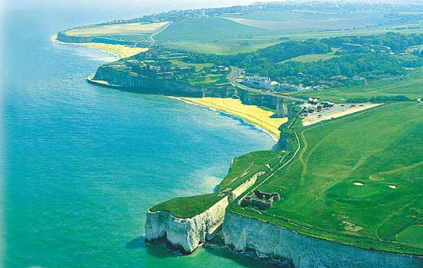
This is a wonderful example of how terrain, and the clever development of it, can result in what is, essentially, privatisation. The cliffs are developed as an exclusive, private estate of (what were once) summer houses. The beaches are only accessible by steps from the houses, or through one of the three tunnels which are owned by the North Foreland Estate (only residents are given keys). The ambience is still one of quiet, discrete, wealth in a relaxed rural (bucolic) setting. It was here that John Buchan wrote The 39 Steps (1919) whilst staying in a house on the estate. The final chapter is set in a very similar environment, and draws a great deal of detail from the locality.
Drive along the coastal road –
there are a number of wonderful bays here with sandy beaches, and sections of once-cliffs standing in the sea or jutting up from the beach. Many are wild and atmospheric – especially when the weather or time of day keeps other visitors away. This coast stood in for the wild beaches of Norfolk in the 2010 BBC adaption of MR James ghost story ‘Whistle and I’ll Come for you’ starring John Hurt.
A good place to stop for coffee and a walk of the beach is at The Captain Digby above Kingsate Bay.
Cliftonville.
It is well documented that the wards of Cliftonville West and Margate Central rank amongst the most deprived wards nationally. The profile of these two wards provides some explanation and background as to the links between the deprivation and the difficulties in dealing with the issues associated with this area. The following information provides indicative evidence of a much wider problem across the two wards where the combined effect of all these issues have led to an area that is suffering from high levels of crime and anti social behaviour, and a lack of cohesion in the community with a negative impact on the community and public services.
(https://thanet.gov.uk/publications/housing/selective-licensing-scheme-2012-2016/the-profile/)
I think Cliftonville is one of the most depressing places in England that I have ever visited. There is very clear evidence of what was once a ‘genteel’ area, indeed it was the up-market suburb of Margate. In the 1920s, when TS Eliot was in Margate, it was actually at a hotel in Cliftonville that he stayed – walking to the other side of Margate to sit in the shelter where he wrote lines for The Waste Land. Now the grandiose houses and once-hotels are subdivided into bedsits, and there hangs over the area a sense of not only desolation but despair. All who live here do so because they cannot afford anything else, or have been ‘placed’ here by local authorities seeking cheap accommodation for those from whom they have some (statutory) responsibility for – the homeless, children in care, refugees etc. It is almost a mockery – the contrast between the pretensions of the once grand buildings and the lived reality of their now inhabitants.
Unsurprisingly, the depiction of this area on film is one of isolation, despair and violence – the latest (premiered September 2015) is Jamie Thomson’s Lost Choices.
There are attempts to bring the revival/gentrification of east Margate around the headland and into Cliftonville/Walpole Bay – the Walpole bay hotel being one example. But it has yet to have, if it ever will, any real impact on the area…
Down by the sea is also a series of abandonments – the closed lift which connected cliff top to beach and the Victorian tidal pool. And, most prominent of all, the carcass of:
The Lido:
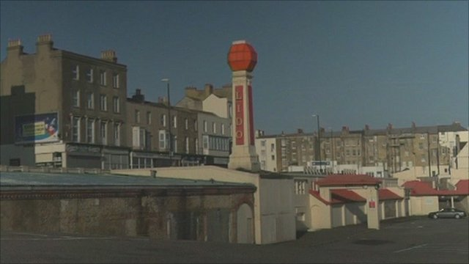

From http://margatearchitecture.blogspot.co.uk/2008/09/clifonville-baths-granted-listed-status.html
The complex of buildings on the site are of two distinct phases: an early-C19 sea bathing establishment, dating from 1824, called the Clifton Baths; and a C20 lido, dating from 1926, called the Cliftonville Lido from 1938. The structures are on four levels, the lower levels excavated from the chalk cliffs and only the upper level, on the landward side, above ground level.
The Clifton Baths were constructed between 1824-8 by John Boys at a cost of £15,000 and excavated from the chalk cliff north-east of the harbour. An engraving of c1829 shows a Gothick style fort-like structure with a massive arch at sea level, buildings above with lancet windows, crenellated parapet and an obelisk-shaped chimney. A detailed description was published in 1830 by George Alexander Cooke, probably based on a visit three or four years earlier. A large domed circular chamber provided storage for 20 to 30 bathing machines which were brought down a curving tunnel to sea level when required. A tunnel also led to the lower reservoir used as a plunge bath for women and children. A horse pump forced sea water from the lower reservoir to the upper reservoir where it supplied the water for hot baths, the power supplied by a horse gin in the open air. An obelisk-shaped chimney served the boiler but was removed in the later C19. A Bathing Room divided into two wings, the north for gentlemen and the south for ladies, had seven hot baths, shower baths and hip baths but was later demolished. There was a Waiting Room which was also a reading and subscription room and a newsroom which also had an organ and billiard table. The upper terrace had round-headed alcoves, seats and benches for enjoying the sea views. A bathers' terrace was erected by 1831 and a second chimney was erected between 1833- 45.
In 1849 ownership of the Clifton Baths passed to John Boys' son, John Harvey Boys. A map of the Margate Sanitation survey of 1852 shows the subterranean plan of the Clifton Baths with the circular dome, a passage leading off to the north-east, a reading room, bathing room, reservoir, tank and horse pump and further subterranean passages. An engraving of circa 1860 shows a further obelisk-shaped chimney had been built by this date.
In 1869 the site was sold to Thomas Dalby Reeve who built a drill hall for the local Artillery Volunteers and a boiler house with tall chimney. These are shown on Bacon's map of Margate of 1875. In 1876 electricity was used to generate ozone, believed to be beneficial to bathers. In the 1880s an indoor salt water swimming pool was provided at the north-east corner of the site. This appears on the 1907 Ordnance Survey map and survived until the mid-C20. By 1903 a cinema had been installed into the former Drill Hall, operational until 1929. In 1924 a theatre or concert hall was built east of the indoor swimming pool but was later demolished.
From 1926 onwards the Clifton Baths were re-modelled under John Henry Iles, a leading figure in the amusement park industry between the wars, who also owned the Dreamland Amusement Park. It was turned into a large modern seaside complex with bars, cafes and restaurants on several storeys and a large open air swimming pool built out into the sea. These buildings were built on to and over the existing Clifton Baths in a Neo-Classical style with Mediterranean influences, laid out over a series of terraces. The Clifton Baths boiler house chimney was adapted with the addition of a large sphere (probably intended to be a lamp), to be an advertising feature for the new complex.
The lido was a semi-circular shaped pool constructed of concrete which held 1000 bathers and could be emptied and filled every day with the ebb and flow of the tide. At the landward end it had an amphitheatre for 3000 people and adjoining promenades and cafes. It had slides, diving boards and moored floats. The changing rooms, comprising lockers and timber changing cubicles, were located under the promenade and tiered seating of the open air swimming pool.The Cliff Bar was erected beside the sun terrace and the interior scheme was often re-decorated. The Cliff Cafe, which could seat 1000 people with entertainment provided by orchestras on a circular stage, was erected underneath the the Cliff Bar and much of the Sun Terrace. The Cafe Normandie was a large cafe where dances were held, destoyed by a great storm in 1953 and replaced by the Echoes Nightclub. The French Bar, in existence by 1933, was damaged by fire in 1953 and is now a small bar at the east end of Echoes Nightclub. In it is a painted timber doorway blocking the lower end of the earlier Clifton Baths bathing machine tunnel and next to this part of the flint retaining wall of the Clifton Baths Bathers Terrace. The Jolly Tar Tavern, to the south of the Cafe Normandie used the blocked up mouth of the Clifton Baths lower reservoir as an arched alcove behind the bar. Under the Cafe Normandie was constructed the Cafe Basque by 1929 which had plaster scenery. Currently this is inundated at high tide. On the upper terrace, the south range, west of the boiler house had 50 private bathrooms providing ozonised sea or fresh water treatments. By 1929 hair dressing salons had been erected at the west end of the range, later used as a snooker club.
In 1938 the Clifton Baths were renamed the Cliftonville Lido. After the Second World War, circa 1948, the private bathrooms in the south range of the lido were closed and replaced by an aquarium and mini-zoo, a billiard hall and by 1949 a puppet theatre. During the storm of 1953 the open air swimming pool was damaged and the Cafe Normandie wrecked and replaced by the Golden Garter saloon, used for a Wild West type show. By 1962 a nightclub called the Cavern Disco had been established in the dome. By circa 1965 the Cliff Bar was re-decorated with a Caribbean theme and renamed the Jamaica Bar. Circa 1971 the Cavern Disco was renamed the Hades discotheque. In the late 1970s the Echoes Nitespot replaced the Golden Garter Saloon. A turf accountants was built by 1974 above the bar at the west end of the south range. The open air pool closed in 1977-8 and was filled in with sand.
Most of the structures above ground level are buildings constructed for the lido, with the exception of the eastern building of the south range, which is the remains of a circa 1870 drill hall with attached boiler house and chimney.
https://www.facebook.com/Cliftonville-Lido-Action-Group-136654829810683/timeline/
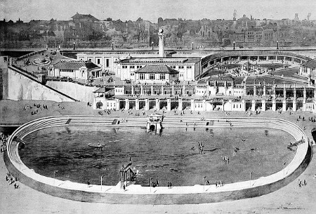
The struggle over the lido is interesting – it has now been ‘saved’ by having been listed – but it is actually the pre-lido underground structures which are protected by the listing. How possible or easy will it be to attract investors with redevelopment plans? And how can this area ever be ‘improved’ whilst it remains a mouldering, decaying empty site? And what must it have been like to have an asset like this when it was up and running - and at its (when?) best?
Drive along sea front into Margate, Turner Contemporary is one your right as you come out onto the front. Park.
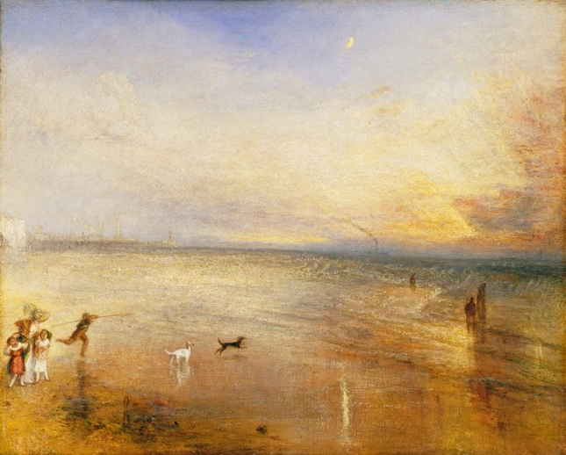
JW Turner – one of his Margate paintings: ‘The New Moon’ (1840) (Tate Britain.)
Margate.
Margate was in the forefront of sea bathing in the 18thC when bathers were taken into the sea in carts, before a fully developed bathing machine appeared, c. 1753, designed by Benjamin Beale (a Quaker). His main innovation was the addition of a modesty hood at the rear of the bathing machine, enabling the bather to enter the sea unobserved (as well as offering some protection from wind and waves). In the late 18thC c30 to 40 bathing machines were recorded as in use at any one time. The development of ‘sea bathing’ from the beach augmented the bathing rooms (now under the lido), from which a bather descended an external staircase on the seaward side into a waiting bathing machine to enter the sea. In 1791 the Quaker physician John Coakley Lettsom established "The Margate Infirmary, for the relief of the Poor whose Diseases require Sea-Bathing" which had its own bathing machine and sea water baths.
During the 19thC, Margate also became place for early ‘tourism’ as pleasure, rather than only as recreation predicated on health: a development aided by the day-trips from London coming down by steamer or train. And in the 20thC , Margate blossomed as a destination favoured by Londoners, whether for a day or a week. This was the time of cheap fun, arcades and Dreamland. But, as with most similar coastal resorts, that time did not last past the end of the century – Margate declined into desolate, trawdry emptiness.
Walking from The Turner along the front is like walking back into a time-line. Turner Contemporary is the iconic (and seemingly successful) attempt to regenerate Margate, through a new form of tourism and through culture. Built on the site of one of Turner’s ‘lodgings’ (or homes?) in Margate (a town he regularly visited, having lived in it for a while as child); the gallery is often buzzing, albeit mostly with people ‘down from London’. This is newly gentrified Margate – and it spills out a little into the immediate area. Walk further down the seafront and you see something of Margate-in-decline, or struggling: shops, cafes and arcades either semi-open or simply shut. But now the next ‘iconic’ regeneration: Dreamland. Closed and the reinvented as a kind of living museum to seaside fun, especially evoking the heady days of the late 50s and 60s when Margate was so popular. Opened in summer 2015, and still a work in progress, this remains, as a regeneration project, rather controversial. Is it a museum of nostalgia for ‘down from Londoners’ to patronise and laugh at, as much as with? Can it be inclusive enough for locals, or those who simply want to enjoy rather than be subjected to a kind of cultural- educational ‘experience’? What about those prices? However it now develops, there is no question that where Dreamland is, its prominence on the seafront, really needs something ‘done’ with it (trying to make it live, be vibrant), in order to give the seafront any chance at all. The sand are still glorious.. but it has to have some back-up.
Walking further back into history – you arrive at the ‘Royal Seabathing Hospital’. This is the splendid establishment derived from the late 18thC initiative of the Quaker philanthropist and physician John Lettsom. It developed as a charitable foundation, particularly serving the London poor, for both treatment and convalescence. (Karl Marx spent a month here in 1866, following one of his frequent attacks of boils.)
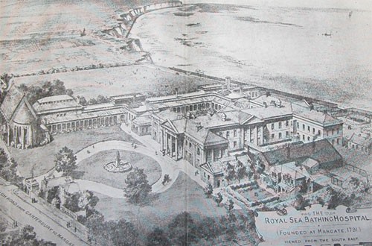
The hospital was transferred in to the NHS, and later became an orthopaedic hospital. After lack of investment or direction for many years, It was finally closed down in 1996. https://www.youtube.com/watch?v=hPNJS03BEDs records the abandoned and derelict hospital in 2004… now it has been ‘redeveloped’ into 272 luxury flats….
Not only was the asset lost (although presumably monies from the sale were recycled in the NHS), but the banality of ‘luxury flats’ missed the opportunity to think more creatively : a hotel and sea water spa? Or, even better, a convalescent home?
Drive out of Margate towards Birchington and turn down in the direction of Birchington-on-Sea. Turn right at Beach, then Avenue, then right into Spenser Road and drive to end (as it turns into Nasmyth Road). Park.
Birchington (on sea).
From Alan Kay: http://www.birchingtonheritage.org.uk/articles/bungalows.htm
….. England's first bungalow was built in Westgate in 1867. But Birchington may lay claim to having the first bungalow "estate". This was mainly due to the restrictive covenants imposed by Edmund Davis, the autocratic developer of the new "private estate" at Westgate. Consequently only two bungalows were ever built there.
The original builder, John Taylor, then moved along the coast to where John Pollard Seddon, a well-known London architect, had bought land along the cliffs at Birchington at the time of the great railway boom of the 1860s.
The Kentish Gazette of 1870 advertised 240 plots of freehold land for sale by Ventum, Bull and Cooper in the ‘rural simplicity of Birchington’. That year saw two small bungalows built each side of Coleman Stairs, later named ‘Fair Outlook’ and ‘Poets Corner’. In 1872 two more bungalows were built close by, ‘Delmonte’ and ‘White Cliffs’, with ‘Skyross’ added in 1873. These five bungalows were assured of “perfect privacy as there is no private right of way along the cliff”. They were also cut off from each other "by a desert of mud and mire from all chance of Christian intercourse".
By 1880 this estate of bungalows had become fully established, benefiting from the pioneering efforts of a decade earlier. Between 1881 and 1882 four more bungalows were added to the line along the edge of the cliffs, as is shown by the contemporary map.
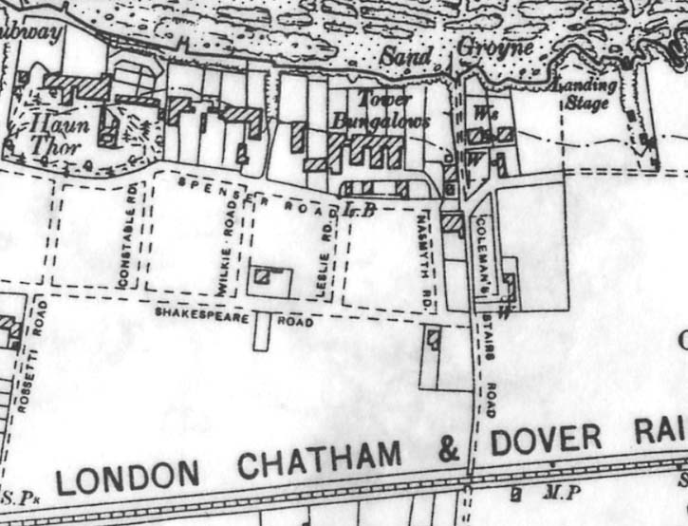
By now Taylor appears to have relinquished his part in the bungalow development. He died some time between 1879 and 1885. J.P. Seddon then designed what became known as the Tower Bungalow Estate. Among the collection of some 2000 drawings by Seddon in the Victoria and Albert Museum is one sheet titled the "Cliff Estate" showing how he planned to develop and expand the site to incorporate the recently-constructed railway station, renamed Birchington-on-Sea in 1878, with the present Station House also designed by Seddon. The site of the bungalows was some distance from the historic rural village of Birchington around the Parish Church and the development of the surrounding open fields did not come until much later. By 1891 some 13 bungalows had been established making the estate the first in this new form of building design. These bungalows were intended as second homes for "gentlemen of position and leisure", enjoying the class distinctions of Victorian times. In 1881, Athol Mayhew wrote, "Here there are no German bands in the gardens, no distressing minstrels on the sands, no revolting donkey drivers on the roads. Birchington offers absolutely nothing, not even a solitary tea garden." Shorn of these attractions the cheap excursionists from London shunned the spot and travelled on to Margate.
The medical profession advertised that nowhere was to be found a cooler, healthier or more bracing spot by the sea. Sir Erasmus Wilson felt that Birchington air was unequalled anywhere along the whole of Britain's coastline. He calculated that "during a period of twenty-four hours a person would consume twice as much air at Birchington-on-Sea as he would given the same time in London."
The Birchington bungalows were well-built and incorporated novel features such as a lockout tower, a damp-proof course and patent interlocking roof tiles. The whole contents of the larder could be lowered sixty feet into the chalk - an early example of refrigeration.
White Cliffs (see above) was purchased by the artist Solomon Joseph Solomon (1860-1927), who had been visiting the area since his sister, the artist Lily Delissa Joseph, and her husband built a summer home here (designed by Delissa Joseph, an architect - more below). Solomon was a wealthy society artist, much used for portraiture. He became a member of the Royal Academy – still unusual at that time for a Jew (his family practiced their faith and were active members of their Sephardic community in London).
White Cliffs can be found in the tight cluster of Tower Bungalows sited at the end of Spencer Road (note the weird pargetting on the walls of one of them - children at play by the sculptor George Frampton, later made famous by his Peter Pan statue in Kensington Gardens). It is difficult to try and ‘image’ them back to hoe they must have been – although the towers can be traced relatively easily, the verandas have generally been enclosed and windows too often replaced. The fact they turn towards the sea also makes it difficult to appreciate both context and design.
Walk down the little cut (just beyond the bungalows) which takes you down to the beach, and then look up to the concrete building sliding down the cliff.
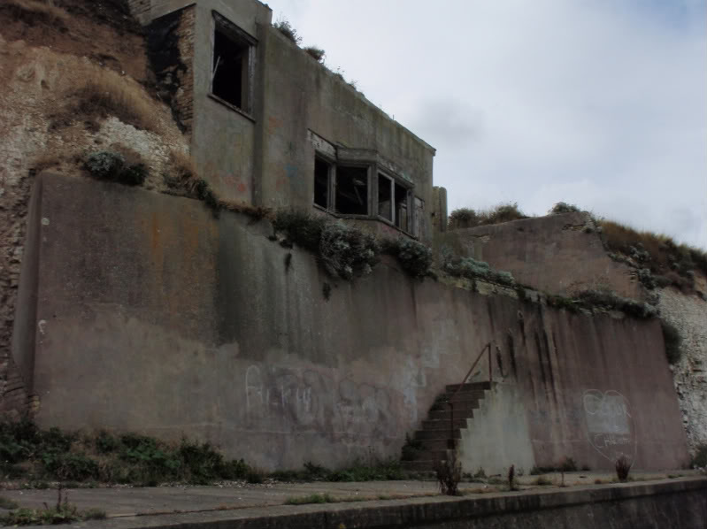
http://www.28dayslater.co.uk/solomon-joseph-solomons-cliff-top-house-birchington-on-sea-kent-august-2010.t53251
This is actually the edge of gardens of White Cliff, and the remains of Solomon’s studio which his brother-in-law had designed ‘into’ the cliff, as if it hung from the edge, as if on a balcony looking out to the sea. It must have been flooded with light and bathed in the sense of the sea moving below. It could not, however, survive the force of the sea and the crumbling of the cliff…
It is interesting to contrast a painting of Solomon’s of the interior of his Birchington home, with one of his sisters of her home:
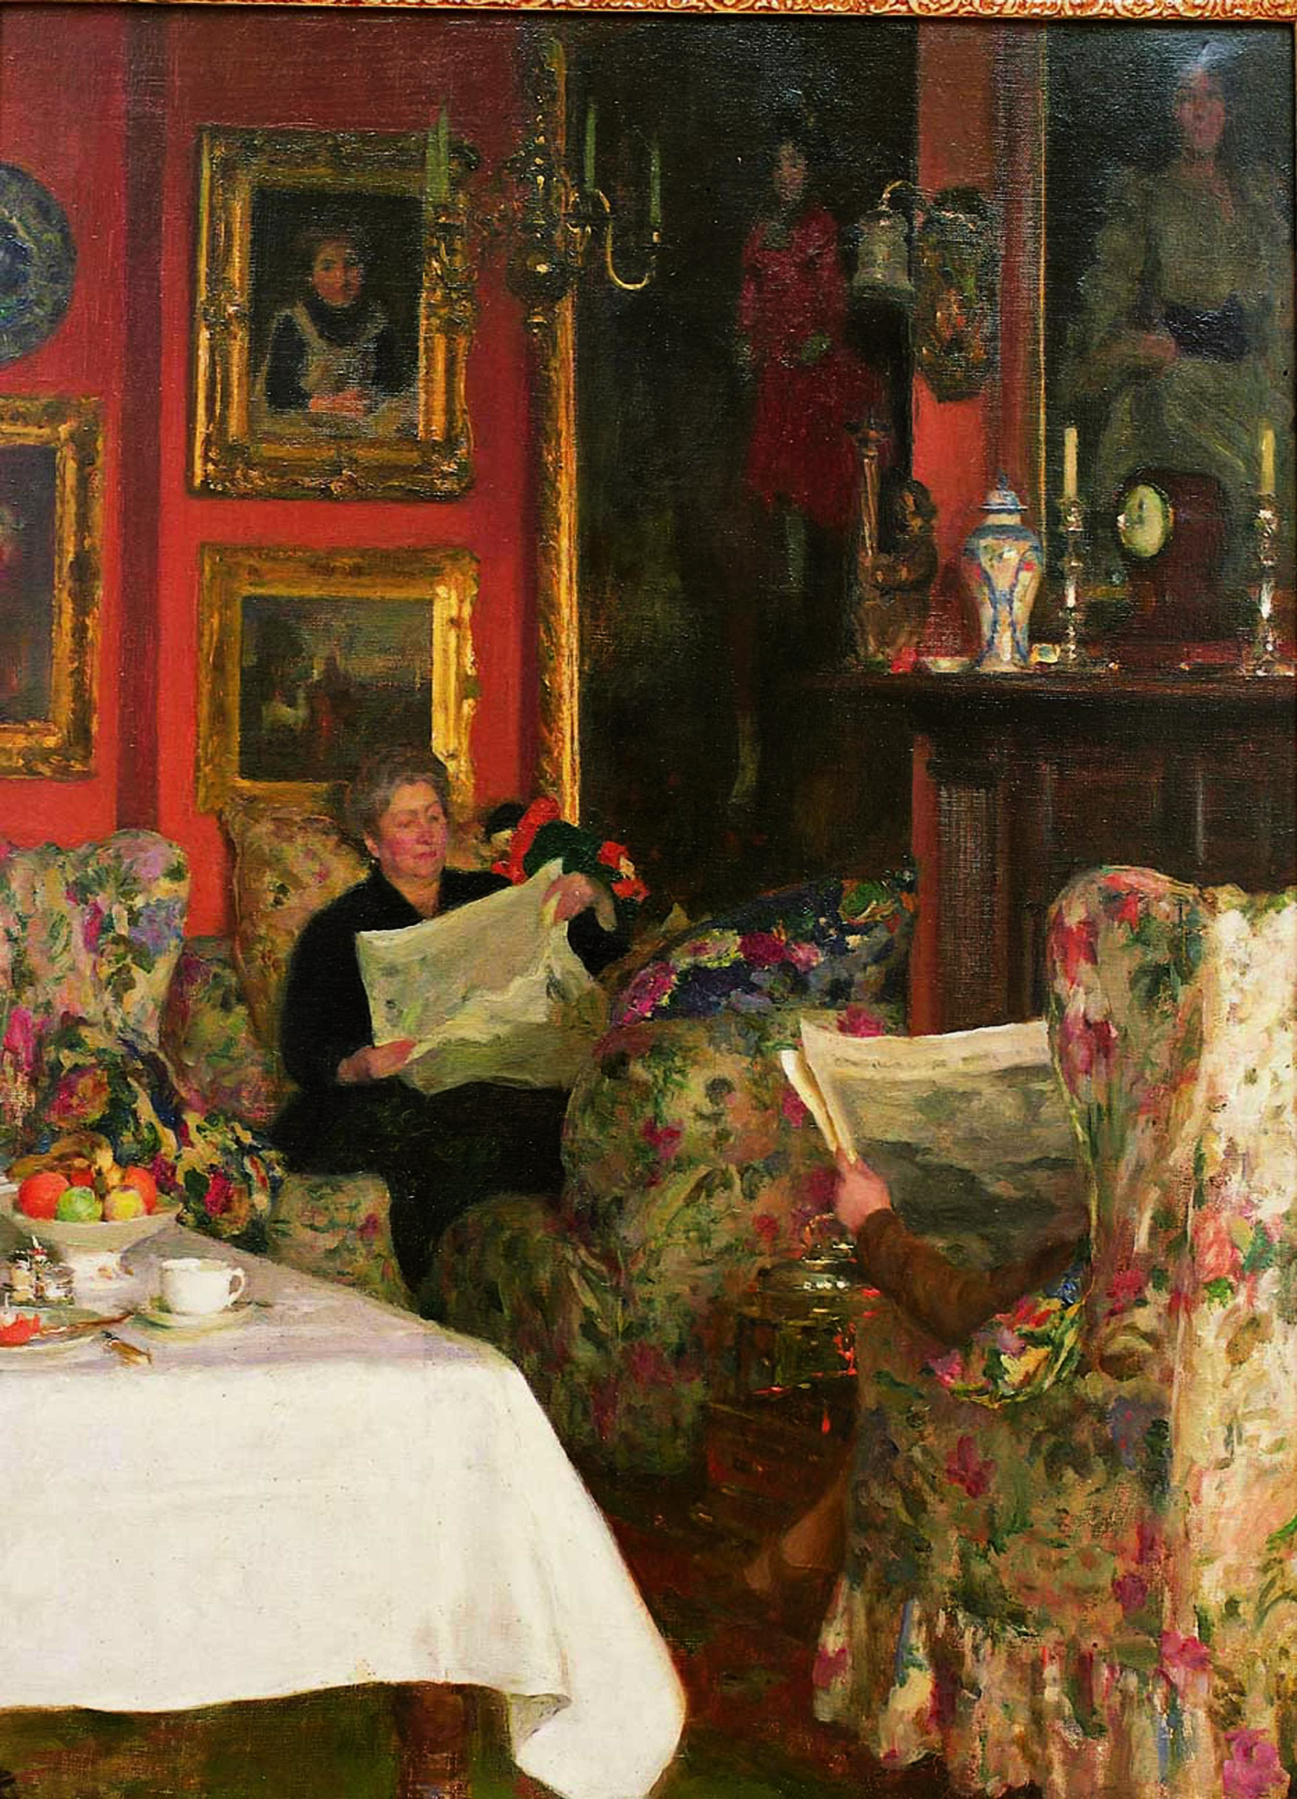
Contrasted with one by Lily Delissa Joseph (1863-1940):
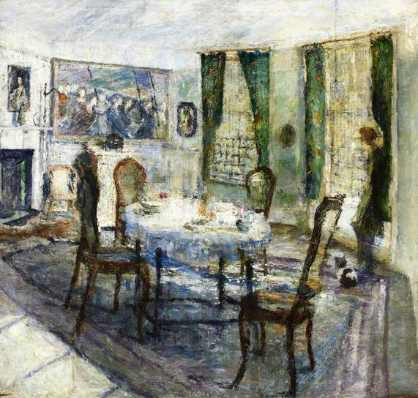
Lily Delissa Joseph Teatime, Birchington (1909) (Ben Uri Gallery).
Light floods into the room through the windows – the atmosphere is informal, relaxed and suggests a much loved holiday home. Note the picture above the fireplace – women on the march! Lily was a committed suffragist. In 1915, her supportive husband (Delissa Joseph) placed an announcement in the Jewish Chronicle beneath a review of Lily’s 1912 exhibition. “We are requested by Mr Delissa Joseph to state that Mrs. Joseph was unable to receive her friends at the Private View of her pictures, as she was detained at Holloway Gaol, on a charge in connection with the Women’s Suffrage Movement”. Lily drove cars before most women would ever have considered it, and learnt to fly in her 50s.
The tower bungalow which Delissa Joseph designed as his family’s summer home was/is North Sea Lodge on Darwin Road, which was for sale in 2011 at just under £600,000:
North Sea Lodge is situated on a tree lined private road in Birchington-on-Sea, within walking distance of both the seafront and train station. It is believed to have been built by Delissa Joseph in the 1880’s and is an early example of an Indian Lodge. One architectural feature of Indian lodges is a tower with high windows that apparently the owners used to view the tea ships coming in from the Thames.
http://www.rightmove.co.uk/property-for-sale/property-33912422.html
No mention of Lily or of the existence of paintings which depict the house. And that muddled myth of the owners watching their tea ships coming into the Thames… Drive back to Whitstable..
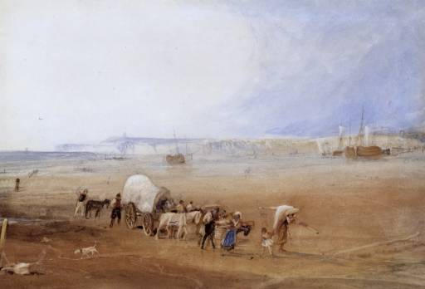 JW Turner ?‘Whitstable’ 1820s. (Tate)

