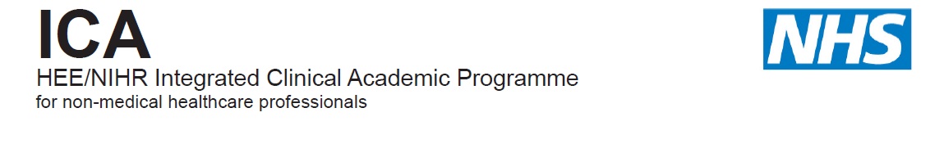

HEE/NIHR ICA Programme
ICAP Internships

University of Kent
Centre for Health Services Studies
Application Form
2021-2022

Please fill in this form as directed. Where necessary, please refer to the available guidance notes to support the quality of your application.

Please complete in BLOCK CAPITALS OR type, so that your information can be read easily.

If you have any questions about completion of this form please contact the following:
Dr Julie MacInnes

ICAP Internship and Bridging Programmes Leader
Research Fellow
Centre for Health Services Studies
University of Kent
Email: j.d.macinnes@kent.ac.uk

1. Personal and Professional Details

Name: | Profession:
Email: | Contact telephone number:

Criteria | Yes/No | State details as appropriate
A member of the eligible profession list with current registration
(Please review list of approved professions from NIHR website:)
https://www.nihr.ac.uk/documents/heenihr-ica-programme-eligible-professions-and-regulators/12204

If you are not a member of one of these eligible professions, please contact the ICAP lead to discuss

Employment contract with NHS or Local Authority employer for duration of internship

Normally employed in clinical/professional practice role

Normally minimum of 1 years clinical practice post registration

Normally BSc/BA at 2.1 or evidence of masters study

Normally evidence of academic study within last 5 years

Employer support with employer statement

State whether you intend to use the internship to help you progress to: i) an MSc, MRes, MClinRes, ii) PhD or iii) be part of a research group applying for funding

2. General Overview

(a) How does your research support the HEE Mandate? Applications welcome in the following HEE’s strategic priorities:

Topic/Area of Research | State details as appropriate
Improving the experience of people with dementia
Primary and community care
Compassionate care and the NHS Constitution
Urgent & Emergency care
Care for people with Intellectual Disabilities
Improving Patient Safety
Technology Enhanced Learning

(b) Research Interest

Evidence of active interest in research e.g. journal clubs, engagement in research activity (100 words max)

Ability to complete internship in a timely manner (50 words max)

Research Idea (this relates to the research project you would want to carry out for your future postgraduate study) (total of 500 words maximum, use headings below):
Title:
Research question:
Rationale:
Methodology:
Methods of data collection and analysis:
Expected outcomes and implications for practice:

Rationale for your application (total of 300 words maximum)

Contact details of a work-based Mentor to support you through the Internship

3. Additional Information

Available budget:
100 hours backfill = £2,000
Training budget = £500

Course costs covered
100 hrs training, to include 30 hrs from University of Kent and NHS/LA mentor, and a range of workshops and seminars, plus full access to Moodle, SDS and Library for completion of 20 (M) level 7 credited units

Checklist of documents to submit

Completed University of Kent online application form ☐

In addition, please upload the following:

Up to date Curriculum Vitae ☐

Employer-support Declaration ☐

Evidence of registration with eligible professional regulator ☐

Evidence of relevant qualifications and certificates ☐

HEE / NIHR ICAP internship application form ☐

Provide two references ☐

You will need to apply online and upload all of your supporting documentation to the University of Kent to:

https://evision.kent.ac.uk/urd/sits.urd/run/siw_ipp_lgn.login?process=siw_ipp_app&code1=PS400001S2CR-FD&code2=0002

