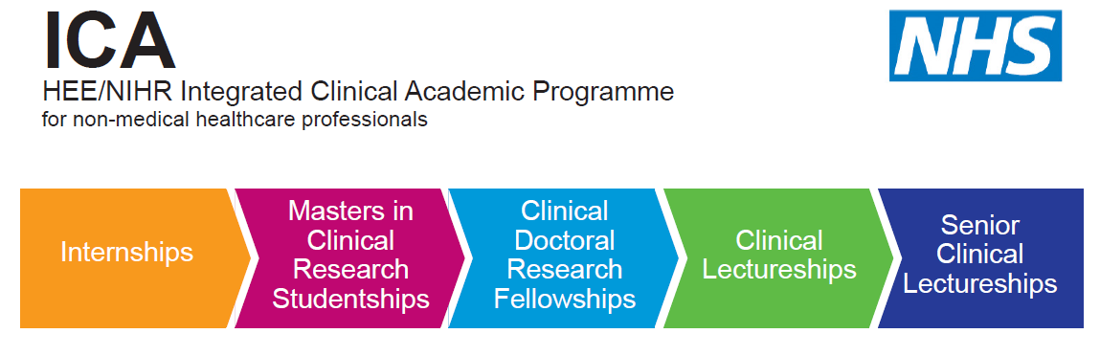

HEE/NIHR ICA Programme
Post-Doctoral Bridging Awards
University of Kent
Centre for Health Services Studies
Application Form
2020-21

Please fill in this form as directed. Where necessary, please refer to the available guidance notes to support the quality of your application.

Please complete in BLOCK CAPITALS OR type, so that your information can be read easily.

If you have any questions about completion of this form please contact the following:
Dr Julie MacInnes

ICAP Internship and Bridging Programmes Leader
Research Fellow
Centre for Health Services Studies
University of Kent
Email: j.d.macinnes@kent.ac.uk

1. Personal details

Please note you must be employed in the Kent, Surrey and Sussex area to be eligible for the HEE/NIHR Clinical Award programme starting in October 2020.

Name:
DOB:
Country of birth: | Nationality:
Profession:
Name of current employing organisation:

Address (work): | Address (home):
(W) Phone Number: | Phone Number:
(W) Email: | Email:
Mobile:

2. Profession
Please review the list of approved professions from the NIHR website. We are sorry to say that if your profession is not listed we are unable to offer you a place on this programme. Please note your professional registration must be active.

https://www.nihr.ac.uk/documents/heenihr-ica-programme-eligible-professions-and-regulators/12204

Profession | Specialty | Professional body | Registration number

3. Professional Qualifications
Name of institution | Dates of study | Qualification obtained | Other information

4. Academic Qualifications (Diploma, Degree and research /clinical related awards)
Name of institution | Dates of study | Subject studied | Qualification & classification obtained | Other information

5. Are you employed by an organisation whose core business is delivery of NHS care as a primary aspect of your professional role?
Yes
No

6. Proposed award working towards

Which HEE/NIHR award do you anticipate applying for: | ☐ HEE/NIHR Clinical Lectureship  ☐ HEE/NIHR Senior Clinical Lectureship  ☐ Other NIHR Fellowship (please state)  ☐ Other funding scheme (see below)
What year do you anticipate on making an application? | ☐ 2019  ☐ 2020
If you are not applying for an HEE/NIHR funding scheme, please provide details of which funding scheme and award you will be applying for, including the intended submission date.

7. Research Interests

Please complete ALL of the following sections.

i. Please specify the activities that you would undertake as part of the ICAP Post-Doctoral Bridging Programme (500 words max).

ii. How do you see the ICAP Post-Doctoral Bridging Programme impacting on patients, your career and your NHS organisation? (500 words max).

iii. Please give details of the support you will be receiving from both your NHS employer and your Higher Education Institution (HEI) to support your application for the Clinical Lectureship / Senior Clinical Lectureship / other funding award (500 words max).

8. Mentor support
Have you identified an academic mentor to support your proposed research and clinical development?
Yes
No
If ‘Yes’ provides details of the proposed mentor below:
If ‘No’ we can help identify an appropriate mentor from the approved Mentor database list.
Name:
Role:
Profession:
Address (work):
Name of employing organisation:
(W) Phone Number:
(W) Email:

9. Managerial Support
Please refer to the advertising material about this award to help guide your responses.
This section must be completed by your line manager.

Line managers name:
Address:
Phone number:
Email:
Please provide a statement which directly confirms that you as the line manager and your Head of Service/Operational Director will release the named applicant for the his/her full entitlement for the Post-Doctoral Bridging Award:
Signed by Line manager:

Date:
Signature of Head of Service:

10. Additional declarations
Do you have any criminal convictions Y/N
If you have answered [Y] (excluding motoring offences for which a fine and/or penalty points were awarded) you may be required to provide details.

11. Declaration and signature:
I confirm that the details and information given on this application form are correct and accurate and no information requested or other material information has been omitted.
Signed by applicant:

12. Additional Information

Available budget:
48 hours backfill = £1260
Training budget = £900

Checklist of documents to submit

Up to date Curriculum Vitae ☐

Evidence of registration with eligible professional regulator ☐

Evidence of relevant qualifications and certificates ☐

HEE / NIHR ICAP Post-doctoral Bridging application form ☐

Provide two references (one academic, one professional) ☐

Please email all of your completed documents to:

Dr Julie MacInnes
ICAP Internship and Bridging Programme Leader
Email: j.d.macinnes@kent.ac.uk

The closing date is Friday 21st August

